# Maturity levels for strategic, tactical and operational asset management

The FAIR framework is as follows:

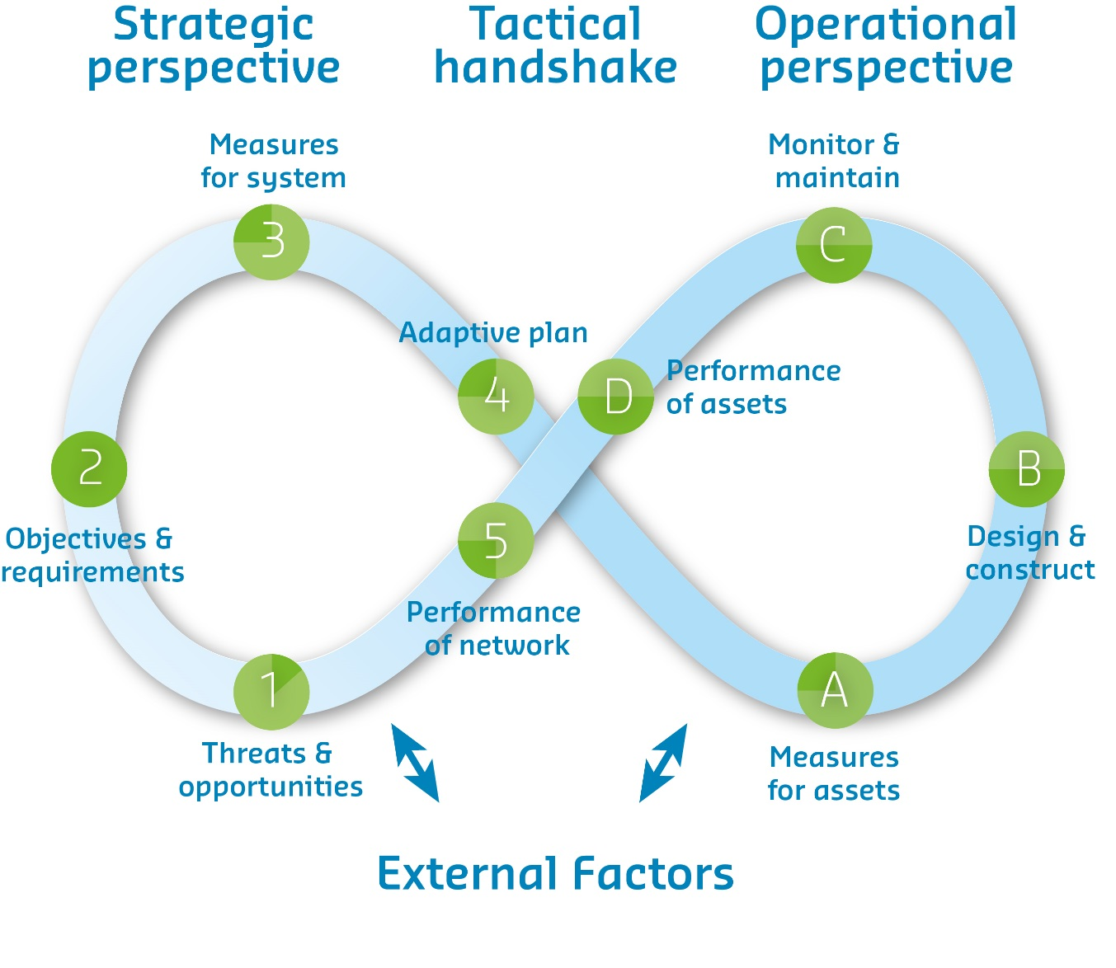

Strategic asset management concerns the asset management at a higher long term, system level, where typically for longer planning horizons plans are made and implemented in order to achieve an acceptable mix of cost, risk and performance levels. This level consists of four steps: first threats and opportunities for the system and its function are identified, next this is translated into objectives and requirements, alternative measures are appraised and the developed in an adaptive plan that best delivers these objectives and requirements.

Operational asset management deals with the shorter term implementation of measures, maintenance plans and the assessment of performance at an asset level.

Tactical asset management links the two, ensuring a smooth transition and connection between the two others. Pivotal is the translation of asset performance to system/network performance, and the translation of an adaptive plan on system level to concrete measures for assets.

Central in the maturity are the three main asset management indicators: cost, performance and risk. The use of these indicators is an important aspect of the maturity of asset management. There are typically 5 maturity levels, the table on the next page describes these.

|  |  |  |  |
| --- | --- | --- | --- |
| Level of maturity | Strategic  1-3 | Tactical  4, 5 & A | Operational  B-D |
| *Relevant steps in framework* | 1. *Threats & opportunities* 2. *Objectives & requirements* 3. *Measures for system* | 1. *Adaptive plan* 2. *Performance of network* 3. *Performance of assets* | 1. *Measures for assets* 2. *Design & construct* 3. *Monitor & maintain* |
| **Optimal** | A long term vision on system development is present, and a consistent method is applied in order to continuously translate this vision into a well-defined asset management strategies, based on cost, risk and performance as indicators. | There is a continuous evaluation of asset performance that translates to network performance. Long term plans are updated both following significant changes in network performance and periodically. These long term plans translate to optimized planning for measures, of which the performance is measured by the main AM indicators. | Performance of assets is reported using a standardized method, based on generally defined performance indicators that are used for all similar assets. There is a continuous evaluation of performance, optimized implementation of measures is realized based on the main asset management indicators. |
| **Managed** | All decisions for long term investments are evaluated using a consistent method based on a small number of the well-defined AM indicators. Performance indicators are specifically defined. | Long term plans result in asset interventions based on general and measurable performance indicators. Asset performance is translated to performance of the network, but doesn't automatically instigate a re-evaluation of the long term vision and/or plan. | Performance of assets is measured using quantitative and measurable performance indicators. The performance is monitored continuously and plans are periodically updated and executed based on the most recent insights. |
| **Standard** | Decisions on long term investments are made based on ideas but not a vision, a consistent decision making method is available but only uses the main asset management indicators in a generalised manner (often qualitative only). | There is a standardized method for translating long term planning to asset interventions. This uses the main AM indicators in a qualitative way. The measurement of performance is also mostly qualitative. | Maintenance plans and plans for interventions on an asset level are common practice. A standardized method for determining performance is used as input. Interventions are based on these plans, but there is no continuous monitoring of the performance of the implemented strategy. |
| **Repeatable** | Long term decisions are transparent but not made using a consistent decision making method. The main asset management indicators (performance, risk and cost) are not used. | Long term strategies translate into asset decisions. However there is no relation between performance and performance requirements defined on a strategic level. Reporting of performance of assets is not done in a standardized way. | Interventions are based on daily issues and qualitative decisions. These decisions are made transparent integration of planning of larger interventions and maintenance plans are scarce. |
| **Ad hoc** | Long term decisions are taken at an ad hoc basis, based on daily issues. The basis for these decisions is not transparent. Performance is not measured or evaluated. | There is no clear relation between long term decisions and decisions for specific assets. The performance of assets is not translated into performance of the network, so any long term decision disregards the actual performance of the network. | Performance of assets is not measured. Interventions are based on daily issues. There is no connection between maintenance, larger interventions and performance. |