Task 3.1a Asset Management: Template Questionnaire
WP3 Investment Planning and Asset Management
Paul Sayers, ……all other authors….
May 2016

Report information

Interreg Programme: Flood infrastructure Asset management & Investment in Renovation, adaptation, optimization and maintenance

Report Title: Task 3.1 Asset management tools and approaches within the North Sea Region

Date: May 2016

Contributing science partners: Sayers and Partners, UK,
Contributing asset owners: list….
Document revision history:

Version | Date | Author(s) | Description
1.0 | 23 May 2016 | Paul Sayers | Outline only for discussion to WP3 partners
1.1 | 27May2016 | Paul Sayers | Based on skype call ST – 27May2015
1.2 | 11July2016 | Paul Sayers | Taking on board the discussion with Remco Schrijver, Wouter jan Klerk, Frank den Heijer and Owen Tarrant

Summary

FAIR (Flood infrastructure: Asset management and Investment in Resilience, adaptation and maintenance), is funded by the EU INTERREG North Sea Region (NSR) Programme and led by the Rijkswaterstaat, FAIR focuses on providing improved, more resilient, more multi-functional and adaptive approaches to providing flood infrastructure. Asset owners and academic colleagues from the Netherlands, Sweden, Germany, Belgium, UK and Denmark will be comparing approaches to asset management and investment planning to share good practice and support new developments.
This report is provided under Work Package 3 (WP3 Investment Planning and Asset Management) and sets out a questionnaire to be completed by the asset owners and science partners within the FAIR consortium. The aim of the template is to guide the Asset Owners in identifying the challenges, barriers and gaps they face in developing more adaptive Asset Management. The science team will then summarise the findings and incorporate elements in international practice and tools.

Glossary of terms
Asset | Item, thing or entity that has potential or actual value to an organization. In the context of flood management this is generally a physical asset (e.g. a gate), but it can also be the data that is used to manage the gate (i.e. if the data is gone, the performance will drop).
Asset function | Function related to an organizational objective that the asset fulfills, an asset can fulfill multiple functions. E.g. a sluice will contribute to shipping (a function), but also to flood risk reduction (a different function).
Asset management | Enables an organization to realize value from assets in the achievement of its  organizational objectives¹. Asset management can be done on different levels, strategic, tactical and operational are the generally distinguished levels. An example of strategic asset management is that safety standards of flood defences are changed due to new societal developments (e.g. economic growth), an example of asset management on a tactical level is the planning of reinforcement of dikes over a longer period of time, an example of a decision on an operational level is how often a dike should be inspected in order to ensure its reliability meets the standard.
Asset performance | Measurable result¹ Measure for the extent to which the asset performs, to be compared with the required performance. E.g. the reliability of a dike or the availability of a sluice.
Availability | Ability of a system to be kept in a functioning state. E.g. the percentage of time that a pump is functioning.
Consequence | Represents an impact such as economic, social or environmental damage or improvement, and may be expressed quantitatively (e.g. monetary value), by category (e.g. High, Medium, Low) or descriptively. For instance the casualties and damage in a flood.
Cost | Capital: Initial investment required to provide a significant change to the performance of an asset or provide a new asset (e.g. reinforcement costs, cost of building a sluice)  Revenue: On-going investment needed to maintain the performance of asset / asset system  Operating: costs for keeping an asset (e.g. the sluice) operational (i.e. satisfying the performance criterion). For instance, cost for energy, maintenance, painting the doors.  Whole life: see life-cycle cost
Life-cycle cost (LCC) | Or: Whole Life-cycle Cost or: Total Cost of Ownership (TCO). The total of all costs and revenues over the life cycle. Enables comparison of e.g. construction, maintenance and removal costs. Generally expressed as Present Value, where all future investments are expressed in current day value using discounting.
Probability | Measure of our strength of belief that an event will occur. ² For more details on different interpretations and views on the concept of probability see².
Reliability | Ability to perform a certain defined task, often expressed as probability of failure. E.g. the reliability of a flood defence is its ability to prevent a flood. Generally expressed in terms of probability
Resilience | Ability of a system to react and recover from a damaging hazard²
Risk | Function of hazard, exposure and vulnerability²  For a flood that would be:  Hazard: the probability that a flood occurs (to given depth, velocity, duration) at a given location.  Exposure: the people, businesses, infrastructure, habitats etc that may experience harm if a given flood occurs.  Vulnerability: the degree of harm (loss of well-being) suffered by those exposed to a given flood.  Please note: This definition supports the more general definition of risk as a function of probability and consequences; where consequences are described by exposure and vulnerability.
Risk attribution | Decomposition of risk to individual assets/objects
Safety | The requirement not to harm people, the environment, or any other assets during a system's life cycle
Scenario | A plausible description of a situation, based on a coherent and internally consistent set of  assumptions.² For instance a description of the development of climate or economic growth in the next decades.
Standard | Of protection:  Performance  Safety  Ultimate limit state  Serviceability limit state
(Investment) strategy | A strategy is a combination of long-term goals, aims, specific targets, technical measures, policy instruments, and process which are continuously aligned with the societal context. ²
Performance criteria | Required: Levels that performance indicators need to meet. E.g. safety standards defined by law.  Desired: Levels of performance indicators that might be met, if benefits for organizational objectives (broadly) outweigh costs. E.g. if an organization has as objective to generate more economic activity on and around a dike, they can make it multifunctional, if it is not too expensive.

Contents

Report information 1
Summary 2
Contents 7
1 Introduction 9
2. Part A National context - Netherlands 10
Question 2.1: Context within which asset management takes place 10
2.1a – Roles and responsibilities 10
2.1b - Relevant policy, plans and codes 11
2.1c Planning timescales of interest 12
2.1e Governance and other aspects 13
Question 2.2: Challenges and barriers to be overcome 14
2.2a Barriers in the understanding of the current system 14
2.2b Future change 14
2.2c Funding barriers 15
2.2d How successful is asset management 16
Question 2.3: Overview of tools and data used (where this is known) 16
2.3a Reliability 16
2.3b Deterioration 17
Question 2.4: Decision process 17
2.4a Investment planning and prioritisation 17
2.4b Social justice 17
2.4c Robustness under conditions of future change 18
3. Part B Case study – Dike reinforcement Marken 19
Question 3.1: Setting the scene of the case study 19
Question 3.2: Specific challenges and barriers to be overcome 21
3.2a What is the asset management challenge 21
3.2bUnderstanding of the current system 21
Socio-economic understanding 23
3.2b Future change 24
3.2b Governance and other aspects - move to be consistent with Part A 25
Question 3.3: Overview of tools and data to be used (where this is known) 25
3.3a Reliability 25
2.3b Deterioration 26
For Marken the specifis challenges are peat (settlement), stability, height and maximum acceptable overtopping volume, LCC and communication with stakeholders. 26
Question 3.4: Decision process 26
3.4a Social justice 26
3.4c Investment planning 26
Question 3.5: The relationship of AM to board planning issues 27

1 Introduction

This template sets outs the questions to be reviewed and completed by the Asset Owners. The responses will then form the basis of a comparison of methods across the North Sea Region and, importantly, common challenges identified and best practice shared. The results from the questionnaire will be taken forward in WP3 and WP5.

The questionnaire is structured in two main parts. This first part of the questionnaire explores the context within which asset management policy is made, strategies development and plans delivered. The aim is to provide a rich understanding of the approaches in each partner country that forms the background to the case studies. The second part of the questionnaire focuses on the specific challenges and approaches at the case study site. By including these two strands an in-depth understanding of the reasons why different approaches are used will be developed and, in doing so, enable best practice to be shared in the most meaningful way.

Note: The responses to the questionnaire should be provided as a standalone report and set out using the question headings given here.

2. Part A National context - Netherlands

Question 2.1: Context within which asset management takes place

2.1a – Roles and responsibilities
We would like to understand the organizations with an interest in AM, their role and responsibilities for delivering AM (funding, programming and permitting etc). This includes both private and public sector organizations, as well as the role of communities and NGOs. We would also like to explore how third party assets treated/managed.

Organization | Interest | Role | Responsibility
National government
Ministry of Business and Growth | Administering the Planning Act | Programming role | Compile overall physical planning
Ministry of Environment and Food of Denmark | Administering parts of the Nature Conservation Act | Permitting role | DCA administers the law concerning coastal set-back lines
Ministry of Environment and Food of Denmark | Administering the Coastal Protection Act | Permitting role | DCA administers the law taking into account those considerations specifically listed
Regional government
N/A | N/A | N/A | N/A
Local government
Municipalities | Administering the Planning Act | Planning role | Responsible for appointing areas for land use locally
Municipalities | Political and social interests (in terms of the Coastal Protection Act) | Initiation and coordination of holistic coastal protection schemes | Responsible for the process, please see below
Operating authorities
N/A | N/A | N/A | N/A
Private owners
Land owners | Protection of their assets | Funding role | According to law, coastal protection is the responsibility of the individual land owner
NGOs
N/A | N/A | N/A | N/A
N/A: Not applicable for asset management in the national context from the Danish Coastal Authorities point of view.

Please feel free to expand below….
In general, coastal protection is the responsibility of the individual land owner. This is according to the coastal protection law.

To promote holistic coastal protection solutions the municipalities have the right to urge the planning process including compilation of preliminary conceptual design, economical party distribution etc. − decisions which all will be necessary to implement coastal protection projects.

In some reaches of the west coast of Denmark economical agreements on coastal protection is signed between the authorities (government) and the local municipalities. This is according to historical and social economic reasons. The Danish Coastal Authorities (DCA) manages the coastal protection efforts according to political agreed objectives concerning safety levels.

During times the dikes in the Wadden Sea area have been funded according to legal documents concluded by the Parliament. Maintenance is transferred to the asset owners organized in associations.

2.1b - Relevant policy, plans and codes

Discuss the policies, plans and codes that specifically influence the delivery of asset management. These should include both flood related and non-flood related (for example, broader development plans). This should be provided as a table as below with supporting text below.

Policy or plan | Level (international;/European/National) | Description | Influence on asset management
Policies
Water Frame Directive | European | Sets the framework for protection e.g. lakes and watercourses | Regulation in associated water plans may put some restrictions on utilization
Floods Directive | European | Oblige some municipalities to develop Risk Management Plans for designated areas with high risk of flooding | Planning may prohibit housing in flood prone areas
Plans
Climate Adaptation Plans | Local | Municipalities are obliged to prepare plans that include flood risk mapping and prioritizing of actions to prevent flooding caused by rainfall and the sea | Planning may prohibit housing in flood prone areas
Codes
Manual for socio-economic analysis - Used methodology and practice. (Manual for samfundsøkonomisk analyse) | National | A tool for compilation of socio-economic analysis. Used methodology and practice. | Applicable rules on transport issues but is useful in other fields as well
Guides
Guidelines for climate adaptation in coastal zones | National | Guidelines on climate adaptation measures at coastal reaches in Denmark as inspiration for municipalities, landowners and other decision makers | Guidelines with no obligation to comply. Useful when prioritizing actions aimed at avoiding flood damages.
Manual for preparation of regulations related to the socio-economic analysis (Manual for udarbejdelse af bestemmelser knyttet til den samfundsøkonomiske analyse) | National | Guidelines on socio-economic analyses, which exemplifies the use of the code mentioned above | Guidelines with no obligation to comply. Useful in prioritizing actions aimed at avoiding flood damages.

Please feel free to expand below….
On the central part of the West Coast of Denmark, a coastal reach of 115 km, objectives for coastal retreat and flooding are agreed upon. Five year plans for compliance are prepared.

2.1c Planning timescales of interest
Discuss the timescale over which asset management activities are assessed and planned and how each influences AM decisions. Consider the multiple timescales within which assessments takes place (national policy cycles, regional planning cycles, maintenance cycles, others).

Time scale | Associated time horizon (in years) | What AM decisions take place over this timescale? | Who leads these decisions?
Long term planning
No planning
Medium term planning
No planning
Short term plans
No planning

Please feel free to expand below….
In general there are no plans, not long term or short term, for coastal protection. The authorities take no responsibility for neither planning nor funding – with the exception of before mentioned areas, in which economical agreements are signed. In those areas recurrent short term (5 year) plans are compiled.

Every 10 years the DCA update the safety levels of the Wadden Sea dikes. The results are then reported to the relevant dike associations and officials for further possible action.

2.1d - Requirements of performance
Discuss what kind of performance requirements have to be met, who defines these and how these are determined.

- Required criteria (i.e. What criteria must be met regardless of cost)

There is no obligation of certain safety criteria levels to be met. However, the Government has introduced a Storm Fund, which is financed from dues on all fire insurance policies, to compensate flood damages on properties (house and furniture). To get compensation a water level of at least 20 year meantime has to be exceeded.

On the central part of the West Coast a minimum safety level of 100 year meantime applies. However, the amount of funding is political decided, not necessarily determined by safety aspects.

- Desired criteria? What criteria might be met? If (broad) benefits outweigh (broad) costs

From a professional point of view the socio-economic arguments involving probabilistic methods normally should provide the desired criterion, which implies different safety criterion for different reaches.

2.1e Governance and other aspects

Funding
- Who pays, the asset management plan to be developed, for maintenance, capital investment and how secure is this funding stream into the future?

In general, the individual landowners pay for coastal protection with the exceptions mentioned in 2.1a.

The coastline of Denmark is about 7.000 km long. In the future, climate change and demographic pressure will increase the necessity for coastal protection. Increasing public pressure for public funding may compel the political system to change their policy. Hefty investments in overall physical measures, i.e. larger dikes and sluices, may be an argument for greater public involvement in coastal protection.

Question 2.2: Challenges and barriers to be overcome

Questions 2.2a to 2.2d seek to tease out the issues in our understanding of asset performance over time and the availability of supporting data.

2.2a Barriers in the understanding of the current system

Physical understanding
Sources
- Extreme storms and river discharges (what are of return period storms do you consider, how do you include joint probability issues)

Due to the fact that Denmark doesn’t have large rivers then the main hazard in this context is flooding from the ocean. Different analysis has been implemented in Denmark, where it has been necessary to define suitable return periods and sea level changes, analysing both the present and future risk. These include the implementation of the EU Floods Directive and a national assessment identifying the hazard and vulnerability from flooding and erosion along the coast.
Regarding joined probabilities this work is ongoing, implementing the second plan period of the EU Floods Directive.

Pathways
- Accuracy of the floodplain topography data (what level of accuracy is typical and is this good enough?)

Denmark has a digital elevation model covering all land. The elevation is given in a 0,4 x 0,4 meter grid. A new model has recently been released and is likely to have an accuracy of 0,05m or higher especially in uniform flat areas. In areas where the topography changes considerably, e.g. in dune terrain, the model is likely to have a lower accuracy.
The model is distributed with an amendment in the form of a hydrology layer, which takes into account the pathway of the water (tunnels, culverts etc.). An updated hydrology layer is under development.

- Accuracy of information on asset location, geometry and construction (what is known and where are the key gaps in knowledge)

The Danish Coastal Authority has the obligation to authorize the construction of proposed structural mitigation measures. The knowledge of the location and type of flood defence is therefore well known and is part of the Authorities’ GIS database. There is a lack however regarding information on geometry and construction materials.
In addition, municipalities often have the only knowledge on minor coastal flood defence structures. Therefore, it is important to include municipalities when conducting hazard and risk assessments.

Socio-economic understanding
Receptors
- Accuracy of information on floodplain usage (residential properties, people, businesses etc.)

The Danish Legislation place some constrictions on land use. Areas are therefore designated a specific purpose. Specific use of land can be changed by municipalities e.g. to improve economic development. If this is pursued in the coastal zone then construction can only take place after receiving a legal permit from the Danish Coastal Authority.

2.2b Future change
We would like to understand how future change is accounted for. In particular:

In climate
What guidance is provided on climate change, including: (change to a table)
- Sea level rise allowances – what estimates of SLR are used for 2025,2050,2080
During assessments and when implementing the EU Floods Directive in recent years the Danish Coastal Authority has used two IPCC scenarios to analyse the risk from flooding; RCP2.6 and RCP8.5. The Danish Meteorological Institute has adjusted the values to reflect the impact on a national scale. These values were used during a recent conducted national assessment.

 | 2065 | 2115
RCP2.6 | 0,3 ± 0,2 m | 0,5 ± 0,3 m
RCP8.5 | 0,4 ± 0,2 m | 0,9 ± 0,4 m
The year 2065 and 2115 has been applied to give a 50 and 100 year time span.

- River flows – what estimate of change in peak flows are assumed for 2025, 2050 and 2080 – if not peak flows how is climate change accounted?
This has to some extent been incorporated in the last plan period of the EU Floods Directive and will receive more attention during the next period.
The Geological Survey of Denmark and Greenland has published a report, which identify the changes in hydrology and river flow as a consequence of climate change. Using values obtained between the years 1961-1990 the changes have been calculated using a Danish model for climate change for the years 2021-2050. Return periods used are 5, 10, 20, 50, 100, 200 500 and 1000 years.

- Rainfall – what change in the estimate of rainfall (30 and 100 year return period hourly, daily, monthly) are assumed for 2025, 2050, 2080s? – If not quantified how is rainfall change accounted for?
Same as above

Is any consideration given to the influence of the following climate change related issues on asset management decisions:

- Temperature – Yes/no – if yes how? No
- Storm sequencing – Yes/no – if yes how? Yes, see above
- Spatial coherence – Yes/no – if yes how? No

In socio-economics
- Population growth – Yes/no – If yes, what assumptions are made about population growth (% increase, by 2025, 2050, 2080)
No

- Economic development – Yes/no – If yes, what assumptions are made about growth (% increase, in GDP by 2025, 2050, 2080)
No. This partly needs to be implemented in the second plan period of the EU Floods Directive.

In land levels
Localised settlement of the levees – If yes, what assumptions are made
No

Regional soil subsidence (i.e groundwater management related consolidation) – If yes, what assumptions are made
It has not been implemented so far. However, the coastal zone of Denmark experience in many places subsidence. A joint work between the Danish Coastal Authorities and other governmental organizations is currently being conducted trying to uncover the main hazard areas and the volume of subsidence. The subsidence is important since it often evens out the isostatic rebound.

Isostatic rebound – If yes, what assumptions are made
Yes. Isostatic rebound is taking place as a consequence of the pressure release from the last ice age. The amount is known on a regional level through-out Denmark.

2.2c Funding barriers

Everyone has a finite pot of money – but is the structure of funding or payment a barrier to optimal / best asset management (compensation for example).

It is well known that to enhance both mitigation and adaptation there is a need for implementing and coordinating both non-structural and structural measures.
Non-structural measures refer to more in-tangible issues including legislation, early warning, increasing of awareness and assessments. These issues are purely the responsibility of the government and the municipalities, who finance such measures.
The funding to implement and build structural coastal protection is in Denmark divided between two. For the Danish west coast both the Government and the municipalities pays to establish and maintain the protection. Regarding the rest of the country, it is the decision of local land owners whether or not they are interested in protecting themselves from flooding. Therefore, they also have the obligation to finance such project. The self-funding principle often leads to implementation of the cheapest coastal protection monetarily but it is often not the best solution. A better structure of funding could benefit and improve holistic solutions.

2.2d How successful is asset management

Is it known whether the asset management is being delivered successfully?
It is undetermined whether a type of asset management is implemented on a national level in Denmark. As the definition indicates, the asset management system resembles the ISO system, which built on the Plan – Do – Check – Act principle, where policies and objectives have to be established before implementation, which has to be monitored and potentially be improved.
The Danish Government has currently not defined an acceptable risk. This has, by the majority of international papers, been identified as a crucial parameter to define if sustainably, cross-cutting and holistic solutions are to mitigate and adapt for future flooding. Without defining an acceptable risk municipalities do not know what to protect themselves against, hereby creating a climate in which transfer of risk will take place. A tactical level in flood risk management is therefore to some degree currently missing except for the overarching goal, which is to prevent flooding. Likewise municipalities in their risk management plans lack prioritization and coordination of the plan-do-check-act principle.
Consider issues of delivering:

- The required process – assets been managed through the process set out
- The performance criteria (see Question 2.1d) – have required and desired performance been met.
- The efficiency of achieving these – minimizing whole life costs for the outcomes achieved

If so, how is it measured? (e.g. required and desired performance requirement (if present) is met?
There is a large gap in asset management in Denmark and a general lack in a holistic national policy for coastal protection.

Question 2.3: Overview of tools and data used (where this is known)

2.3a Reliability

Overview
- What approaches do you typically use to support policy analysis and design?

A net of water level gauges – in total 68 − is spread over Denmark. Every five years the DCA updates high water statistics for each gauge.

Only policy on coastal reaches with joint agreement:
- Analyses of the development of the coastal profile down to ÷6 m level.
- Analysis of sufficient safety level of the dune barrier (height and width).

- Do you have data to support these methods? If so, who collects it, who collates it and can access it and is it t openly available, if so where? Is uncertainty in the data considered?
The DCA maintains a comprehensive monitoring programme on the west coast of Denmark, i.e.
- Multibeam monitoring of coastal profiles with about 1 km distance mutually
- LIDAR monitoring of the dune barrier.

Uncertainty in data is considered.

Specific challenges and gaps in understanding
What are you particularly grappling with

- Lack of mathematical model describing dike breach development over time
- Better damage functions for different type of damage dependant on the coastal profile

2.3b Deterioration
With and without management….

In connection with floods parts of the low lying coastal plains in Denmark may be affected, depending on wind – wind force, persistence and wind direction – and changes in wind direction.

No valid overview if the flooded assets have been duly protected.

Question 2.4: Decision process
The following question explore the aspects that shape the choices made.

2.4a Investment planning and prioritisation
Expenditure type
- Total expenditure (whole life cycle costs) – or just capital or revenue?

Cost-benefit analyses are often not constructed.

Prioritisations
- First in the queue – early bird gets the worm – constraints on permitting for example
- Given the nature of expenditure, do you seek to identify least cost or max BCR, or other
- Individual asset versus asset portfolio planning: How is investment optimised across the portfolio of assets that exist?

Except for the Danish west coast it is up to the individual land owners to protect themselves from flooding. It is therefore the responsibility of private land owners, including the municipalities, to decide on and prioritize mitigation measures.
Analysing the 22 risk management plans from the recent plan period of the EU Floods Directive indicate that municipalities in general do not prioritize implementation of measures. They use a more ad-hoc method in which mitigation measures are implemented at random. Often mitigation measures are non-structural, in the form of assessments, so that informed decision making can be made. By doing this hopefully investments can be optimized.

Opportunities for enhancing the return on investment
- Payment for non-FM benefits/functions? i.e broader benefits – is this possible and do they change the investment ranking?
In general there is a lack of cross-cutting and holistic solutions. If mitigation measures have broader benefits they are not prioritized.

- Private contributions – does this change the ranking?
No.

- Opportunities of material reuse and other infrastructure investment synergies – i.e tunneling programme has generated potential source of materials?
In Denmark there exist some cases where materiel has been reused to construct flood protection. In general flood protection does not serve other purposes.

2.4b Social justice
How are the three principles of justice considered:

- Equality – Are all citizens treated equally in the FRM process? If no, why not? If so, how is this ensured?
Yes and No. Funding is distributed un-even and governmental funding is only given to the municipalities on the west coast of Jutland.

- Are the most vulnerable members of society prioritized? If no, why not? If so, how is this ensured?
No.

- Utility – Is it a required to ensure the best return for each euro spent? If no, why not? If so, how is this ensured?
No. Often cost-benefit analysis is not performed. The solutions are more ad hoc.

3. Part B Case study – Thorsminde

The following questions focus on the specific approaches taken at the case study sites. The responses here follow on from those in Part A and will help provide an understanding of how the approaches nationally influence and are taken up locally.

Question 3.1: Setting the scene of the case study

Please describe (in no more the two pages including figures) the context of your case study. This should include:

Name of the case study and a map

Dewatering of Nissum Fjord in relation to climate change

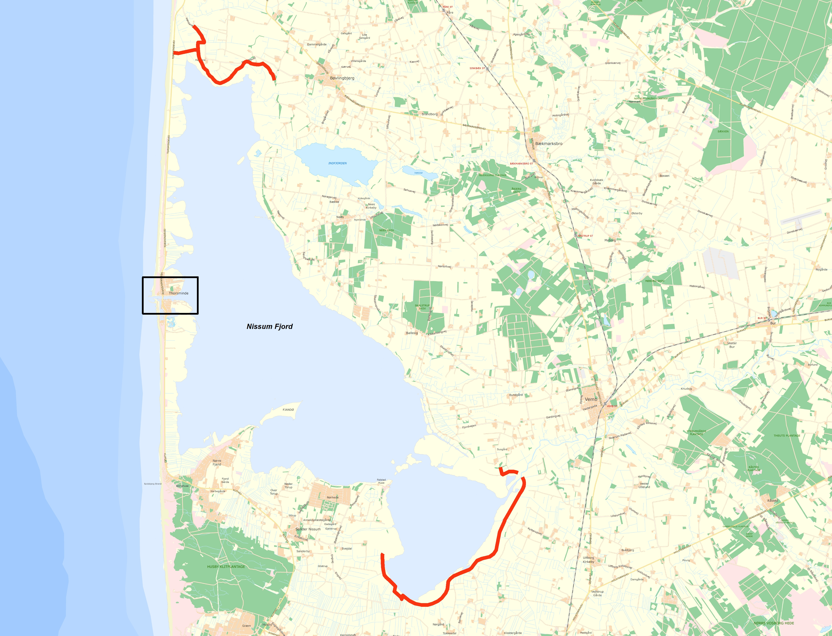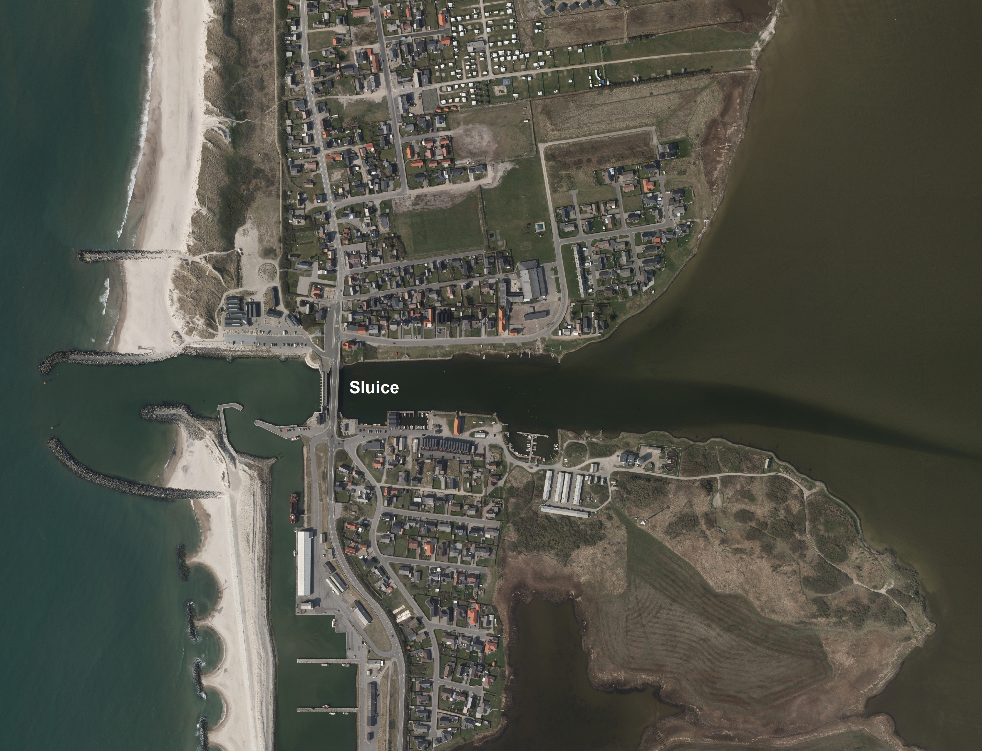

On the map it is possible to see Nissum Fjord and the hinterland. The red lines display the fjord dikes. The photo on the right shows Thorsminde town with harbour and sluice. Source Danmarks Miljøportal

Focus/objective of the case

Decision focus: Tactical. In the future larger areas around the fjord will be flood prone, including areas located behind existing dikes. What will be the most robust solution to the problem when taking into account the economy setting a time horizon until 2100?

Objective: Adaptation to the future situation. Sea level rise equals mean shorter periods for dewatering through the sluice resulting in more frequent high water situations/problems in the fjord. The objective is to analyse the possibilities for adaption measures.

The physical setting

Nature and topography
Nissum Fjord is a former bay which has been cut off by a barrier island from the sea. The fjord is surrounded by salt marshes. Some places dikes protect low lying farmland.

Sources of flooding
A major water course, Storåen, discharges its volume into the fjord. Moreover several minor fresh water inlets contribute to the fjord.
We are only looking at potential flooding from the fjord. A potential flood threat from the sea will be managed through supervision of dune safety and corresponding nourishment activities.

Existing flood defence infrastructure
The area (plains) around the fjord is protected my minor dikes.

The socio-economic setting

State if rural, semi-urban, dense urban
The threatened area is primarily rural. Thorsminde is a minor town situated in the middle of the barrier island heading the North Sea.

What is the nature of the communities to be protected, residential and non-residential activities, important infrastructure services (hospitals, transport hubs etc) that may be in the floodplain and how these might be impacted by a flood.

Parts of Thorsminde town will be threatened by flooding. The road, which connects the town to the mainland, may also be threatened. If a breach of a dike occurs or if they are overflowed then farmland will be flooded.
Thorsminde is a minor town with about 400 residents. Primarily livelihood is based on fishing activity. A small fishing harbour is situated in the town. There are also non-residential housing and income from tourists. A maritime museum and a marine activity centre are some of the touristic attractions.

Have there been past floods in the area? If so, how was it caused and what impact did it have?

There is no evidence of historical flooding behind the existing fjord dikes. However incidents with extreme water levels in the fjord have occurred as a combination of large discharge from the inland and sluice gates closed due to high sea water level or longer periods with no possibility for discharge. With raising water levels in the fjord the salt marshes act as immediate reservoirs.

We are only looking on potential flooding from the fjord. Flood threat from the sea will be managed through supervision of dune safety and corresponding nourishment activities.

Question 3.2: Specific challenges and barriers to be overcome

3.2a What is the asset management challenge
what is the driver for the case study and what makes AM difficult:

Make thorough analysis of the future situation with an interest in raising political awareness of the problem. Furthermore it is preferred to suggest adaptive solutions to the problem.

3.2bUnderstanding of the current system

Physical understanding
- Vertical accuracy and source of the floodplain topography data
The vertical accuracy of the topography is: 0,05 m
The horizontal resolution of the topography is: 0,15 m

- What flood defence assets are important to the case study

A basic typology of the flood and coastal erosion risk management infrastructure is provided in the table below (Sayers et al, 2015). Which asset types exist in the pilot study area and what role do they play?

Asset types to be considered in the pilot (asset typology after Sayers et al, 2015)

Type of asset |  | Example activities | Considered in pilot (yes/no) | Why?
Local scale infrastructure
Private homes and businesses | Avoidance | Raising properties above flood levels (actively, floating homes, or passively, raised thresholds) or some other way to avoid flooding. | No | s Conventional methods can be used
 | Resistance | The use of flood products and construction detailing to prevent water entering a property. | No | Not the focus of the analysis
 | Recovery | Use of building materials and practice that such that although flood water may enter the building no permanent damage is caused, structural integrity is maintained and drying, cleaning and minor repairs are facilitated. | No | Not the focus of the analysis
Critical service nodes | Avoidance | Raising critical functions / building above flood levels. Deployment of property scale ‘ring dykes’. | Yes | If a demand for physical expansion of the town.
 | Resistance | The use of flood products and construction detailing to prevent water entering a property. | No
 | Recovery | The use of function specific building designs and network redundancy to avoid loss of function if flooded (i.e. continued power or communication distribution). | Yes | If analyses show risk of destruction of critical infrastructure.
System scale infrastructure
Hard path infrastructure – Planning, design and management of built infrastructure
Linear and network assets | Active | Barriers that can be deployed as temporary and demountable defences. | Yes | Could be a solution to consider locally dependant of circumstances.
 | Passive - Above ground | Raised defences and shore parallel structures (i.e. embankments, levee or dyke, breakwaters) through to storm water storage ponds. | Yes | Raised rural dikes around the fjord. Possibly dike construction in front of Thorsminde town.
 | Passive - Below ground | Individual pipes, CSO’s and the drainage network they compose. | Not applicable
Point assets | Active | Pumps, floodgates and sluices. | Yes | Thorsminde Sluice dewaters the fjord. Expansion of dewatering capacity of the sluice may be relevant.
 | Passive | Fixed trash screen, groynes as well as interface assets (that link above and below ground linear systems) such as manholes and gullies. | Not applicable
Soft path infrastructure – Utilizing natural infrastructure systems
Watercourse | Channel | The management of vegetation (e.g. weed cutting) and sediment (e.g. shoal removal and dredging). | Yes | The management of vegetation is determined by regulations
 | Floodplain | The management of floodplain roughness and debris recruitment. | Yes | Plans of using floodplains as temporary upstream reservoirs
Coast | Foreshore and backshore | The management of dunes and beaches through active (e.g. recycling and profiling) and passive (e.g. sand fencing, marram grass planting) management as well as natural wetlands and soft cliffs. | Not applicable
Urban landscape | Urban land use | The engineering of urban green space, managing surface permeability (e.g. through SuDs) and debris recruitment. | Not applicable
Rural catchment | Rural land use | The management of rural run-off, sediment yields as and debris recruitment. | (Yes) | To a certain degree the fjord functions as a run-off catchment
Note: FCERMi includes any feature that is actively managed to reduce the chance of flooding or erosion (Sayers et al., 2010). Dams and associated ancillary structures are excluded from this paper

- Accuracy and source of information on asset geometry and their performance

Information on geometry of the sluice and its performance is in-house information.

Socio-economic understanding
- Accuracy and source of information on floodplain usage (receptor etc)

Information on floodplain usage will be requisitioned by the proper authority.

Existing plans and policies
How do existing plans and policy influence the approach to asset management in the case study site
The sluice association has decided a practice regarding opening and closing of the gates dependant on water levels in the fjord and in the sea.

Policy or plan | Description | Influences on asset management at case study location  <Impact?>
European policy
Nature2000 | Bird protected area | Changing of seasonal mean water level in the fjord may have impact on bird breeding
Ramsar Convention | Wetland reserve | Less influence
National policy
Nature Conservation Act | Protection of nature types, commons and marshland | Changing of mean water level in the fjord may have impact on nature types
Nature reserve | Migratory bird sanctuary | Changing of seasonal mean water level in the fjord may have impact on bird breeding
Zoning and land use regulation, set back lines |  | A permit is required for building activity
Regional strategies
Local plans
Municipality plan | The overall planning, which determines the development in the municipality | Goals for wetland planning and use
Sluice practice | Managing opening and closing of the gates dependant on water levels in the fjord and in the sea | Important  for management of the water level in the fjord

3.2b Future change
We would like to understand how future change is accounted for. In particular:

In climate – repeat by the Part A questions here but answer for the specifics of the case study
National climate scenarios for Denmark are drafted by Danish Meteorological Institute. In fact it is IPPC’s climate scenarios downscaled to Danish conditions.

What guidance is provided on climate change, including:
- Sea level rise allowances
- River flows
- Temperature?
- Storm sequencing?
- Spatial coherence?
Referring to description in 2.2b.

3.2b Governance and other aspects - move to be consistent with Part A

Funding
- Who pays, the asset management plan to be developed, for maintenance, capital investment and how secure is this funding stream into the future?
It is a research project. Funding is dependent on political decision in a later stage. Today maintenance of the dike is paid by the land owners and maintenance of the sluice by the state.

- Are there other funding or payment barriers (compensation for example)
Not applicable.

How successful is asset management – review Part A question
- Is it known whether the asset management is being delivered successfully? If so, how is it measured? (e.g. required and desired performance requirement (if present) is met?)

There are no performance demands available.

Question 3.3: Overview of tools and data to be used (where this is known)

3.3a Reliability

Overview
- What approaches are you planning to apply?
Deterministic and statistical methods.
- What are minimum data requirements for this approach(es)?
  - Terrain model data
  - Sea level and fjord water level data
  - Discharge data from the rivers/creeks
  - Geometry data of the sluice gates
- Will the analysis be undertaken by a specialist engineer? If yes, is this in-house or external?
Yes, probably by in-house engineers.

Specific challenges and gaps in understanding
What are you particularly issues are you grappling with
- Gaps in physical process knowledge: Time delay in water system from rainfall till outlet into the fjord.
- Gaps in analysis capability: Not known so far.

2.3b Deterioration
Why is deterioration of assets important at the pilot? Are the deterioration rates known, if so, what is the evidence that is used? Is deterioration managed, and how is value for money of the associated expenditure evaluated?
General water level rise in the fjord will increase the risk of floods deteriorating the ecosystem for water birdlife and deface low-lying housing.

Specific challenges and gaps in understanding
What are you particularly grappling with – transitions, piping, on-demand M+E, peat, exceedance?
Economic assessment of immaterial assets, e.g. valuation of nature and recreational interests

Question 3.4: Decision process

3.4a Social justice
How are the three principles of justice considered:
- Equality
- The most vulnerable are prioritized
- Utility (best return)
Utility aspects predominate.

3.4b Robustness under conditions of future change

What are the specific values of future change that have been considered in the pilot site:

- How is climate change factored in?
Changes in future sea level and changes in future intensity of precipitation will be factored in.

- How is development in the floodplain factored in?
No significant development in the floodplain is anticipated; refer to regulations for the area.

- How is uncertainty over future funding factored in?
Not applicable, see 3.2b.

3.4c Investment planning

What funding constraints exist at the pilot site?
Not applicable.

How is long term funding secured?
Not applicable.

Is additional funding for multi-benefits being sought - if so, where from and is this likely to be successful?
Not applicable.

Question 3.5: The relationship of AM to board planning issues

Within the pilot location, do flood defence activities and funding link with broader planning policies and plans, if so how?

As a minimum consider the relationship of the flood defence approach to:

- Spatial planning
- Environmental regulation (such as the Water Framework Directive)
- Promotion of redevelopment or tourism
- Evacuation planning?

If dewatering capacity of the sluice is sufficient, it means possibility to take environmentally aspects into consideration. Today, intake from the sea is part of the applied sluice practice helping to improve the quality of the fjord water.

3. Part B Case study – Ribe

The following questions focus on the specific approaches taken at the case study sites. The responses here follow on from those in Part A and will help provide an understanding of how the approaches nationally influence and are taken up locally.

Question 3.1: Setting the scene of the case study

Please describe (in no more the two pages including figures) the context of your case study. This should include:

Name of the case study and a map

Ribe flood plain

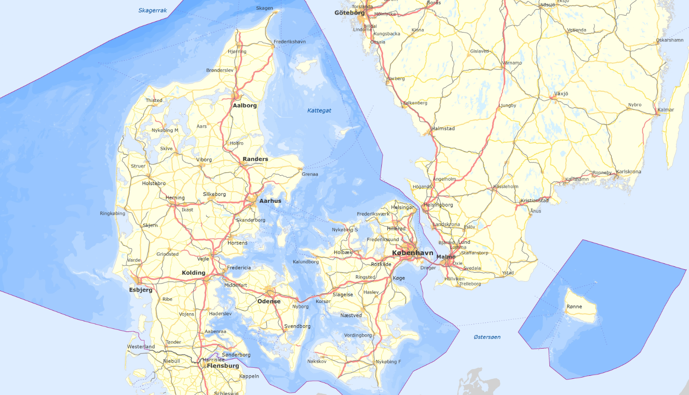

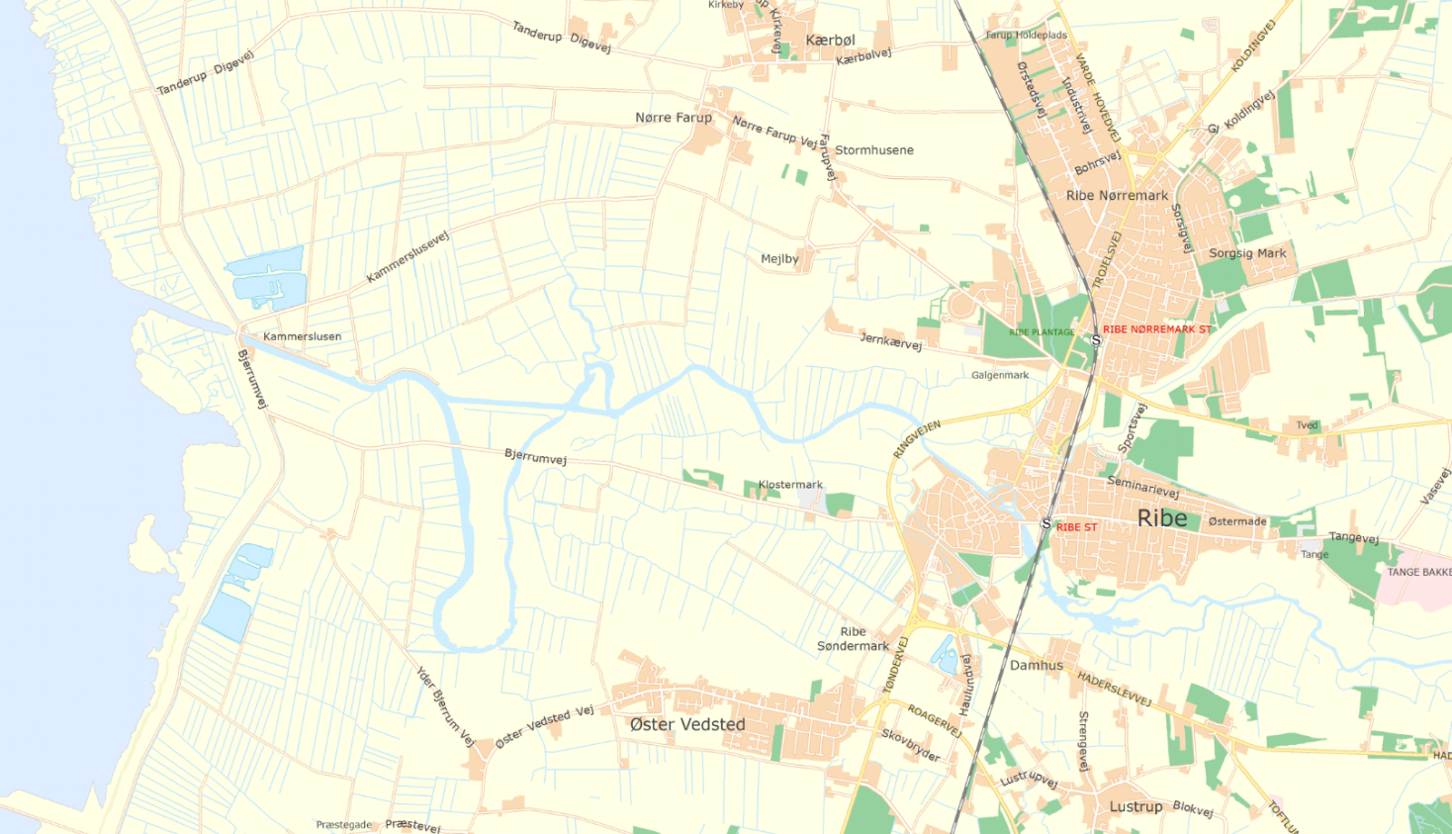
Kammerslusen
(Lock)
Dike
Dike
Ribe Å
Medieval town-centre
Ribe Å

Image source: ensure rights to use….resolution ok for pdf reporting

Focus/objective of the case

Decision focus:

Tactical – Deciding how to best protect the low lying area around Ribe

Objective:

The objective is to determine the optimal way to protect Ribe and the surrounding area from future storm surges from the sea and water rise in the local river, Ribe Å. Coupling of events.

The goal is to provide the local and regional authorities and inhabitants a recommendation for protection against future flooding that is both sufficient and cost effective.

The physical setting

Nature and topography
The area around Ribe is a large low-lying flood plain containing mostly drained farmland, mostly lying between +1,0 to +2,0 above MSL. The area is behind the frontier dikes to the Wadden Sea. The total area of the flood plain is 97km². In the bottom of the flood plain is located the medieval town of Ribe, population of around 8000 people. The old town centre is mostly elevated above +4.0 MSL, but the town has spread and also occupies residential and industrial areas located down to +2,0 MSL. See Figure 1.

Two small rivers, Ribe Å and Kongeåen, and two smaller creeks have their outlet in the Wadden Sea, and are let through the dike by either lock or sluice.

The river Ribe Å runs through the old town centre of Ribe, before running through the drained farmland and finally passes the dike protection through the lock, Kammerslusen, into the Wadden Sea.

Sources of flooding
The flood risk in the Ribe flood plain is two-fold. One risk is flooding from the sea, caused by dike breach or overtopping during storm surges. The other risk is flooding of the local rivers, like Ribe Å.

During storm surges, the water level in this part of the Wadden Sea can rise upwards of 4,92 meters above MSL (100 year return period), exceeding the terrain height of most of the Ribe flood plain. During a storm on the 3rd of December 1999, water levels were measured at Kammerslusen to 5,10 meters, before the measurement device broke. The storm surge happened to coincide with low tide, and no breach occurred of the dike. Regular difference in low and high tide water levels is around 1,0 meter in this part of the Wadden Sea. Had the peak of the surge coincided with high tide, the water level would be expected to have increased to above +6,0 meters. With a dike crest of +6,88 meters, the overtopping would be severe and would threaten to breach the dikes entirely.

The probability of flooding the rivers is greatest during storm surges. During storm surges, the lock and sluices in the dike line are closed, and water levels rise due to the discharge in the rivers. Water levels rising in Ribe Å can lead to flooding of the low lying area around the town of Ribe, as has happened on several occasions the last couple of years.

Existing flood defence infrastructure
The Ribe flood plain is protected from the Wadden Sea by a grass covered dike.

The socio-economic setting

State if rural, semi-urban, dense urban

Most of the Ribe flood plain is a rural area, except for the town of Ribe, with a population of around 8000. Other smaller villages are also located in the flood plain.

What is the nature of the communities to be protected, residential and non-residential activities, important infrastructure services (hospitals, transport hubs etc) that may be in the floodplain and how these might be impacted by a flood.

In case of a dike breach during a storm surge, large areas including parts of the historic town centre and roads to and from Ribe could be flooded, see Figure 1.

The town is both residential, and contains important historic and cultural sites, like old town houses, historic dig sites and the Ribe Cathedral. In addition, the main road (route 24) is below +3,0m MSL, and in danger of being cut off in case of major flooding.
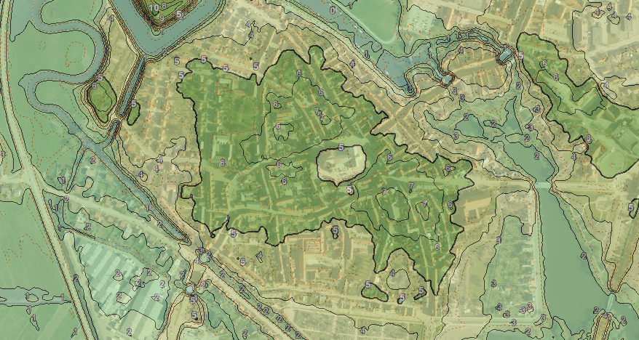
Ribe Å
Main Road
(Route 24)
Cathedral

Figure 1 Ribe medieval town centre with terrain height overlay - Dark green areas within the thicker drawn contour are more than 5 meters above MSL. Fully drawn contours and change in palette colours represent a change of +/- 1m; dashed lines represent the intermittent +/- 0,5m. The orthophotography (Niras, spring 2014) and height map overlay (DTM 2005-2007) is taken from the internal Webgis database of the Danish Coastal Authorities.

Have there been past floods in the area? If so, how was it caused and what impact did it have?
Flooding of the marsh lands from the overflow of Ribe Å is typical during winter storms, when the sluice gates are closed. However, most of the infrastructure and residential areas are usually unaffected. Since the construction of the modern dikes in the early 20th century, no breach of the dikes at Ribe and no major flooding incidents of residential areas have occurred (Gram-Jensen, 1991).

Question 3.2: Specific challenges and barriers to be overcome

3.2a What is the asset management challenge
what is the driver for the case study and what makes AM difficult:

Make thorough analyses of the future situation to raise political awareness of the problem. Furthermore suggest adaptive solutions to the problem.

Main challenge of AM is to implement large-scale solutions, as responsibility, authority and funding is not centralized, but spread out among municipalities and landowners.

3.2bUnderstanding of the current system

Physical understanding
- Vertical accuracy and source of the floodplain topography data
The vertical accuracy of the topography is: 0,05m
The horizontal resolution of the topography is: 0,15m

- What flood defence assets are important to the case study

A basic typology of the flood and coastal erosion risk management infrastructure is provided in the table below (Sayers et al, 2015). Which asset types exist in the pilot study area and what role do they play?

Asset types to be considered in the pilot (asset typology after Sayers et al, 2015)

Type of asset |  | Example activities | Considered in pilot (yes/no) | Why?
Local scale infrastructure
Private homes and businesses | Avoidance | Raising properties above flood levels (actively, floating homes, or passively, raised thresholds) or some other way to avoid flooding. | No | Historic and protected town centre
 | Resistance | The use of flood products and construction detailing to prevent water entering a property. | No | The scope of the project is to develop a plan to protect the town area and historic town centre.  Individual property protection is the responsibility of the individual property owners
 | Recovery | Use of building materials and practice that such that although flood water may enter the building no permanent damage is caused, structural integrity is maintained and drying, cleaning and minor repairs are facilitated. | No
Critical service nodes | Avoidance | Raising critical functions / building above flood levels. Deployment of property scale ‘ring dykes’. | No
 | Resistance | The use of flood products and construction detailing to prevent water entering a property. | No
 | Recovery | The use of function specific building designs and network redundancy to avoid loss of function if flooded (i.e. continued power or communication distribution). | No
System scale infrastructure
Hard path infrastructure – Planning, design and management of built infrastructure
Linear and network assets | Active | Barriers that can be deployed as temporary and demountable defences. | No
 | Passive - Above ground | Raised defences and shore parallel structures (i.e. embankments, levee or dyke, breakwaters) through to storm water storage ponds. | Yes | Seaside dikes exist but may need reinforcement or expansion due to future climate and expected water levels.  Additional inland dikes, either river side or as a secondary dike near the town could be considered, but none currently exist.
 | Passive - Below ground | Individual pipes, CSO’s and the drainage network they compose. | No
Point assets | Active | Pumps, floodgates and sluices. | Yes | Kammerslusen (Lock/Sluice) is located on the existing dike line. Three additional smaller sluices exist.  A secondary dike line would require additional sluices or flood gates.
 | Passive | Fixed trash screen, groynes as well as interface assets (that link above and below ground linear systems) such as manholes and gullies. | Not applicable
Soft path infrastructure – Utilizing natural infrastructure systems
Watercourse | Channel | The management of vegetation (e.g. weed cutting) and sediment (e.g. shoal removal and dredging). | No
 | Floodplain | The management of floodplain roughness and debris recruitment. | No
Coast | Foreshore and backshore | The management of dunes and beaches through active (e.g. recycling and profiling) and passive (e.g. sand fencing, marram grass planting) management as well as natural wetlands and soft cliffs. | No | The coast is not an erosion zone, but some sand fencing has been done in the past. In case of a dike expansion, increasing the foreshore may be beneficial to maintain a low slope of the dike.
Urban landscape | Urban land use | The engineering of urban green space, managing surface permeability (e.g. through SuDs) and debris recruitment. | No | Historic town centre with cultural heritage sites and protected medieval buildings.
Rural catchment | Rural land use | The management of rural run-off, sediment yields as and debris recruitment. | No
Note: FCERMi includes any feature that is actively managed to reduce the chance of flooding or erosion (Sayers et al., 2010). Dams and associated ancillary structures are excluded from this paper

- Accuracy and source of information on asset geometry and their performance
The top of the Ribe Dike is levelled every five years. Next planned levelling is in 2017. Accuracy is 0,02m.

Socio-economic understanding
- Accuracy and source of information on floodplain usage (receptor etc)
Specific uses of the agricultural areas are not monitored by the coastal authorities.

Locations of residential areas and sites of interest are primarily based on bi-annual ortophotography.

Hydrological connections and canals are included to the Danish Terrain Models used in modelling. Last update of hydrological connections is from 2015.

Existing plans and policies
How do existing plans and policy influence the approach to asset management in the case study site

Policy or plan | Description | Influences on asset management at case study location
European policy
Nature2000 | Bird protected area | Changing the flood plain both west and east of the town of Ribe may harm the marsh-like habitat used by native and migrating birds.
Ramsar Convention | Wetland reserve | Less influence
National policy
Nature Conservation Act | Protection of nature types, commons and marshland | Changing of mean water level in Ribe Å may have impact on nature types
Nature reserve | Wild life sanctuary | The areas along Ribe Å to the immediate South East and North West of the town centre are both wildlife sanctuaries.
Zoning and land use regulation, set back lines |  | A permit is required for building activity
Regional strategies
Local plans
Municipality plan | The overall planning, which determines the development in the municipality | Goals for wetland planning and use
Sluice practice | Managing opening and closing of the gates dependant on water levels in Ribe Å and in the sea | Important  for management of the water level in the Ribe river

3.2b Future change
We would like to understand how future change is accounted for. In particular:

In climate – repeat by the Part A questions here but answer for the specifics of the case study
National climate scenarios for Denmark are drafted by Danish Meteorological Institute. In fact it is IPPC’s climate scenarios downscaled to Danish conditions.

No guidance or regulations are provided by the national authorities on how to design flood protection with regards to climate change.

3.2b Governance and other aspects - move to be consistent with Part A

Funding
- Who pays, the asset management plan to be developed, for maintenance, capital investment and how secure is this funding stream into the future?
The expansion of the dike in 1978-1980 was funded in a 60/40 distribution of cost between state and local investment (municipality and county).

The local dike association (land and property owners) are responsible for funding maintenance of the dikes. The Danish Coastal Authority assists with a technical inspection two times every year, but otherwise does not contribute with funding.

Maintenance and operation of the sluices is directly or indirectly financed by the local municipality of Esbjerg Kommune.

- Are there other funding or payment barriers (compensation for example)
The Danish Counties were abolished in 2007, and many obligations were transferred to the local municipality. However, no agreement or precedence of dike reinforcement funding exists after 2007. In case of a required dike expansion due to climate change, it is unsure how the funding will be raised and split.

How successful is asset management – review Part A question
- Is it known whether the asset management is being delivered successfully? If so, how is it measured? (e.g. required and desired performance requirement (if present) is met?)
Asset management is not centralized. As such, detailed goals and requirements are not established, beyond the general goal of ensuring flood protection.

Question 3.3: Overview of tools and data to be used (where this is known)

3.3a Reliability

Overview
- What approaches are you planning to apply?
Deterministic and statistical methods.

- What are minimum data requirements for this approach(es)?
  - Bathymetry and topography data for the flood plains
  - Sea level data
  - Discharge data from the Ribe Å and contributing creeks
  - Geometry data of the dikes and lock gates at Kammerslusen

- Will the analysis be undertaken by a specialist engineer? If yes, is this in-house or external?
In-house – Civil engineers and geographers.

Specific challenges and gaps in understanding
What are you particularly issues are you grappling with
- Gaps in physical process knowledge:
- Gaps in analysis capability

2.3b Deterioration
Why is deterioration of assets important at the pilot? Are the deterioration rates known, if so, what is the evidence that is used? Is deterioration managed, and how is value for money of the associated expenditure evaluated?
The top of the dike is levelled every five years. DCA’s technical inspection of the dike two times a year insures that status quo is kept for the dike.

Specific challenges and gaps in understanding
What are you particularly grappling with – transitions, piping, on-demand M+E, peat, exceedance?
An economic assessment of immaterial assets, e.g. valuation of nature and recreational interests. Preserving cultural heritage.

Question 3.4: Decision process

3.4a Social justice
How are the three principles of justice considered:
- Equality
- The most vulnerable are prioritized
- Utility (best return)

Maintenance and funding of the flood protection is the responsibility of the individual land owners, united in the local dike association, and the state is not involved in any prioritising decisions.

Recommendations are predominately focused on utility.

3.4b Robustness under conditions of future change

What are the specific values of future change that have been considered in the pilot site:

- How is climate change factored in?
Changes in future sea level and changes in future intensity of precipitation will be factored into any technical recommendations from the Danish Coastal Authority.

- How is development in the floodplain factored in?
Regulations in the area prohibit change to the flood plains. However, additional dikes, flood gates or other type of flood protections will be investigated and analysed and could be required. Consideration for the protected habitats will be taken in to account as much as possible.

- How is uncertainty over future funding factored in?
Some uncertainty exists regarding funding of possible future expansions due to abolishment of the Danish Counties in 2007.

3.4c Investment planning

What funding constraints exist at the pilot site?
Not applicable.

How is long term funding secured?
Not applicable.

Is additional funding for multi-benefits being sought - if so, where from and is this likely to be successful?
Not applicable.

Question 3.5: The relationship of AM to board planning issues

Within the pilot location, do flood defence activities and funding link with broader planning policies and plans, if so how?

As a minimum consider the relationship of the flood defence approach to:

- Spatial planning
- Environmental regulation (such as the Water Framework Directive)
- Promotion of redevelopment or tourism
- Evacuation planning?

Flood defence activities are primarily based on the dike protection from the sea, and are not currently part of a broader planning.

Looking forward on estimated climate change and sea levels, a well-documented safety level against flooding from both salt water and fresh water is crucial for the use of the whole Ribe area.

ISO55000
http://www.ntnu.edu/c/document_library/get_file?uuid=ae1f2570-1191-4d7c-b4c3-9686aaeccaf8&groupId=151572
FLOODsite: The Language of Risk
http://www.ntnu.edu/c/document_library/get_file?uuid=ae1f2570-1191-4d7c-b4c3-9686aaeccaf8&groupId=151572

