|  |
| --- |
|  |
| **Task 3.1a Asset Management: Template Questionnaire** |
| **WP3 Investment Planning and Asset Management** |
|  |
| **Paul Sayers, ……all other authors….** |
| **May 2016** |

# Report information

**Interreg Programme:** Flood infrastructure Asset management & Investment in Renovation, adaptation, optimization and maintenance

**Report Title:** Task 3.1 Asset management tools and approaches within the North Sea Region

**Date:** May 2016

**Contributing science partners:** Sayers and Partners, UK,

Contributing asset owners: list….

**Document revision history:**

|  |  |  |  |
| --- | --- | --- | --- |
| Version | Date | Author(s) | Description |
| 1.0 | 23 May 2016 | Paul Sayers | Outline only for discussion to WP3 partners |
| 1.1 | 27May2016 | Paul Sayers | Based on skype call ST – 27May2015 |
| 1.2 | 11July2016 | Paul Sayers | Taking on board the discussion with Remco Schrijver, Wouter jan Klerk, Frank den Heijer and Owen Tarrant |

# Summary

FAIR (Flood infrastructure: Asset management and Investment in Resilience, adaptation and maintenance), is funded by the EU INTERREG North Sea Region (NSR) Programme and led by the Rijkswaterstaat, FAIR focuses on providing improved, more resilient, more multi-functional and adaptive approaches to providing flood infrastructure. Asset owners and academic colleagues from the Netherlands, Sweden, Germany, Belgium, UK and Denmark will be comparing approaches to asset management and investment planning to share good practice and support new developments.

This report is provided under Work Package 3 (WP3 Investment Planning and Asset Management) and sets out a questionnaire to be completed by the asset owners and science partners within the FAIR consortium. The aim of the template is to guide the Asset Owners in identifying the challenges, barriers and gaps they face in developing more adaptive Asset Management. The science team will then summarise the findings and incorporate elements in international practice and tools.

**Glossary of terms**

|  |  |
| --- | --- |
| Asset | Item, thing or entity that has potential or actual value to an *organization*[1]*.* In the context of flood management this is generally a physical asset (e.g. a gate), but it can also be the data that is used to manage the gate (i.e. if the data is gone, the performance will drop). |
| Asset function | Function related to an organizational objective that the asset fulfills, an asset can fulfill multiple functions. E.g. a sluice will contribute to shipping (a function), but also to flood risk reduction (a different function). |
| Asset management | Enables an organization to realize value from assets in the achievement of its  organizational objectives1. Asset management can be done on different levels, strategic, tactical and operational are the generally distinguished levels. An example of strategic asset management is that safety standards of flood defences are changed due to new societal developments (e.g. economic growth), an example of asset management on a tactical level is the planning of reinforcement of dikes over a longer period of time, an example of a decision on an operational level is how often a dike should be inspected in order to ensure its reliability meets the standard. |
| Asset performance | Measurable result1 Measure for the extent to which the asset performs, to be compared with the required performance. E.g. the reliability of a dike or the availability of a sluice. |
| Availability | Ability of a system to be kept in a functioning state[2]. E.g. the percentage of time that a pump is functioning. |
| Consequence | Represents an impact such as economic, social or environmental damage or improvement, and may be expressed quantitatively (e.g. monetary value), by category (e.g. High, Medium, Low) or descriptively.[3] For instance the casualties and damage in a flood. |
| Cost | **Capital**: Initial investment required to provide a significant change to the performance of an asset or provide a new asset (e.g. reinforcement costs, cost of building a sluice)  **Revenue**: On-going investment needed to maintain the performance of asset / asset system  **Operating**: costs for keeping an asset (e.g. the sluice) operational (i.e. satisfying the performance criterion). For instance, cost for energy, maintenance, painting the doors.  Whole life: see life-cycle cost |
| Life-cycle cost (LCC) | Or: Whole Life-cycle Cost or: Total Cost of Ownership (TCO). The total of all costs and revenues over the life cycle. Enables comparison of e.g. construction, maintenance and removal costs. Generally expressed as Present Value, where all future investments are expressed in current day value using discounting. |
| Probability | Measure of our strength of belief that an event will occur. 2 For more details on different interpretations and views on the concept of probability see2. |
| Reliability | Ability to perform a certain defined task, often expressed as probability of failure. E.g. the reliability of a flood defence is its ability to prevent a flood. Generally expressed in terms of probability |
| Resilience | Ability of a system to react and recover from a damaging hazard2 |
| Risk | Function of hazard, exposure and vulnerability2  For a flood that would be:  Hazard: the probability that a flood occurs (to given depth, velocity, duration) at a given location.  Exposure: the people, businesses, infrastructure, habitats etc that may experience harm if a given flood occurs.  Vulnerability: the degree of harm (loss of well-being) suffered by those exposed to a given flood.  Please note: This definition supports the more general definition of risk as a function of probability and consequences; where consequences are described by exposure and vulnerability. |
| Risk attribution | Decomposition of risk to individual assets/objects |
| Safety | The requirement not to harm people, the environment, or any other assets during a system's life cycle[4] |
| Scenario | A plausible description of a situation, based on a coherent and internally consistent set of  assumptions.2 For instance a description of the development of climate or economic growth in the next decades. |
| Standard | Of protection:  Performance    Safety  Ultimate limit state  Serviceability limit state |
| (Investment) strategy | A strategy is a combination of long-term goals, aims, specific targets, technical measures, policy instruments, and process which are continuously aligned with the societal context. 2 |
| Performance criteria | Required: Levels that performance indicators need to meet. E.g. safety standards defined by law.  Desired: Levels of performance indicators that might be met, if benefits for organizational objectives (broadly) outweigh costs. E.g. if an organization has as objective to generate more economic activity on and around a dike, they can make it multifunctional, if it is not too expensive. |

# Contents

Report information 1

Summary 2

Contents 7

1 Introduction 9

2. Part A National context - Netherlands 10

Question 2.1: Context within which asset management takes place 10

2.1a – Roles and responsibilities 10

2.1b - Relevant policy, plans and codes 11

2.1c Planning timescales of interest 12

2.1e Governance and other aspects 13

Question 2.2: Challenges and barriers to be overcome 14

2.2a Barriers in the understanding of the current system 14

2.2b Future change 14

2.2c Funding barriers 15

2.2d How successful is asset management 16

Question 2.3: Overview of tools and data used (where this is known) 16

2.3a Reliability 16

2.3b Deterioration 17

Question 2.4: Decision process 17

2.4a Investment planning and prioritisation 17

2.4b Social justice 17

2.4c Robustness under conditions of future change 18

3. Part B Case study – Dike reinforcement Marken 19

Question 3.1: Setting the scene of the case study 19

Question 3.2: Specific challenges and barriers to be overcome 21

3.2a What is the asset management challenge 21

3.2bUnderstanding of the current system 21

*Socio-economic understanding* 23

3.2b Future change 24

3.2b Governance and other aspects - move to be consistent with Part A 25

Question 3.3: Overview of tools and data to be used (where this is known) 25

3.3a Reliability 25

2.3b Deterioration 26

For Marken the specifis challenges are peat (settlement), stability, height and maximum acceptable overtopping volume, LCC and communication with stakeholders. 26

Question 3.4: Decision process 26

3.4a Social justice 26

3.4c Investment planning 26

Question 3.5: The relationship of AM to board planning issues 27

# 1 Introduction

This template sets outs the questions to be reviewed and completed by the Asset Owners. The responses will then form the basis of a comparison of methods across the North Sea Region and, importantly, common challenges identified and best practice shared. The results from the questionnaire will be taken forward in WP3 and WP5.

The questionnaire is structured in two main parts. This first part of the questionnaire explores the context within which asset management policy is made, strategies development and plans delivered. The aim is to provide a rich understanding of the approaches in each partner country that forms the background to the case studies. The second part of the questionnaire focuses on the specific challenges and approaches at the case study site. By including these two strands an in-depth understanding of the reasons why different approaches are used will be developed and, in doing so, enable best practice to be shared in the most meaningful way.

**Note:** The responses to the questionnaire should be provided as a standalone report and set out using the question headings given here.

# 2. Part A National context - Netherlands

## Question 2.1: Context within which asset management takes place

### 2.1a – Roles and responsibilities

We would like to understand the organizations with an interest in AM, their role and responsibilities for delivering AM (funding, programming and permitting etc). This includes both private and public sector organizations, as well as the role of communities and NGOs. We would also like to explore how third party assets treated/managed.

|  |  |  |  |
| --- | --- | --- | --- |
| **Organization** | **Interest** | **Role** | **Responsibility** |
| **National government** |  |  |  |
| Ministry of Infrastructure and Environment | Maintain an appropriate level of national safety against flooding. | *Setting the standard*  Set what is considered an appropriate standard (statutory safety level, laid down in legislation)  Set regulatory framework (i.e. 12 year review) and provide associated ‘how to do’ guidelines – to be undertaken by others.  *Operational flood management by National Water authority Rijkswaterstaat (public works department of Ministry):*  accomplishing the prescribed safety by constructing and managing flood protection structures of national importance.  *National inspectorate*  Control of the regional authorities (waterboards) and Rijkswaterstaat in the field of the performance on flood risk management. | *Funding:* To provide 50% of the funding requirement for Waterboard owned primary flood defences and 100% funding for Rijkswaterstaat owned primary flood defences.  *Note:* assetmanagement costs for regional flood defences are fully covered by asset owner (waterboard or Rijkswaterstaat).  *Programme prioritization:* To work with the 23 Water Boards to agree a programme of prioritised major reinforcements (capital programme) asset management activities. |
| Staatsbosbeheer (state forestry department) | *nature conservation* | *nature conservation* | *nature conservation* |
| **Reginal government** |  |  |  |
| Regional water authorities (water boards) | Protection of residents towards flooding according to set safety levels | *Operational flood management:* accomplishing the prescribed safety by constructing and managing flood protection structures. | *Funding:* To contribute to the ‘dike fund’ and finance 10% of the reinforcement of primary flood defences.  Maintain flood defences to the statutory safety level (laid down in legislation) |
| Provinces | Regional integrated development | Permitting | Responsible for spatial planning on regional scale |
| **Local government** |  |  |  |
| Municipalities | Local integrated development | Permitting | Responsible for spatial planning on local scale |
| **Operating authorities** |  |  |  |
| Regional water authorities (water boards) | See above | See above | See above |
| National Water Authority (public works department), Rijkswaterstaat | See above | See above | See above |
| **Private owners** |  |  |  |
| Several (like farmers) |  | Maintenance of some of the regional/secondary flood defences and waterways |  |
| **NGOs** |  |  |  |
| Nature conservation organizations:  Natuurmonumenten  Provincial organisations (provinciale landschappen)  WWF  etc |  | maintenance of the dunes and flood plains |  |

*Please feel free to expand below….*

### 2.1b - Relevant policy, plans and codes

Discuss the policies, plans and codes that specifically influence the delivery of asset management. These should include both flood related and non-flood related (for example, broader development plans). This should be provided as a table as below with supporting text below.

|  |  |  |  |
| --- | --- | --- | --- |
| **Policy or plan** | **Level (international;/European/National)** | **Description** | **Influence on asset management** |
| **Policies** |  |  |  |
| Floods Directive | European |  | The requirement for a national understanding of areas at significant risk and develop Flood Risk Management Plans for those areas |
| National Waterplan  (frequency : every 6 yr’s) | National | The National Water Plan describes the measures that must be taken to keep the Netherlands safe and habitable for current and future generations and to make the most of the opportunities that water has to offer. | It is the framework for flood protection issues, like the new safety standard. |
| **Plans** |  |  |  |
| Management plans |  | Description  of all asset management activities on water management. | Rijkswaterstaat and waterboards |
|  |  |  |  |
| **Codes** |  |  |  |
| Eurocodes | European | Technical annexes: e.g. geotechnical codes, reliability analysis | Some of the technical eurocodes are incorporated in Dutch codes. |
|  |  |  |  |
| **Guides** |  |  |  |
| Hydraulic boundary conditions | National | Hydraulic loads used for the safety assessment and design of flood protection infratrstructure | The results of the safety assessment determine the influx for Dutch Flood Protection Programme |
| Assessment method and rules | National | Description of the assessment procedures and assessment rules for each asset type and failure mechanism | The results of the safety assessment determine the influx for Dutch Flood Protection Programme |
| Design guide | National | Description of design procedures and rules for each asset type and failure mechanism |  |

*Please feel free to expand below….*

### 2.1c Planning timescales of interest

Discuss the timescale over which asset management activities are assessed and planned and how each influences AM decisions. Consider the multiple timescales within which assessments takes place (national policy cycles, regional planning cycles, maintenance cycles, others).

|  |  |  |  |
| --- | --- | --- | --- |
| **Time scale** | **Associated time horizon (in years)** | **What AM decisions take place over this timescale?** | **Who leads these decisions?** |
| **Long term planning** |  |  |  |
| Delta programme | 2100 | Is there is a need to revisit the national approach towards water management | Delta Commissioner (as advisor of Ministry) |
| **Medium term planning** |  |  |  |
| National safety standards | Considers the situation in 2050 (taking account of socio-economic and climate change). This is repeated about every 50 years. | Sets the safety standards to be provided | Min. of Infra and Environment |
| **Short term plans** |  |  |  |
| Evaluation of safety | A nowcast assessment that is repeated in a 12 yearly re-evaluation cycle. | Sets the influx for the Dutch Flood Protection Program | Min. of Infra and Environment and regional water authorities |

*Please feel free to expand below….*

**2.1d - Requirements of performance**

Discuss what kind of performance requirements have to be met, who defines these and how these are determined.

* **Required criteria (i.e.** What criteria must be met regardless of cost)

The legal safety standard must be met. According the new approach (implemented 1-1-2017) the safety standard is a maximum allowable probability of flooding, i.e. annual chance of a breach (ultimate limit state).

These new standards were set using a risk-based approach. The first step in deriving the new standards is the introduction of a basic safety level of 10-5 per year for the acceptable probability (per year, on a specific place) of a fatality due to flooding. This is the so-called local individual risk. The second step is to check whether a higher level of protection may apply for areas in which flooding could lead to large groups of casualties or significant economic losses. A higher protection level may also apply if vital functions are present, such as a nuclear power plant.

These analyses result in economically efficient flood protection standards for different parts of the Netherlands that significantly differ from the present standards. Especially in the river area the new standards are stricter than the present standards. The optimization may also lead to different standards for flood protection structures surrounding the same dike ring area (if the consequences of flooding are different). The concept of multi-layered protection has been applied in deriving the safety standard:

* Layer 1: measures to prevent flooding (like dikes, dams and dunes, but also creating more room for the rivers);
* Layer 2: counteracting the consequences of flooding through spatial planning;
* Layer 3: counteracting the consequences of flooding through emergency management.

Layer 3 has been taken into account using an evacuation rate depending on the type of flooding and

dike ring area. Level 2 has been taken into account by anticipating on the spatial planning situation of 2050. The final result is the flood protection standard is expressed as the acceptable yearly probability of flooding due to a failed flood protection section (see figure below).

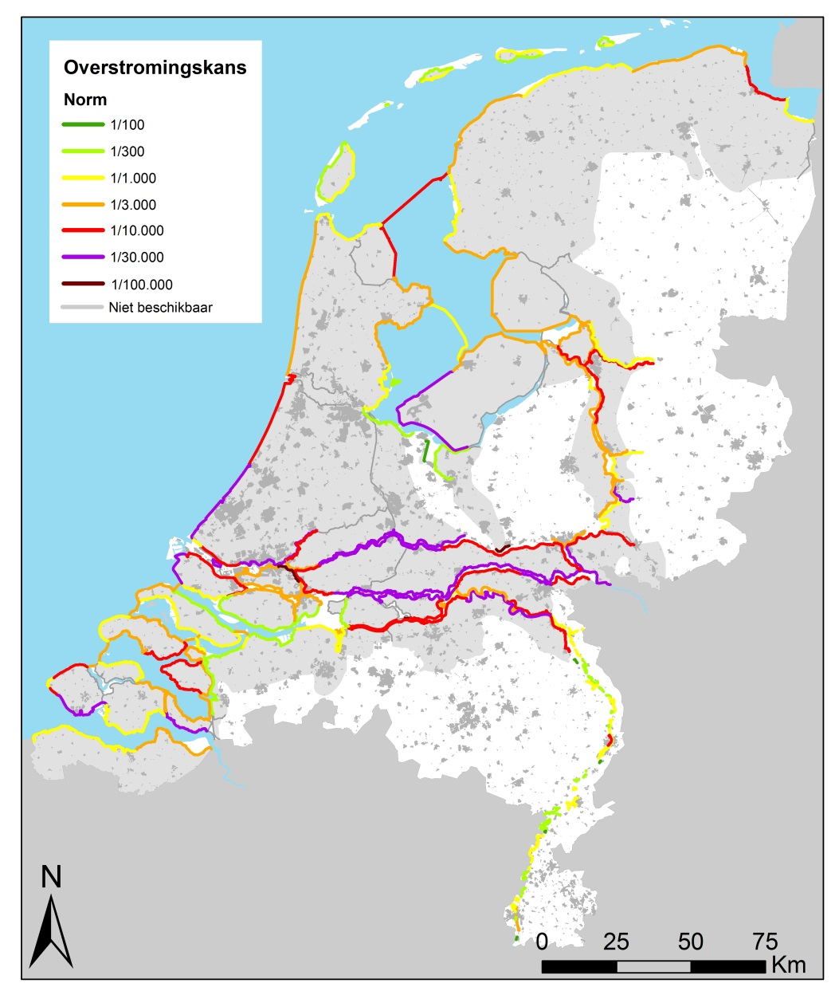

*Overstromingskans norm = maximal allowable probability of flooding*

* **Desired criteria?** What criteria might be met? If (broad) benefits outweigh (broad) costs

A national cost benefit study was carried out to set the national standards. So per project no desired criteria (BCR based) are set. This is to reduce the implementation time per project, now often at 5 to 15 years. Very large projects > 100 million euros often have to carry out additional cost benefit studies. Cost for issues not related to flood defence have to be covered by local participants (provinces and /or municipalities). Multi-objectives are promoted whereby third parties are responsible for the additional budget. For example (i) Parking garage in a dune (Katwijk) and (ii) a Boulevard along a river dike

### 2.1e Governance and other aspects

#### Funding

* Who pays, the asset management plan to be developed, for maintenance, capital investment and how secure is this funding stream into the future?

The regional water authorities and Rijkswaterstaat need to assess their flood protection assets every 12 years. Failure means reinforcement. If an asset fails the test (because of new standards, new hydraulic boundary conditions and/or new assessment rules), the asset is upgraded in the Dutch Flood Protection Programme.

The upgrade of the primary flood defences owned by the regional water authorities, is financed out of the dike account. This is financed by the national government (50% Ministry of infrastructure and the Environment) and 50 % by all the regional water authorities, even those without flood defences).

The projects costs are covered for 90 % out of the dike account and 10% of the costs are covered by the benefitting regional water authority.

The national assets owned by Rijkswaterstaat are paid by the national government (Delta fund).

Maintenance costs of the primary flood defences are always covered by the regional water authority at 100% (regional taxes).

See diagram below, regarding the financial structure for the reinforcement of primary flood defences in the National flood protection program.

## 

## 

There is also a network of regional flood defences. The assetmanagement costs (maintenance and reinforcement) is covered by the asset owner (no funding agreements like the dike account for primary flood defences).

## Question 2.2: Challenges and barriers to be overcome

Questions 2.2a to 2.2d seek to tease out the issues in our understanding of asset performance over time and the availability of supporting data.

### 2.2a Barriers in the understanding of the current system

#### Physical understanding

*Sources*

* Extreme storms and river discharges (what are of return period storms do you consider, how do you include joint probability issues)

The Ministry of Infrastucture and the Environment has set the new risk base standards for flood defences. Returnperiods for rivers, lakes and coastal regions vary. The lowest return period is 100 years. The highest return period is 100 000 years.

For the assessment of flood defences computer models are part of the formal tools. These models cover the issue of joint probabilies, e.g. high water levels and wave action, estuaries, storm surges, high river discharges and wave action

*Pathways*

* Accuracy of the floodplain topography data (what level of accuracy is typical and is this good enough?)

A digital elevation map is available with the elevation level with a resolution of 16 points per square meter, with an accuracy of 0,05 m.

* Accuracy of information on asset location, geometry and construction (what is known and where are the key gaps in knowledge)

By national law (Water act) the primary flood defences are defined (3600 km). The regional flood defences have been defined by provincial governments (15000 km).

The regional water authorities and Rijkswaterstaat (the national water authority) have the data on exact asset location (coordinates in the national datum), geometry and construction type. information/Data on old hydraulic structures is an issue to tackle.

Key knowledge gaps have been assessed

* how to determine the hydraulic boundary conditions for extreme events (1/100 000 year events)
* ultimate limit state, determining the exact moment a flood defence fails, determining residual strength

Socio-economic understanding

*Receptors*

* Accuracy of information on floodplain usage (residential properties, people, businesses etc)

All information on landuse is available from the central bureau of statistics both for the protected flood plain and for the non-protected flood plain. For the protected flood plain land use is incorporated in the legal risk based safety standar for flood defences: (1) individual risk, (2) group risk and (3) economical risk.

### 2.2b Future change

We would like to understand how future change is accounted for. In particular:

#### In climate

What guidance is provided on climate change, including: (change to a table)

* Sea level rise allowances – what estimates of SLR are used for 2025,2050,2080

This process took a lot of time. We currently follow the IPCC scenario’s from 2006.

Historical overview:

Storm surge barriers along the sea take observed sea level rise into account (Eastern Scheldt 1985 and Maesland 1997). Since 2000 the ledgers for permitting around flood defences took 200 years of sea level rise into account along the coast and 100 years along river estuaries.

Since room for the river 2002 changes in discharge (due climate change) and predicted sea level rise had to taken into account in design of projects to enlarge the river or realigned dikes.

Since 2009 predicted sea level rise has to be taken into account in the design of all flood defences.

With 1985 as a reference the estimated SLR at 2050 is +0,35 m and +0,85 cm at 2100 (0,01 m/yr for 2040-2100).This corresponds with the scenario KNMI06W+ (see appendix for more information: brochure on climate scenario’s).

* River flows – what estimate of change in peak flows are assumed for 2025,2050 and 2080 – if not peak flows how is climate change accounted?

We follow IPCC scenario’s for 2006 for changes in precipitation. River discharges for the Rhine will change from 16000 m3/s to around 18 000 m3/s and the Meuse from 3800 m3/s to around 5000 m3/s in 2100. Note these figures also take flooding in Germany into account

In the study GRADE (Generator of Rainfall And Discharge Extremes) a more precise method has been used. Rainfall is an input parameter for GRADE that is used for the determination of the hydraulic boundary conditions. GRADE is used to derive the discharges and associated flood hydrographs for the rivers Rhine and Meuse. Stochastic simulation of the weather and hydrological hydrodynamic modeling are the key elements of this method. The new instrument, called GRADE, is meant to provide an alternative, more physically based method for the estimation of the design discharge.

* Rainfall – what change in the estimate of rainfall (30 and 100 year return period hourly, daily, monthly) are assumed for 2025, 2050, 2080s? – if not quantified how is rainfall change accounted for?

See the added Appendix to this questionnaire: brochure of Dutch weather agency

Is any consideration given to the influence of the following climate change related issues on asset management decisions:

* Temperature – Yes/no – if yes how? No, not directly
* Storm sequencing – Yes/no – if yes how? Full probabilistic approach (see article)
* Spatial coherence – Yes/no – if yes how? Yes, incorporated in legal safety standard (Flooding probability).

#### In socio-economics

* Population growth – Yes/no – If yes, what assumptions are made about population growth (% increase, by 2025, 2050, 2080)

Yes, incorporated in legal safety standard (Flooding probability). Assumptions have been made for 2050 (see appendix for more information: scientific article).

* Economic development – Yes/no – If yes, what assumptions are made about growth (% increase, in GDP by 2025, 2050, 2080)

Yes, incorporated in legal safety standard (Flooding probability). Assumptions have been made for 2050 (see appendix for more information: scientific article).

*In land levels*

Localised settlement of the levees – If yes, what assumptions are made

Settlement is monitored nationally and locally. Trends are calculated and used locally. This can be meters per century for some spots.

Regional soil subsidence (i.e groundwater management related consolidation) – If yes, what assumptions are made

Settlement is monitored nationally. Trends are calculated and used locally.

Isostatic rebound – If yes, what assumptions are made

Isostatic rebound is monitored nationally. Trends are calculated and used locally. The west of the Netherlands is rising and the east of the Netherlands is subsiding.

### 2.2c Funding barriers

Everyone has a finite pot of money – but is the structure of funding or payment a barrier to optimal / best asset management (compensation for example).

In the Dutch system there is differencee between maintenance and reinforcement, when it comes to financing:

* Maintenance is paid by the waterboards and budgets are gained by local taxation per region. There is a regional solidarity for maintenance. There are 22 regional water authorities in 2016 instead of 2500 water boards in 1953.
* Maintenance of RWS assets is payed by the National government (i.e. storm surge barriers, large dams)
* Reinforcements are financed form the national ‘dike account’. Only the planning cost are paid directly by the regional water authority. This can be a negative incentive for optimal asset management.

### 2.2d How successful is asset management

Is it known whether the asset management is being delivered successfully?

Consider issues of delivering:

* The required process – assets been managed through the process set out
* The performance criteria (see Question 2.1d) – have required and desired performance been met.
* The efficiency of achieving these – minimizing whole life costs for the outcomes achieved

If so, how is it measured? (e.g. required and desired performance requirement (if present) is met?

Normal maintenance is carried out on vregular bases. Large assets are maintained and visually inspected daily.

In Netherlands the 12 y assessment of all flood defences is the keystone for managing the assets. The required criteria are set in the Water act and with the assessment the flooding probability of the asset is compared with the required flooding probability.

## Question 2.3: Overview of tools and data used (where this is known)

### 2.3a Reliability

#### Overview

* What approaches do you typically use to support policy analysis and design?

In policy analyses a full probabilistic analyses is carried out for a relatively small number of failure modes. For design both a semi-probabilistic and probabilistic approach is used. The probabilistic approach is used to reduce design costs, this has been carried out for all storm surge barriers and many expensive dike projects.

* Do you have data to support these methods? If so, who collects it, who collates it and can access it and is it t openly available, if so where? Is uncertainty in the data considered?

Policy tools and data are freely available, some however are only in Dutch. Design tools are freely available. Data on design is less freely available. Data on design costs have been assembled and are available in a tool

Data from the Flood Safety in the 21st Century study (WV21) and the Deltaprogram is available. This project analysed changes in flood risk due to climate change, economic development and the effects of reinforcement of flood defences for 2015, 2050 and 2100.

(between 2010 and 2015 a number of large reinforcement projects has been finished)

Data produced in the project Flood Risk in the Netherlands (VNK2) is openly available. This project has analysed current flood risk in the Netherlands (in the year 2010). Using an

innovative method, flood probability is being linked to the consequences of flooding expressed in terms of economic damage and potential casualties. The insights produced by the project will help authorities take more targeted, cost-effective measures to protect the Netherlands from flooding. The project was an initiative of the Ministry of Infrastructure and the Environment, the Association of Regional Water Authorities and the Association of Provincial Authorities.

#### Specific challenges and gaps in understanding

What are you particularly grappling with

The main challenge in The Netherlands is implementing the new risk based safety standards (based on the probability of flooding and impact). The challenge is to meet the new standards in 2050. Relating issues are ultimate limit state for the failure modes: piping, slope stability, the residual strength of peat soils, erosion of revetments.

### 2.3b Deterioration

With and without management….

All assets are managed. There are regional differences between managers of flood defences in policy. This is very visible for asphalt revetments. For well managed asphalt revetments we have graphs to show how the deteriorate over time. Every asset has at least one visual inspection every year “dike schouw”.

## Question 2.4: Decision process

The following question explore the aspects that shape the choices made.

### 2.4a Investment planning and prioritisation

*Expenditure type*

* Total expenditure (whole life cycle costs) – or just capital or revenue?

There is a set budget of about 400 million euros a year. It is prioritized based on the 12 yearly nation assessment of flood defences. Each project has to meet the national standards. No new cost benefit analysis is done, except for onerous projects. For each individual project life cycle costing is done to determine which measure will be chosen. This is to optimize between design live, maintenance and construction costs. In general flood defences were built for a 50 years design life (dikes) or 100 years hydraulic structures. Design life can freely be chosen with this new approach.

*Prioritisations*

* First in the queue – early bird gets the worm – constraints on permitting for example
* Given the nature of expenditure, do you seek to identify least cost or max BCR, or other
* Individual asset versus asset portfolio planning: How is investment optimised across the portfolio of assets that exist?

The influx for the Dutch Flood Protection programme is determined by the regular safety assessments. Regional water authorities and Rijkswaterstaat assess the actual safety of the embankments against the legal standards using up-to-date information and tools (hydraulic loads and technical criteria). According to the present safety standards each cross-section of the flood protection structures is tested for about 25 failure modes. All proposed reinforcement projects are ranked based on the actual risk due to flooding. The ranking for these projects is calculated by the distance between the actual probability of flooding and the new safety standard (based on economical damage and loss of lifes).

*Opportunities for enhancing the return on investment*

* Payment for non-FM benefits/functions? i.e broader benefits – is this possible and do they change the investment ranking?
* Private contributions – does this change the ranking?
* Opportunities of material reuse and other infrastructure investment synergies – i.e tunneling programme has generated potential source of materials?

Payment for non-FM benefits have to be covered locally often by the provincial government, the municipality or a sometimes private party when a building is on a flood defense.

The distance between the actual risk due to flooding and the legal safety standard is the standard used for programming. Opportunities for enhancing the return of investment are project driven (not on national scale).

Private contributions for secondary non flood management benefits from provinces and municipalities can speed up the process. Often this the result of a political deal.

Most flood defences are made of clay, sand, stone revetments. These materials are often reused. Asphalt revetments are not reused.

### 2.4b Social justice

How are the three principles of justice considered:

* Equality – Are all citizens treated equally in the FRM process? If no, why not? If so, how is this ensured? Yes, by introducing the same individual risk at 10-5 (incorporated in the legal safety standard) a minimum safety level is guaranteed for all Dutch citizens.
* Are the most vulnerable members of society prioritized? If no, why not? If so, how is this ensured? No, the distance between the actual risk due to flooding and the legal safety standard is the standard used for prioritization (in the DFPP). We are discussing this for reaction plans in case of a flood event.
* Utility – Is it a required to ensure the best return for each euro spent? If no, why not? If so, how is this ensured? Yes, this is the starting point (LCC). Also with the introduction of the risk based safety level , the level of safety will increase a factor 10 to each euro spent.

# 3. Part B Case study – Dike reinforcement Marken

The following questions focus on the specific approaches taken at the case study sites. The responses here follow on from those in Part A and will help provide an understanding of how the approaches nationally influence and are taken up locally.

## Question 3.1: Setting the scene of the case study

Please describe (in no more the two pages including figures) the context of your case study. This should include:

#### Name of the case study and a map

Dike reinforcement Marken

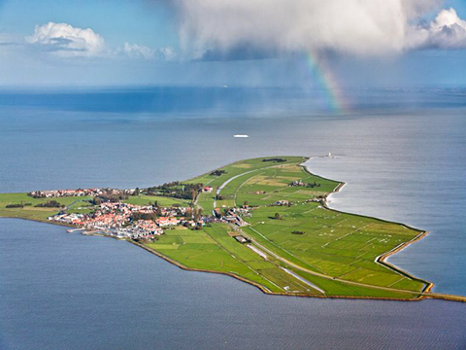

Image source: ensure rights to use….resolution ok for pdf reporting <Will be given for final report>

The island of Marken, The dikes reduce wave action and flooding due to wave overtopping[5].

#### Add map

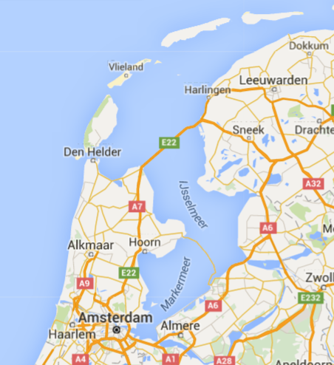

Houtrib ijk

Afsluitdijk

Marken is about 20 km north east of Amsterdam

Image source: ensure rights to use….resolution ok for pdf reporting <Will be given for final reportn>

#### Focus/objective of the case

*Decision focus:* Tactical – deciding how best to deliver set goals.

*Objective:* The goal of the dike reinforcement Marken is to meet the new safety standards in the most efficient way with acceptance of local and regional authorities and inhabitants. By using LCC (life cycle costing) the most efficient way is determined.

The project is carried out in three phases (after the necessary preparation steps such as a safety assessment):

1. The first step is the **exploration** step in which a wide range of alternative solutions is investigated after which a so called preferencial alternative is selected.
2. This alternative is further investigated and designed during the **planning** step.
3. The results of this step are laid down in spatial planning and contracting documents. The final step is the **construction** step.

The project Dike reinforcement Marken has nearly finished the exploration step.

#### The physical setting

*Nature and topography*

Marken is a peninsula in the lake Marker, close to Amsterdam. The average ground level of the inland is 0,7 below mean sea level (average).

*Sources of flooding*

The sources of flooding is lake water overtopping

*Existing flood defence infrastructure*

The existing flood defense infrastructure is a 8 km ring dike with a grass cover and stone revetments, with some special issues (a small harbor, houses of historic interest and some hydraulic structures. Because of the subsoil (peat), settlement during the construction phase and the maintenance after is one of the biggest challenges.

#### The socio-economic setting

State if rural, semi-urban, dense urban

What is the nature of the communities to be protected, residential and non-residential activities, important infrastructure services (hospitals, transport hubs etc) that may be in the floodplain and how these might be impacted by a flood.

Marken is a small islands with about 1800 residents. The islands is a popular place to be visited by tourists (mainly one-day visits). Since the islands do not have important infrastructure services, the low amount of residents and the low flood risk, the new safety standard is low (1/100 flooding probability).

#### Have there been past floods in the area? If so, how was it caused and what impact did it have?

The last flood was in 1916, with 16 human casualties on Marken. This flood was the reason for building a closure dam (the Afsluitdijk, see map in section B-3.1).

## Question 3.2: Specific challenges and barriers to be overcome

### 3.2a What is the asset management challenge

what is the driver for the case study and what makes AM difficult:

Subsidence?

Flood plain development?

Funding/political momentum/support?

Are there any constraints on the solutions? {environmental, technical feasibility}

Subsidence because of peat layer in the subsoil. The main question is the most optimal solution in terms of LCC. And the inhabitants have special wishes (no high dikes) and have a different view on the actual flood risk.

### 3.2bUnderstanding of the current system

#### Physical understanding

* **Vertical accuracy and source of the floodplain topography data**

The vertical accuracy of the topography is: +/- 0.05 m

The horizontal resolution of the topography is: 0,5 m

* **What flood defence assets are important to the case study**

A basic typology of the flood and coastal erosion risk management infrastructure is provided in the table below (Sayers et al, 2015). Which asset types exist in the pilot study area and what role do they play?

*Asset types to be considered in the pilot (asset typology after Sayers et al, 2015)*

|  |  |  |  |  |
| --- | --- | --- | --- | --- |
| **Type of asset** | | **Example activities** | **Considered in pilot (yes/no)** | **Why?** |
| **Local scale infrastructure** | | |  |  |
| **Private homes and businesses** | Avoidance | Raising properties above flood levels (actively, floating homes, or passively, raised thresholds) or some other way to avoid flooding. | No | Many traditional houses already have been raised, this is the local style. The island flooded more the once over the last centuries. |
| Resistance | The use of flood products and construction detailing to prevent water entering a property. | Yes | Some local scale infrastructure will be better protected towards flooding |
| Recovery | Use of building materials and practice that such that although flood water may enter the building no permanent damage is caused, structural integrity is maintained and drying, cleaning and minor repairs are facilitated. | No |  |
| **Critical service nodes** | Avoidance | Raising critical functions / building above flood levels. Deployment of property scale ‘ring dykes’. | No | property scale ring dikes were been forbidden since 1200 in the area. |
| Resistance | The use of flood products and construction detailing to prevent water entering a property. | No | No floods have hit the island since 1916. |
| Recovery | The use of function specific building designs and network redundancy to avoid loss of function if flooded (i.e. continued power or communication distribution). | No |  |
| **System scale infrastructure** | | |  |  |
| ***Hard path infrastructure – Planning, design and management of built infrastructure*** | | |  |  |
| **Linear and network assets** | Active | Barriers that can be deployed as temporary and demountable defences. | No | The storm can develop within a number of hours. |
| Passive - Above ground | Raised defences and shore parallel structures (i.e. embankments, levee or dyke, breakwaters) through to storm water storage ponds. | Yes | dikes |
| Passive - Below ground | Individual pipes, CSO’s and the drainage network they compose. | Yes | Depends on accepted overtopping volumes |
| **Point assets** | Active | Pumps, floodgates and sluices. | Yes |  |
| Passive | Fixed trash screen, groynes as well as interface assets (that link above and below ground linear systems) such as manholes and gullies. | No |  |
| ***Soft path infrastructure – Utilizing natural infrastructure systems*** | | |  |  |
| **Watercourse** | Channel | The management of vegetation (e.g. weed cutting) and sediment (e.g. shoal removal and dredging). | No | This is not a river. Note: Removing sediment /dredging will increase wave height and overtopping.  Roughness and vegetation will reduce wave height. |
| Floodplain | The management of floodplain roughness and debris recruitment. | No |  |
| **Coast** | Foreshore and backshore | The management of dunes and beaches through active (e.g. recycling and profiling) and passive (e.g. sand fencing, marram grass planting) management as well as natural wetlands and soft cliffs. | No | This is a lake. There are no dunes or natural beaches. |
| **Urban landscape** | Urban land use | The engineering of urban green space, managing surface permeability (e.g. through SuDs) and debris recruitment. | No |  |
| **Rural catchment** | Rural land use | The management of rural run-off, sediment yields as and debris recruitment. | No |  |

*Note: FCERMi includes any feature that is actively managed to reduce the chance of flooding or erosion (Sayers et al., 2010). Dams and associated ancillary structures are excluded from this paper*

* **Accuracy and source of information on asset geometry and their performance**

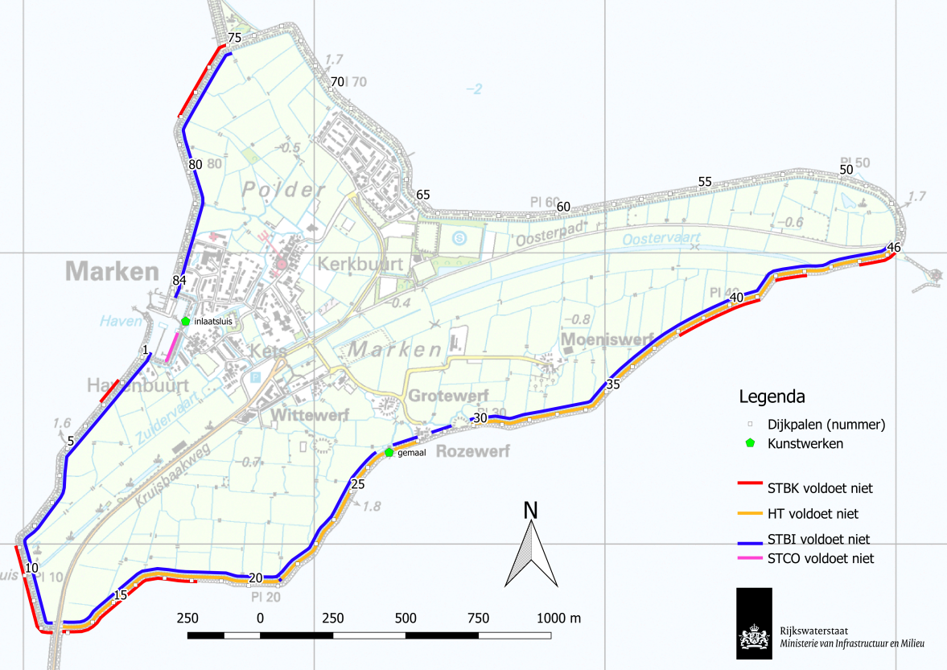

Dike trajects to be reinforced (STBK = steenbekleding --> REVETMENT, HT = hoogte --> HEIGHT, STBI = stabiliteit binnenwaarts --> STABILITY, STCO= waterkerende constructie onderdelen --> CONSTUCTIVE ELEMENTS)

### Socio-economic understanding

* Accuracy and source of information on floodplain usage (receptor etc)

Is incorporated in the legal safety standard. For the determination of the safety standard national datasets are used.

#### Existing plans and policies

How do existing plans and policy influence the approach to asset management in the case study site

|  |  |  |
| --- | --- | --- |
| **Policy or plan** | **Description** | **Influences on asset management at case study location**  **<Impact?>** |
| **European policy** |  |  |
| **Natura 2000** | Sets the requirements regarding nature conservation | A permit is required for building activities |
| **Eurocode** | Some of the eurocode are incorporated in national code | no influence for dikes, some influence for material choice of structures |
| **National policy** |  |  |
| Deltaprogramme – National level | Sets the requiremensts on the longer term on national scale | Less influence |
| Bird habitat directive | Sets the requirements regarding nature conservation | A permit is required for building activities |
| national directives | sets rules for building in the lake | 1 to 2 % of the lake surface area is allowed to be used for constructing made made islands for housing |
| **Regional strategies** |  |  |
| Deltaprogramme – Lake IJssel region | Sets the regional ambitions on the longer term | Less influence |
|  |  |  |
| Zoning and land-use regulations / area development | Sets the requirements regarding regional spatial planning | Upgrading methods for flood defense must meet regional regulations |
| **Local plans** |  |  |
| Zoning and land-use regulations / area development | Sets the requirements regarding local spatial planning | Upgrading methods for flood defense must meet national regulations |

### 3.2b Future change

We would like to understand how future change is accounted for. In particular:

#### In climate – repeat by the Part A questions here but answer for the specifics of the case study

Climate scenarios are incorporated in hydraulic boundary conditions which are drafted by order of the Ministry of Infrastructure and Environment. These boundaries are used to determine the design boundaries.

What guidance is provided on climate change, including:

* Sea level rise allowances
* River flows
* Temperature?
* Storm sequencing?
* Spatial coherence?

See 2.2b for the general answer.

Specific for Marken the influence of climate change on the design is limited since The Lake Marken is a regulated water system with sluice gate to evacuate water to the Ijssel lake. Sea level rise however will influence the lake levels. Large pumping stations added to the sluice gates to regulate the lake levels.

#### In socio-economics

Socio-economic aspects (population growth and development) are incorporated in the legal safety standard.

Note: Housing on the island cannot expanded due to its historic setting.

### 3.2b Governance and other aspects - move to be consistent with Part A

#### Funding

* Who pays, the asset management plan to be developed, for maintenance, capital investment and how secure is this funding stream into the future?

Since the asset owner is Rijkswaterstaat the dike reinforcement is financed by the national government (Delta fund).

At this moment the capacity is a bigger problem than the funding stream in the future, we do not have enough staff.

* Are there other funding or payment barriers (compensation for example)

The way of funding can result in less effective measures: reinforcement is financed out of the dike account and maintenance from the account of the regional water authority

#### How successful is asset management – review Part A question

* Is it known whether the asset management is being delivered successfully? If so, how is it measured? (e.g. required and desired performance requirement (if present) is met?)

After delivery the flood defences will be assessed in the next round in 2035. If Marken does not meet the new standards it can be concluded that asset management had not being delivered successfully.

## Question 3.3: Overview of tools and data to be used (where this is known)

### 3.3a Reliability

#### Overview

* What approaches are you planning to apply?

Full probabilistic approach for the hydraulic loads and the failure mechanism overtopping.

Semi-probabilistic approach for revetements and other failure modes.

* What are minimum data requirements for this approach(es)?

There is requirement for the necessary amount of data. This is determined by the specialist engineer – to be elaborated in the full response

* Will the analysis be undertaken by a specialist engineer? If yes, is this in-house or external?

The analysis will be done by an external specialist engineer, probebly from outside the water board.

#### Specific challenges and gaps in understanding

What are you particularly issues are you grappling with

* Gaps in physical process knowledge: settlement because of peat in subsoil and acceptable overtopping volumes in relation to impact of inland water management system.
* Gaps in analysis capability: Not known, so far

### 2.3b Deterioration

Why is deterioration of assets important at the pilot? Are the deterioration rates known, if so, what is the evidence that is used? Is deterioration managed, and how is value for money of the associated expenditure evaluated?

The dike was poorly maintained. To heavy equipment was used for mowing over a prolonged period of time. This led to large settlements and very bad grass cover.

The most important parameter is the settlement during the lifetime of this dike. The prediction will be compared to actual measurements. The maximum settlement accepted will be a contractual issue. Complication is the transfer of possession from Rijkswaterstaat to the regional waterboard after completion of the dike reinforcement.

If the dike is reinforced with a large load of soil settlement will accelerate. A gradual loading is necessary. The financing issue favors large rapid project instead slow incremental projects which reduce settlement.

#### Specific challenges and gaps in understanding

What are you particularly grappling with – transitions, piping, on-demand M+E, peat, exceedance?

### For Marken the specific challenges are peat (settlement), stability, height and maximum acceptable overtopping volume, LCC and communication with stakeholders (the inhabitants of the island).

## Question 3.4: Decision process

### 3.4a Social justice

How are the three principles of justice considered:

* Equality
* The most vulnerable are prioritized
* Utility (best return)

Several possible solutions were analysed with the LCC method. The least cost was not chosen because of lack of support of residential and regional authorities.

3.4b Robustness under conditions of future change

What are the specific values of future change that have been considered in the pilot site:

* How is climate change factored in?

In the Netherlands the climate scenario is prescribed and hereby the climate change to be accounted for. This is accounted for in the hydraulic loads. This policy has been set since 2009.Probabilistic hydraulic load models are available for design purposes. Since this is a lake with a regulated water level, extra sluicegates and /or pumps will be built to reduce the effect of sea level rise in the future.

* How is development in the floodplain factored in?

Is incorporated in the legal safety level. Only 1 to 2% of lake area can only be built up with new island and housing.

* How is uncertainty over future funding factored in?

Maintenance funds are covered by local taxation by the waterboards

Future reconstruction costs are covered by the water act and the HWBP fund (see above).

### 3.4c Investment planning

What funding constraints exist at the pilot site?

There are no funding constraints since the necessary budget has been programmed – to be elaborated in the full response

How is long term funding secured?

After completion of the reinforcement the maintenance (specific for this case) will we taken over by the regional water authority. See above (local taxation).

Is additional funding for multi-benefits being sought - if so, where from and is this likely to be successful?

There are initiatives. The initiator is also responsible for the necessary additional funding. These are often provinces, municipalities and sometimes wild live conservation organizations.

## Question 3.5: The relationship of AM to board planning issues

Within the pilot location, do flood defence activities and funding link with broader planning policies and plans, if so how?

As a minimum consider the relationship of the flood defence approach to:

* Spatial planning
* Environmental regulation (such as the Water Framework Directive)
* Promotion of redevelopment or tourism
* Evacuation planning?

The available budget is used for upgrading the flood defence to the legal safety level. Other initiatives can be incorporated only when additional budget is available (see 3.4c). For Marken these initiatives are related to the promotion of tourism (the livelihood of the island).

T

1. ISO55000
2. http://www.ntnu.edu/c/document_library/get_file?uuid=ae1f2570-1191-4d7c-b4c3-9686aaeccaf8&groupId=151572
3. FLOODsite: The Language of Risk
4. http://www.ntnu.edu/c/document_library/get_file?uuid=ae1f2570-1191-4d7c-b4c3-9686aaeccaf8&groupId=151572
5. Flooding from stormsurges is no longer an issue since the barrier dams (Afsluitdijk and Houtribdijk were built).