|  |
| --- |
|  |
| **Task 3.1a Asset Management: Template Questionnaire** |
| **WP3 Investment Planning and Asset Management** |
|  |
| **Paul Sayers, ……all other authors….** |
| **May 2016** |

# Report information

**Interreg Programme:** Flood infrastructure Asset management & Investment in Renovation, adaptation, optimization and maintenance

**Report Title:** Task 3.1 Asset management tools and approaches within the North Sea Region

**Date:** May 2016

**Contributing science partners:** Sayers and Partners, UK,

Contributing asset owners: list….

**Document revision history:**

|  |  |  |  |
| --- | --- | --- | --- |
| Version | Date | Author(s) | Description |
| 1.0 | 23 May 2016 | Paul Sayers | Outline only for discussion to WP3 partners |
| 1.1 | 27May2016 | Paul Sayers | Based on skype call ST – 27May2015 |
| 1.2 | 11July2016 | Paul Sayers | Taking on board the discussion with Remco Schrijver, Wouter jan Klerk, Frank den Heijer and Owen Tarrant |

# Summary

FAIR (Flood infrastructure: Asset management and Investment in Resilience, adaptation and maintenance), is funded by the EU INTERREG North Sea Region (NSR) Programme and led by the Rijkswaterstaat, FAIR focuses on providing improved, more resilient, more multi-functional and adaptive approaches to providing flood infrastructure. Asset owners and academic colleagues from the Netherlands, Sweden, Germany, Belgium, UK and Denmark will be comparing approaches to asset management and investment planning to share good practice and support new developments.

This report is provided under Work Package 3 (WP3 Investment Planning and Asset Management) and sets out a questionnaire to be completed by the asset owners and science partners within the FAIR consortium. The aim of the template is to guide the Asset Owners in identifying the challenges, barriers and gaps they face in developing more adaptive Asset Management. The science team will then summarise the findings and incorporate elements in international practice and tools.

**Glossary of terms**

|  |  |
| --- | --- |
| Asset | Item, thing or entity that has potential or actual value to an *organization*[1]*.* In the context of flood management this is generally a physical asset (e.g. a gate), but it can also be the data that is used to manage the gate (i.e. if the data is gone, the performance will drop). |
| Asset function | Function related to an organizational objective that the asset fulfills, an asset can fulfill multiple functions. E.g. a sluice will contribute to shipping (a function), but also to flood risk reduction (a different function). |
| Asset management | Enables an organization to realize value from assets in the achievement of its  organizational objectives1. Asset management can be done on different levels, strategic, tactical and operational are the generally distinguished levels. An example of strategic asset management is that safety standards of flood defences are changed due to new societal developments (e.g. economic growth), an example of asset management on a tactical level is the planning of reinforcement of dikes over a longer period of time, an example of a decision on an operational level is how often a dike should be inspected in order to ensure its reliability meets the standard. |
| Asset performance | Measurable result1 Measure for the extent to which the asset performs, to be compared with the required performance. E.g. the reliability of a dike or the availability of a sluice. |
| Availability | Ability of a system to be kept in a functioning state[2]. E.g. the percentage of time that a pump is functioning. |
| Consequence | Represents an impact such as economic, social or environmental damage or improvement, and may be expressed quantitatively (e.g. monetary value), by category (e.g. High, Medium, Low) or descriptively.[3] For instance the casualties and damage in a flood. |
| Cost | **Capital**: Initial investment required to provide a significant change to the performance of an asset or provide a new asset (e.g. reinforcement costs, cost of building a sluice)  **Revenue**: On-going investment needed to maintain the performance of asset / asset system  **Operating**: costs for keeping an asset (e.g. the sluice) operational (i.e. satisfying the performance criterion). For instance, cost for energy, maintenance, painting the doors.  Whole life: see life-cycle cost |
| Life-cycle cost (LCC) | Or: Whole Life-cycle Cost or: Total Cost of Ownership (TCO). The total of all costs and revenues over the life cycle. Enables comparison of e.g. construction, maintenance and removal costs. Generally expressed as Present Value, where all future investments are expressed in current day value using discounting. |
| Probability | Measure of our strength of belief that an event will occur. 2 For more details on different interpretations and views on the concept of probability see2. |
| Reliability | Ability to perform a certain defined task, often expressed as probability of failure. E.g. the reliability of a flood defence is its ability to prevent a flood. Generally expressed in terms of probability |
| Resilience | Ability of a system to react and recover from a damaging hazard2 |
| Risk | Function of hazard, exposure and vulnerability2  For a flood that would be:  Hazard: the probability that a flood occurs (to given depth, velocity, duration) at a given location.  Exposure: the people, businesses, infrastructure, habitats etc that may experience harm if a given flood occurs.  Vulnerability: the degree of harm (loss of well-being) suffered by those exposed to a given flood.  Please note: This definition supports the more general definition of risk as a function of probability and consequences; where consequences are described by exposure and vulnerability. |
| Risk attribution | Decomposition of risk to individual assets/objects |
| Safety | The requirement not to harm people, the environment, or any other assets during a system's life cycle[4] |
| Scenario | A plausible description of a situation, based on a coherent and internally consistent set of  assumptions.2 For instance a description of the development of climate or economic growth in the next decades. |
| Standard | Of protection:  Performance    Safety  Ultimate limit state  Serviceability limit state |
| (Investment) strategy | A strategy is a combination of long-term goals, aims, specific targets, technical measures, policy instruments, and process which are continuously aligned with the societal context. 2 |
| Performance criteria | Required: Levels that performance indicators need to meet. E.g. safety standards defined by law.  Desired: Levels of performance indicators that might be met, if benefits for organizational objectives (broadly) outweigh costs. E.g. if an organization has as objective to generate more economic activity on and around a dike, they can make it multifunctional, if it is not too expensive. |

# Contents

Report information 1

Summary 2

Contents 7

1 Introduction 9

2. Part A National context - Netherlands 10

Question 2.1: Context within which asset management takes place 10

2.1a – Roles and responsibilities 10

2.1b - Relevant policy, plans and codes 11

2.1c Planning timescales of interest 12

2.1e Governance and other aspects 13

Question 2.2: Challenges and barriers to be overcome 14

2.2a Barriers in the understanding of the current system 14

2.2b Future change 14

2.2c Funding barriers 15

2.2d How successful is asset management 16

Question 2.3: Overview of tools and data used (where this is known) 16

2.3a Reliability 16

2.3b Deterioration 17

Question 2.4: Decision process 17

2.4a Investment planning and prioritisation 17

2.4b Social justice 17

2.4c Robustness under conditions of future change 18

3. Part B Case study – Dike reinforcement Marken 19

Question 3.1: Setting the scene of the case study 19

Question 3.2: Specific challenges and barriers to be overcome 21

3.2a What is the asset management challenge 21

3.2bUnderstanding of the current system 21

*Socio-economic understanding* 23

3.2b Future change 24

3.2b Governance and other aspects - move to be consistent with Part A 25

Question 3.3: Overview of tools and data to be used (where this is known) 25

3.3a Reliability 25

2.3b Deterioration 26

For Marken the specifis challenges are peat (settlement), stability, height and maximum acceptable overtopping volume, LCC and communication with stakeholders. 26

Question 3.4: Decision process 26

3.4a Social justice 26

3.4c Investment planning 26

Question 3.5: The relationship of AM to board planning issues 27

# 1 Introduction

This template sets outs the questions to be reviewed and completed by the Asset Owners. The responses will then form the basis of a comparison of methods across the North Sea Region and, importantly, common challenges identified and best practice shared. The results from the questionnaire will be taken forward in WP3 and WP5.

The questionnaire is structured in two main parts. This first part of the questionnaire explores the context within which asset management policy is made, strategies development and plans delivered. The aim is to provide a rich understanding of the approaches in each partner country that forms the background to the case studies. The second part of the questionnaire focuses on the specific challenges and approaches at the case study site. By including these two strands an in-depth understanding of the reasons why different approaches are used will be developed and, in doing so, enable best practice to be shared in the most meaningful way.

**Note:** The responses to the questionnaire should be provided as a standalone report and set out using the question headings given here.

# 2. Part A National context - Belgium

## Question 2.1: Context within which asset management takes place

### 2.1a – Roles and responsibilities

We would like to understand the organizations with an interest in AM, their role and responsibilities for delivering AM (funding, programming and permitting etc). This includes both private and public sector organizations, as well as the role of communities and NGOs. We would also like to explore how third party assets treated/managed.

|  |  |  |  |
| --- | --- | --- | --- |
| **Organization** | **Interest** | **Role** | **Responsibility** |
| **National government** |  |  |  |
|  |  | . | *Funding:* To provide 50% of the funding requirement (see figure below) for Waterboard owned assets and 100% funding for RWS owned assets.  *Programme prioirtisation:* To work with the 23 Water Boards to agree a programme of prioritised major reinforcements (capital programme) asset management activities. |
| **Reginal government** |  |  |  |
| Ministry for public works and mobility , Agency for Maritime Services and Coast (MDK) – Coastal Division | Maintain an appropriate level of national safety against coastal flooding. | *Setting the standard*  Set what is considered an appropriate standard (  Set regulatory framework (i.e. 6 year review) and provide associated ‘how to do’ guidelines – to be undertaken by others.  *Operational flood management:*  accomplishing the prescribed safety by constructing and managing flood protection structures  . | *Funding:* 100% except if an additional touristic or architectural value is wanted by the coastal community  Maintain flood defences to the safety level  *Programme prioirtisation:* set up a programme of prioritised major reinforcements (capital programme) asset management activities. |
| Province of West-Vlaanderen | Regional integrated development | Permitting | Responsible for spatial planning on regional scale |
| **Local government** |  |  |  |
| Municipalities | Local integrated development | Permitting | Responsible for spatial planning on local scale  Funding the touristic and architectural aspects of investments in coastal protection |
| **Operating authorities** |  |  |  |
| N/A | N/A | N/A | N/A |
| **Private owners** |  |  |  |
| N/A | N/A | N/A | N/A |
| **NGOs** |  |  |  |
| N/A | N/A | N/A | N/A |

N/A: Not applicable for asset management in the national context from the Rijkswaterstaat point of view

*Please feel free to expand below….*

### 2.1b - Relevant policy, plans and codes

Discuss the policies, plans and codes that specifically influence the delivery of asset management. These should include both flood related and non-flood related (for example, broader development plans). This should be provided as a table as below with supporting text below.

|  |  |  |  |
| --- | --- | --- | --- |
| **Policy or plan** | **Level (international;/European/National)** | **Description** | **Influence on asset management** |
| **Policies** |  |  |  |
| Floods Directive | European |  | The requirement for a national understanding of areas at significant risk and develop Flood Risk Management Plans for those areas |
| Coastal Safety Masterplan | National | The Coastal Safety Master plan describes the measures that must be taken to keep the Flemish Coast safe for current and future generations. It is an integrated plan: all investments made have a touristic or a nature added value | It is the framework for flood protection issues, like the safety standard and locations where flood measures needs to be taken. |
| **Plans** |  |  |  |
| ???? |  |  |  |
|  |  |  |  |
| **Codes** |  |  |  |
| Eurocodes | European | Technical annexes: e.g. geotechnical codes, reliability analysis | Eurocodes are used for the design of flood measures. |
|  |  |  |  |
| **Guides** |  |  |  |
| Hydraulic boundary conditions | regional | Hydraulic loads used for the safety assessment and design of flood protection infratrstructure | The results of the safety assessment determine the flood measures that need to be taken |
| Assessment method and rules | Regional | Description of the assessment procedures and assessment rules for each asset type and failure mechanism | The results of the safety assessment determine the flood measures that need to be taken |
| Design guidelines | Regional | Description of design procedures and rules for each asset type and failure mechanism |  |

*Please feel free to expand below….*

### 2.1c Planning timescales of interest

Discuss the timescale over which asset management activities are assessed and planned and how each influences AM decisions. Consider the multiple timescales within which assessments takes place (national policy cycles, regional planning cycles, maintenance cycles, others).

|  |  |  |  |
| --- | --- | --- | --- |
| **Time scale** | **Associated time horizon (in years)** | **What AM decisions take place over this timescale?** | **Who leads these decisions?** |
| **Long term planning** |  |  |  |
| Vlaamse Baaien | 2100 | Is there is a need to revisit the national approach towards water management | The Maritime Access Division (an other part of the Ministry of Public works and mobility) |
| **Medium term planning** |  |  |  |
| The Coastal Safety Masterplan | Considers the situation in 2050 (taking account of socio-economic and climate change). | Sets the safety standards and the flood measures that needs to be taken | Coastal Division |
| **Short term plans** |  |  |  |
| Evaluation of safety | A nowcast assessment that is repeated in a 6 yearly re-evaluation cycle. | Sets the measures that needs to be taken | Coastal Division |

*Please feel free to expand below….*

**2.1d - Requirements of performance**

Discuss what kind of performance requirements have to be met, who defines these and how these are determined.

* **Required criteria (i.e.** What criteria must be met regardless of cost)

The Belgian coast needs to be protected against a 1 in 1000 year flood event.

* **Desired criteria?** What criteria might be met? If (broad) benefits outweigh (broad) costs

All flood measures that need to be taken are designed by an integrated approach: creating an additional touristic or natural value. (or improve mobility)

### 2.1e Governance and other aspects

#### Funding

* Who pays, the asset management plan to be developed, for maintenance, capital investment and how secure is this funding stream into the future?

Coastal Division pays the major parts of the investments and maintenance costs. The communities pay the added costs for the touristic aspects. Coastal Division has a fixed yearly budget for maintenance and investments. That is not the case for the communities.

## 

## Question 2.2: Challenges and barriers to be overcome

Questions 2.2a to 2.2d seek to tease out the issues in our understanding of asset performance over time and the availability of supporting data.

### 2.2a Barriers in the understanding of the current system

#### Physical understanding

*Sources*

* Extreme storms and river discharges (what are of return period storms do you consider, how do you include joint probability issues)

Coastal Division is, besides setting the safety standard towards flooding, responsible for assessment method & rules and the hydraulic boundary conditions (including computer models).

In the hydraulic boundary conditions the extreme storms are described. The joint probability for storm and a high river discharge is only an issue in the coastal harbors (where the rivers flows into the harbor). In that case a specific approach is being used to make sure that the safety standards for river flooding and coastal flooding are obtained.

*Pathways*

* Accuracy of the floodplain topography data (what level of accuracy is typical and is this good enough?)

A digital elevation map is available with the elevation level for every 1 square meter (1 m x 1 m), with an accuracy of 10 cm.

* Accuracy of information on asset location, geometry and construction (what is known and where are the key gaps in knowledge)

The location of the coastal flood defences are well-known. The detailed construction details (for example: the amount of reinforcement, the depth of the foundation) are sometimes missing because a part of the assets are more than 100 year old. In that time construction plans weren’t that detailed as now is.

Socio-economic understanding

*Receptors*

* Accuracy of information on floodplain usage (residential properties, people, businesses etc)

Are incorporated in the flood risk calculations that were done in 2011.

### 2.2b Future change

We would like to understand how future change is accounted for. In particular:

#### In climate

What guidance is provided on climate change, including: (change to a table)

* Sea level rise allowances – what estimates of SLR are used for 2025,2050,2080

With 2006 as a reference the estimated SLR at 2050 is +0,30 m and +0,80 cm at 2100 .

* River flows – what estimate of change in peak flows are assumed for 2025,2050 and 2080 – if not peak flows how is climate change accounted?

Coastal Division isn’t responsible for river flooding.

* Rainfall – what change in the estimate of rainfall (30 and 100 year return period hourly, daily, monthly) are assumed for 2025, 2050, 2080s? – if not quantified how is rainfall change accounted for?

Coastal Division isn’t responsible for river flooding.

Is any consideration given to the influence of the following climate change related issues on asset management decisions:

* Temperature – Yes/no – if yes how? No, not directly
* Storm sequencing – Yes/no – if yes how? Yes, see above.
* Spatial coherence – Yes/no – if yes how?

No, because the safety standard is based on the return period of storms.

#### In socio-economics

* Population growth – Yes/no – If yes, what assumptions are made about population growth (% increase, by 2025, 2050, 2080)

Yes/No: population growth will be taken into account when new risk calculations are made. But for the moment the safety standard is based on the return period of storms.

* Economic development – Yes/no – If yes, what assumptions are made about growth (% increase, in GDP by 2025, 2050, 2080)

idem

*In land levels*

Localised settlement of the levees – If yes, what assumptions are made

No: not an issue at the coast

Regional soil subsidence (i.e groundwater management related consolidation) – If yes, what assumptions are made

No: not an issue at the coast

Isostatic rebound – If yes, what assumptions are made

No

### 2.2c Funding barriers

Everyone has a finite pot of money – but is the structure of funding or payment a barrier to optimal / best asset management (compensation for example).

The fixed budget for coastal protection is difficult when big investments are needed. Additional money is needed form the ministry or investment works needs to be ‘split into phases’.

### 2.2d How successful is asset management

Is it known whether the asset management is being delivered successfully?

Consider issues of delivering:

* The required process – assets been managed through the process set out
* The performance criteria (see Question 2.1d) – have required and desired performance been met.
* The efficiency of achieving these – minimizing whole life costs for the outcomes achieved

If so, how is it measured? (e.g. required and desired performance requirement (if present) is met?

In Flanders the 6 y assessment is the keystone of managing the assets.

## Question 2.3: Overview of tools and data used (where this is known)

### 2.3a Reliability

#### Overview

* What approaches do you typically use to support policy analysis and design?

In Flanders in general the semi-probabilistic approach is used. The probabilistic approach is used once for a safety assessment of a sluice.

* Do you have data to support these methods? If so, who collects it, who collates it and can access it and is it t openly available, if so where? Is uncertainty in the data considered?

Data are collected and collated by the asset owner, Coastal Division. In general the data are available on request.

#### Specific challenges and gaps in understanding

What are you particularly grappling with

The safety assessment of the stability of old constructions (100 year old) because of lacking data on these constructions.

### 2.3b Deterioration

With and without management….

The deterioration of assets is not exactly known. It is managed by inspection (visual and technical monitoring).

## Question 2.4: Decision process

The following question explore the aspects that shape the choices made.

### 2.4a Investment planning and prioritisation

*Expenditure type*

* Total expenditure (whole life cycle costs) – or just capital or revenue?

In Flanders LCC is used.

*Prioritisations*

* First in the queue – early bird gets the worm – constraints on permitting for example
* Given the nature of expenditure, do you seek to identify least cost or max BCR, or other
* Individual asset versus asset portfolio planning: How is investment optimised across the portfolio of assets that exist?

The flood measures that are included in the Coastal Safety Masterplan are the result of a cost-benefit analysis (risk vs. investment and maintenance costs). The timing of construction of the measures is based on the risk, available budget and the time needed for design and permitting.

After the Masterplan was approved in 2011, the nourishments were executed very fast because they improve the safety level quite fast, they don’t need a permit and the design process is quite short. The design and permitting of hard measures (building of a new seawall, storm walls in harbors, storm surge barrier,…) take more time.

*Opportunities for enhancing the return on investment*

* Payment for non-FM benefits/functions? i.e broader benefits – is this possible and do they change the investment ranking? Other benefits don’t change the investment ranking.
* Private contributions – does this change the ranking? There are no private contributions.
* Opportunities of material reuse and other infrastructure investment synergies – i.e tunneling programme has generated potential source of materials? Most coastal communities take the coastal flood protection works as an opportunity to improve the touristic value of the assessts.

### 2.4b Social justice

How are the three principles of justice considered:

* Equality – Are all citizens treated equally in the FRM process? If no, why not? If so, how is this ensured? Yes, the Coastal Safety Masterplan provides the same minimum protection level to all citizens.
* Are the most vulnerable members of society prioritized? If no, why not? If so, how is this ensured? In the planning of flood protection works the most vulnerable locations of the coast are prioritized, not single members of society.
* Utility – Is it a required to ensure the best return for each euro spent? If no, why not? If so, how is this ensured? Yes, this is the starting point (LCC and cost-benefit anaylysis.).

# 3. Part B Case study – Flood measures in the municipality of Middelkerke: widening of the sea wall by means of a stilling wave basin

The following questions focus on the specific approaches taken at the case study sites. The responses here follow on from those in Part A and will help provide an understanding of how the approaches nationally influence and are taken up locally.

## Question 3.1: Setting the scene of the case study

Please describe (in no more the two pages including figures) the context of your case study. This should include:

#### Name of the case study and a map

Flood measures in the municipality of Middelkerke: widening of the sea wall by means of a stilling wave basin’

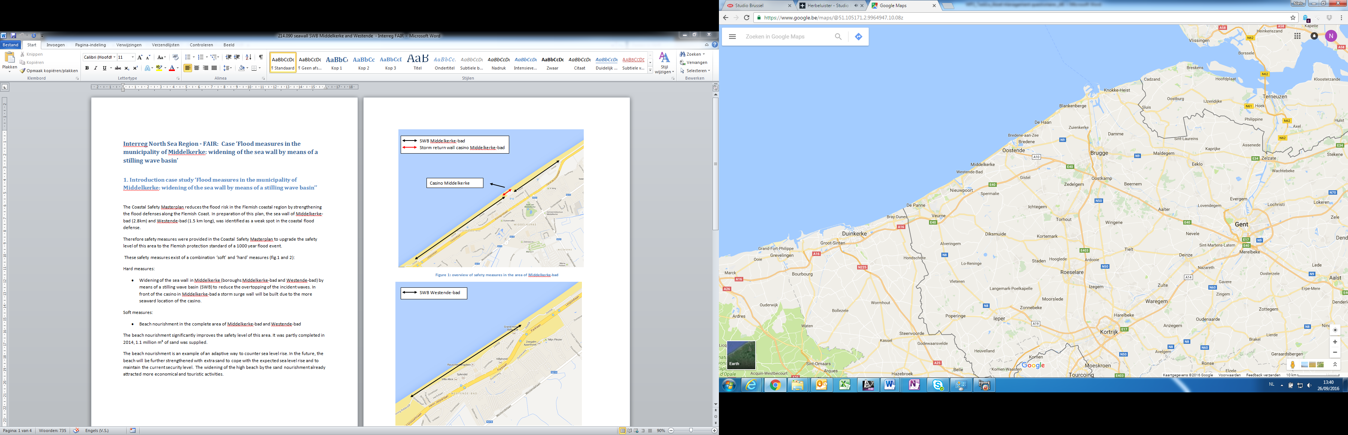

Figure 1: Location of Middelkerke

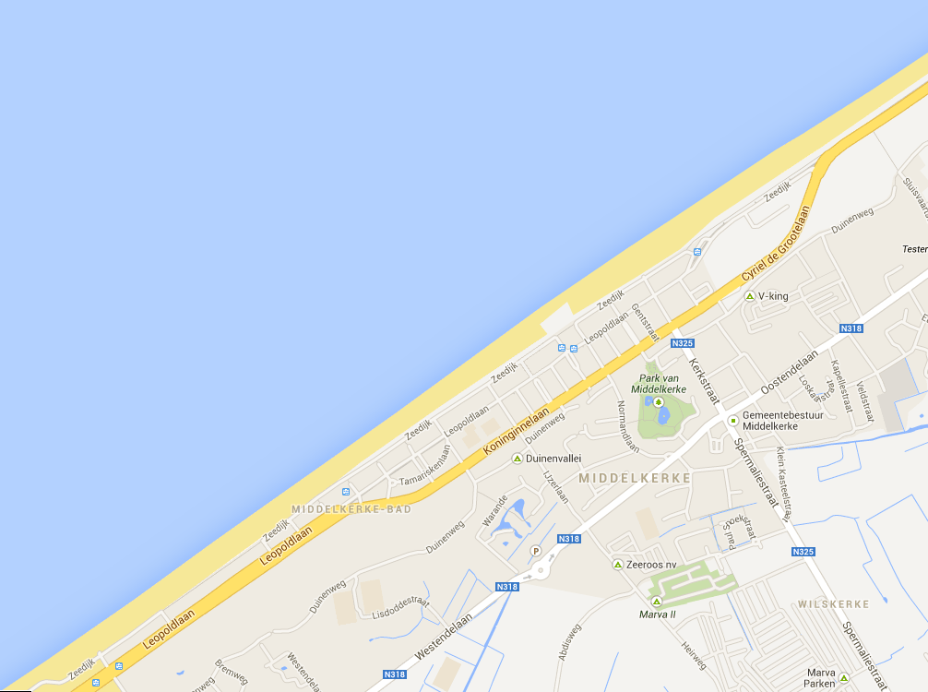

SWB Middelkerke-bad   
Storm return wall casino Middelkerke-bad

Casino Middelkerke

Figure 2: overview of safety measures in the area of Middelkerke-bad

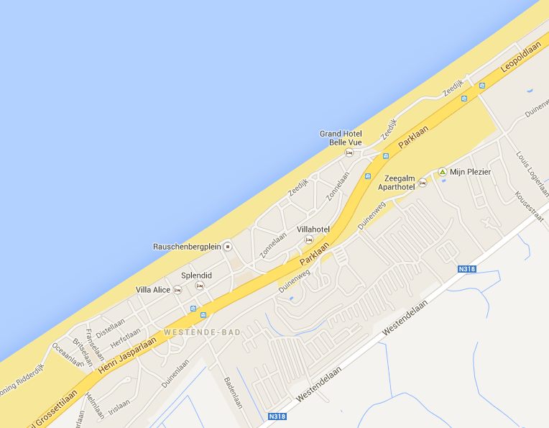

SWB Westende-bad

Figure 3: overview of the safety measures in the area of Westende-bad

#### Focus/objective of the case

*Decision focus:* Operational – how to implement an action

*Objective:* The Coastal Safety Masterplan reduces the flood risk in the Flemish coastal region by strengthening the flood defenses along the Flemish Coast. In preparation of this plan, the sea wall of Middelkerke-bad (2.8km) and Westende-bad (1.5 km long), was identified as a weak spot in the coastal flood defense. Therefore safety measures were provided in the Coastal Safety Masterplan to upgrade the safety level of this area to the Flemish protection standard of a 1000 year flood event.

These safety measures exist of a combination ‘soft’ and ‘hard’ measures (fig.2 and 3):

Hard measures:

* Widening of the sea wall in Middelkerke (boroughs Middelkerke-bad and Westende-bad) by means of a stilling wave basin (SWB) to reduce the overtopping of the incident waves. In front of the casino in Middelkerke-bad a storm surge wall will be built due to the more seaward location of the casino.

Soft measures:

* Beach nourishment in the complete area of Middelkerke-bad and Westende-bad

#### The physical setting

*Nature and topography*

Middelkerke is a coastal community. The average ground level of the rural areas behind the urban areas is around 3 m TAW. The average high water is 4,3 m TAW.

*Sources of flooding*

The source of flooding is the sea.

*Existing flood defence infrastructure*

The existing flood defense infrastructure is a 6 km sea wall. This sea wall has a average height of 9,5 m TAW.

#### The socio-economic setting

State if rural, semi-urban, dense urban

What is the nature of the communities to be protected, residential and non-residential activities, important infrastructure services (hospitals, transport hubs etc) that may be in the floodplain and how these might be impacted by a flood.

Middelkerke is a community with 19.000 inhabitants. Especially the coastal region, the area with a width of 1km next to the sea wall is a very dense urban area. TYhere are a lot of economic and touristic activities. All the important infrastructure services are located in this area and may flood when the sea wall would be breached.

#### Have there been past floods in the area? If so, how was it caused and what impact did it have?

There are no reported floods in this area.

## Question 3.2: Specific challenges and barriers to be overcome

### 3.2a What is the asset management challenge

what is the driver for the case study and what makes AM difficult:

This project is part of the Masterplan Coastal Safety. The town council also wants to broaden the existing sea wall for economic, spatial and touristic means.

The biggest challenge will be to have the support of all the people who have a business or live in the vicinity of the sea dike as the necessary infrastructural works will cause a lot of nuisance for a long period.

Subsidence?

Flood plain development?

Funding/political momentum/support?

Are there any constraints on the solutions? {environmental, technical feasibility}

### 3.2bUnderstanding of the current system

#### Physical understanding

* **Vertical accuracy and source of the floodplain topography data**

The vertical accuracy of the topography is: +/- 0.01 m

The horizontal resolution of the topography is: 5 m

* **What flood defence assets are important to the case study**

A basic typology of the flood and coastal erosion risk management infrastructure is provided in the table below (Sayers et al, 2015). Which asset types exist in the pilot study area and what role do they play?

*Asset types to be considered in the pilot (asset typology after Sayers et al, 2015)*

|  |  |  |  |  |
| --- | --- | --- | --- | --- |
| **Type of asset** | | **Example activities** | **Considered in pilot (yes/no)** | **Why?** |
| **Local scale infrastructure** | | |  |  |
| **Private homes and businesses** | Avoidance | Raising properties above flood levels (actively, floating homes, or passively, raised thresholds) or some other way to avoid flooding. | No |  |
| Resistance | The use of flood products and construction detailing to prevent water entering a property. | No |  |
| Recovery | Use of building materials and practice that such that although flood water may enter the building no permanent damage is caused, structural integrity is maintained and drying, cleaning and minor repairs are facilitated. | No |  |
| **Critical service nodes** | Avoidance | Raising critical functions / building above flood levels. Deployment of property scale ‘ring dykes’. | No |  |
| Resistance | The use of flood products and construction detailing to prevent water entering a property. | No |  |
| Recovery | The use of function specific building designs and network redundancy to avoid loss of function if flooded (i.e. continued power or communication distribution). | No |  |
| **System scale infrastructure** | | |  |  |
| ***Hard path infrastructure – Planning, design and management of built infrastructure*** | | |  |  |
| **Linear and network assets** | Active | Barriers that can be deployed as temporary and demountable defences. | No | All the flood infrastructure will be permanent |
| Passive - Above ground | Raised defences and shore parallel structures (i.e. embankments, levee or dyke, breakwaters) through to storm water storage ponds. | Yes |  |
| Passive - Below ground | Individual pipes, CSO’s and the drainage network they compose. | No |  |
| **Point assets** | Active | Pumps, floodgates and sluices. | Yes |  |
| Passive | Fixed trash screen, groynes as well as interface assets (that link above and below ground linear systems) such as manholes and gullies. | No |  |
| ***Soft path infrastructure – Utilizing natural infrastructure systems*** | | |  |  |
| **Watercourse** | Channel | The management of vegetation (e.g. weed cutting) and sediment (e.g. shoal removal and dredging). | No |  |
| Floodplain | The management of floodplain roughness and debris recruitment. | No | Is |
| **Coast** | Foreshore and backshore | The management of dunes and beaches through active (e.g. recycling and profiling) and passive (e.g. sand fencing, marram grass planting) management as well as natural wetlands and soft cliffs. | Yes | The beach will need to have a minimum level in order the limit the incident wave height at the toe of the dike |
| **Urban landscape** | Urban land use | The engineering of urban green space, managing surface permeability (e.g. through SuDs) and debris recruitment. | No |  |
| **Rural catchment** | Rural land use | The management of rural run-off, sediment yields as and debris recruitment. | No |  |

*Note: FCERMi includes any feature that is actively managed to reduce the chance of flooding or erosion (Sayers et al., 2010). Dams and associated ancillary structures are excluded from this paper*

* **Accuracy and source of information on asset geometry and their performance**

The current flood risk analysis showed out that the area of Middelkerke didn’t meet the safety standard (1000-year storm with a overtopping limit of 1 l/m/s).

### Socio-economic understanding

* Accuracy and source of information on floodplain usage (receptor etc)

Official information of the Flemish government was used.

#### Existing plans and policies

How do existing plans and policy influence the approach to asset management in the case study site

|  |  |  |
| --- | --- | --- |
| **Policy or plan** | **Description** | **Influences on asset management at case study location**  **<Impact?>** |
| **European policy** |  |  |
| **Eurocode** | Some of the eurocode are incorporated in national code | Less influence |
| **National policy** |  |  |
| Masterplan Coastal safety | This document sets the safety standard on the long term | The sea wall has to meet the safety standards |
| **Regional strategies** |  |  |
| Zoning and land-use regulations / area development | Sets the requirements regarding regional spatial planning | Upgrading methods for flood defense must meet regional regulations |
| **Local plans** |  |  |
| Zoning and land-use regulations / area development | Sets the requirements regarding local spatial planning | Upgrading methods for flood defense must meet national regulations |

### 3.2b Future change

We would like to understand how future change is accounted for. In particular:

#### In climate – repeat by the Part A questions here but answer for the specifics of the case study

For the sea level rise will be accounted for by widening and heightening the beach in front of the sea wall. The hydraulic boundary conditions at the toe of the dike will stay the same in the future.

What guidance is provided on climate change, including:

* Sea level rise allowances
* River flows
* Temperature?
* Storm sequencing?
* Spatial coherence?

#### In socio-economics

The widening of the sea wall is also being done to attract more economic and touristic activities.

### 3.2b Governance and other aspects - move to be consistent with Part A

#### Funding

* Who pays, the asset management plan to be developed, for maintenance, capital investment and how secure is this funding stream into the future?

This project will be financed by the Flemish government (both soft and hard measures) and by the local municipality (only the hard measures)

* Are there other funding or payment barriers (compensation for example)

NA

#### How successful is asset management – review Part A question

* Is it known whether the asset management is being delivered successfully? If so, how is it measured? (e.g. required and desired performance requirement (if present) is met?)

After the construction of the new sea wall new flood risks assessments will be done periodically to determine the safety of Middelkerke.

## Question 3.3: Overview of tools and data to be used (where this is known)

### 3.3a Reliability

#### Overview

* What approaches are you planning to apply?

The design will be based on hydraulic data measured over the last 100 years. With this data boundary conditions have been calculated with numerical models in front of the sea dike. To determine the resulting overtopping and forces on the sea wall, physical model test will done.

* What are minimum data requirements for this approach(es)?

Hydraulic boundary conditions in front of the coast in Middelkerke, bathymetry, topography, …

* Will the analysis be undertaken by a specialist engineer? If yes, is this in-house or external?

The necessary calculations will be done by consultants and supervised by own engineers.

#### Specific challenges and gaps in understanding

What are you particularly issues are you grappling with

* Gaps in physical process knowledge: /
* Gaps in analysis capability: /

### 2.3b Deterioration

Why is deterioration of assets important at the pilot? Are the deterioration rates known, if so, what is the evidence that is used? Is deterioration managed, and how is value for money of the associated expenditure evaluated?

The beach in front of the sea dike is very erosive due to storms and needs to be periodically nourished in order to maintain a certain height and width.

#### Specific challenges and gaps in understanding

What are you particularly grappling with – transitions, piping, on-demand M+E, peat, exceedance?

### The communication with the stakeholders will the biggest challenge.

## Question 3.4: Decision process

### 3.4a Social justice

How are the three principles of justice considered:

* Equality
* The most vulnerable are prioritized
* Utility (best return)

Several possible solutions were analyzed. Due to social-economics requirements from the local community the widening of the sea wall was chosen (was not the most cost-effective solution)

3.4b Robustness under conditions of future change

What are the specific values of future change that have been considered in the pilot site:

* How is climate change factored in?

The sea level rise will be compensated by widening and heightening the beach

* How is development in the floodplain factored in?

The safety lines is just next to sea wall, the complete area needs to be protected.

* How is uncertainty over future funding factored in?

The funding is being done by the Flemish government and the municipality

### 3.4c Investment planning

What funding constraints exist at the pilot site?

The necessary budgets are already allocated.

How is long term funding secured?

The long term funding is being secured by the Flemish government and by the municipality.

Is additional funding for multi-benefits being sought - if so, where from and is this likely to be successful?

No other funding will be sought.

## Question 3.5: The relationship of AM to board planning issues

Within the pilot location, do flood defence activities and funding link with broader planning policies and plans, if so how?

As a minimum consider the relationship of the flood defence approach to:

* Spatial planning
* Environmental regulation (such as the Water Framework Directive)
* Promotion of redevelopment or tourism
* Evacuation planning?

The flood defence activities will be incorporated in the existing urban area. The new sea wall be will designed by architects and will allow a lot more touristic and economic activities than the current sea wall.

1. ISO55000
2. http://www.ntnu.edu/c/document_library/get_file?uuid=ae1f2570-1191-4d7c-b4c3-9686aaeccaf8&groupId=151572
3. FLOODsite: The Language of Risk
4. http://www.ntnu.edu/c/document_library/get_file?uuid=ae1f2570-1191-4d7c-b4c3-9686aaeccaf8&groupId=151572