**Source-Pathway-Receptor framework**

Briefing Note provided to the FAIR partners: Paul Sayers Aug 2017

# **The Source-Pathway-Receptor framework**

## **Introduction**

The basic components of probability and consequence can be usefully disaggregated further into their constituent components, based on the Source-Pathway-Receptor framework (Figure 1, Sayers et al, 2002).

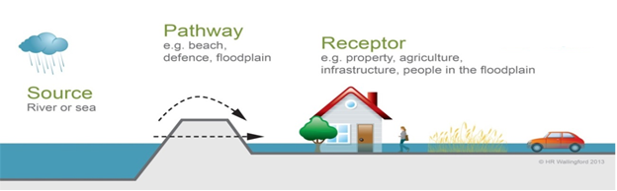

**Figure 1** – The basic Source-Pathway-Receptor framing (Sayers et al, 2002)

**Redrawn from Sayers et al, 2002**

In exploring flood probability, this reflects both the probability of the initiating event (the **source** of the flood such as rainfall or a marine storm) and the probability that flood waters will reach a particular location in the floodplain, taking account of the performance of the intervening system of wetlands, channels, dams, levees, gates, floodwalls and other structures (the **pathway** of the flood water).

The consequences should flooding occur reflects both the vulnerability of the **receptors** and the chance that a given receptor will be exposed to the flood when it occurs.

The SPR framework also provides a structured means of considering the necessary aspects of the system to include in the system risk analysis, and how future changes in different aspects may change this system (Figure 2 – Sayers et al, 2013).

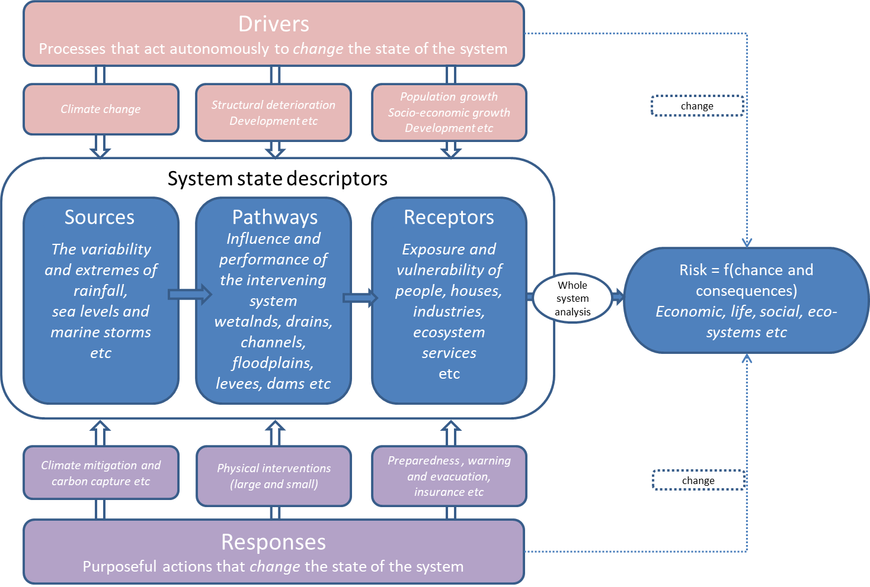

**Figure 2** Drivers and responses include different aspects of the SPR framework (Sayers et al, 2013)

**References**

**Sayers PB**; Hall JW; Meadowcroft IC (2002). [**Towards risk-based flood hazard management in the**](http://www.sayersandpartners.co.uk/uploads/6/2/0/9/6209349/2002_-_sayers_et_al_-_towards_risk-based_flood_hazard_management_in_the_uk.pdf)**UK.**Civil Engineering 2002, 150(5), 36-42.

P. Sayers, Y. Li, G. Galloway, E. Penning-Rowsell, F. Shen, K. Wen, Y. Chen, and T. Le Quesne.  [**Flood Risk Management: A strategic approach**](https://www.adb.org/sites/default/files/publication/30246/flood-risk-management.pdf)**(2013)**. Published in 2013 by the United Nations Educational, Scientific and Cultural Organization 7, place de Fontenoy, 75352 Paris 07SP, France © UNESCO 2013 in association with Asian Development Bank, WWF-International and the GIWP, China. ISBN 978-92-3-001159-8.