A Joint Probability Analysis in Skjern Å (Ringkøbing Fjord?)
1. Introduction 2
2. Location 2
2.1 Hinterland 4
2.2 Historical floods 6
3. Data Foundation 8
3.1 Ringkøbing Fjord 8
3.1.1 Bork Harbor 8
3.1.2 Ringkøbing Harbor 8
3.1.3 Hvide Sande Harbor 9
3.2 Skjern Å 9
3.2.1 Skjern 1 (No. 250097 Gjaldbæk Bro) 9
3.2.2 Skjern 2 (No. 250082 Alergårde) 9
4. Return Period Combination Selection Methods 9
5. Results 10
5.1 Skjern 1 (No. 250097 Gjaldbæk Bro) 11
5.1.1 Bivariate statistics – SEA and STREAM 11
5.1.1.1 Sample – VAR.1.SEA 11
5.1.1.2 Return Plots – VAR.1.SEA 11
5.1.1.3 Copula Plot - VAR.1.SEA 12
5.1.2 Univariate Statistics - STREAM 12
5.1.2.1 Sample – UNI.STAT.STREAM 12
5.1.2.2 Return Plot – UNI.STAT.STREAM 13
5.1.3 The Joint Probability Table for Skjern 1 13
5.2 Skjern 2 (No. 250082 Alergårde) 14
5.2.1 Bivariate statistics – SEA and STREAM 14
5.2.1.1 Sample - VAR.1.SEA 14
5.2.1.2 Return Plots - VAR.1.SEA 14
5.2.1.3 Copula Plot - VAR.1.SEA 15
5.2.2 Univariate Statistics – STREAM 15
5.2.2.1 Sample – UNI.STAT.STREAM 15
5.2.2.2 Return Plot – UNI.STAT.STREAM 16
5.2.3 The Joint Probability Table for Skjern 2 16
5.3 Return Period Combination Selection Methods 17
5.3.1 Skjern 1 17
5.3.2 Skjern 2 20
7. Discussion 23
7.1 Why is the univariate value not larger than the VAR.1.STREAM (Skjern 1)? 23
7.2 Why should the return values be transformed into a new univariate return period? 24
7.3 The SCALGO Tool Performance 25
8. Conclusion 26
9. Suggested Work 26
9. References 26

1. Introduction
A flood caused by one source (e.g. from a storm surge) is understood and in most cases protective structures are put into place to prevent a flood in a given area, however handling flooding from two or more sources can be abstract and difficult to handle. That is why The Danish Coastal Authority aim to develop a tool for cities/municipals to use so that they may get a better picture of how a flood would look like (flood extent) when e.g. a storm surge results in high/extreme water level in the sea and a long precipitation ultimately leading to more water flow in the streams occurs simultaneously.
This report is the third in a series of reports meant to create, evaluate and improve a method for finding the joint probability of flood sources colliding. The project FAIR and the EU’s Flood Directive aims to reduce the risk of flooding.
The first report The Joint Probability Method Report, DCA 2019 introduces the statistical method and identifies some weaknesses in the method. In the second report A Joint Probability Analysis in Konge Å and Ribe Å, DCA 2019 the weaknesses are analyzed and the best method is found. This report analæyse3s the complications in determining which combinations of events (in Sea and Stream respectively) to take into a hydrological model. It also provides suggestions as to how to determine which events to combine to find the largest flood extent.
This report provides 1) A joint probability analysis of Ringkøbing Fjord (sea) and Skjern Å (stream) and 2) The expected issues with the sluice and other flood protection constructions that will arise with changing climate, over time.

2. Location
Ringkøbing Fjord - MIE’S SYSTEMBESKRIVELSE
Ringkøbing fjord is located on the Danish North Sea coast, which can be seen on map 1. This area has been chosen as one of two pilot sites for the Danish Coastal Authority’s contribution to the InterReg project FAIR. Some of the rationalizations for selecting the area of Ringkøbing fjord are the need for upgrading worn-out flood infrastructure, the ongoing urban development in flood prone areas and the in effect grade II listed nature in flood prone areas. These challenges make for an interesting pilot site where different aspects are necessary to consider when handling flood infrastructure asset management.
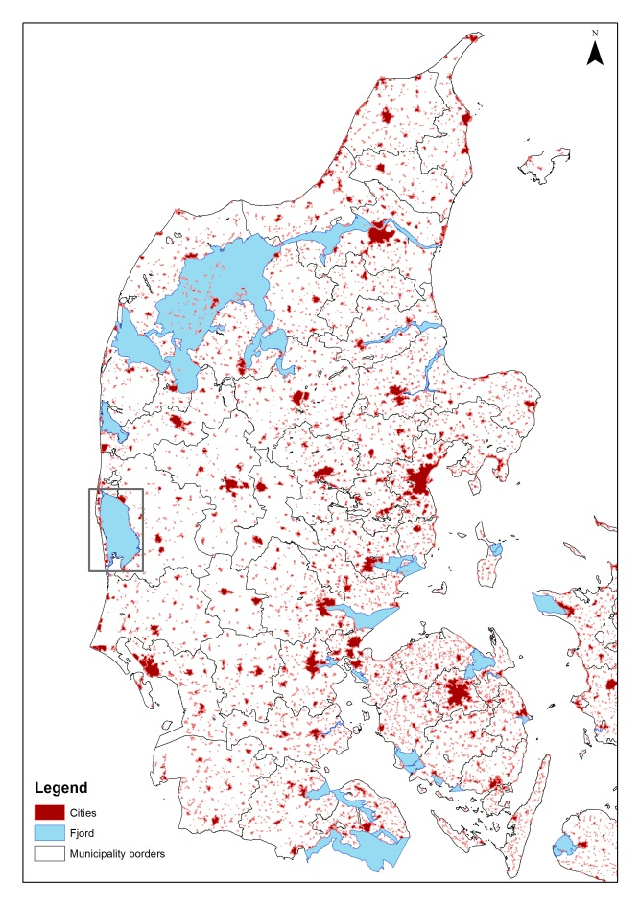
Figure 1 Project area Ringkøbing fjord
Ringkøbing Fjord is 30 km long and approximately 10 to 12 km wide with a water area of 290 km² (+0,1DVR). The average depth of water is 1.8 meter and at a water level of 0.1 m DVR the water volume is 560 million m³. The catchment to Ringkøbing Fjord is 3.470 km² and daily runoff to the fjord is between 2 and 12 million m³.
The possible flooding sources in this pilot are water from the ocean, from Ringkøbing fjord and from surface runoff to Ringkøbing fjord from the water basin. Additional possible flood sources include groundwater and torrential rain. In this pilot the potential source of flooding that will be operated with is primarily the fjord due to storm and surface runoff. The flood threat from the sea will be managed through supervision of dune safety and corresponding nourishment activities. Hvide Sande has a dewatering sluice that is 120 m long and 24 m wide with 14 openings. Every opening is 6.25 m wide with a depth of 4.1 m DVR. One of the main causes for floods is sluice practice during high water level. This results in flooding of the fjord and creeks given that it is impossible for the water at high level to run-off to the sea. The water is instead gathered along the creeks and an overflowing of the low-lying areas occurs. A local phenomenon that occurs is when the fjord tilt during a combination of a longer period with the sluicegates closed, wind from west and increased run-off from the water basin to the fjord. If the wind changes direction from west to north-west the water is pressed to the southern part of the fjord where the city Bork is located. The city experience floods due to this occurrence. In the future the municipality is expecting to have increasing challenges with percolating of rain, wastewater and general discharge of rain in creeks, which is not focused on in this project.
Some places along the fjord minor dikes protect low-lying farmland and plains. The dikes in the northern part of Ringkøbing Fjord are at 1.40 DVR and the dikes at the southern side are 1.70 DVR. Furthermore, the sand dunes along the coast near Hvide Sande have been enhanced over several occasions to maintain a safety level against coastal erosion and a breach.
In the future larger areas around the fjord will be flood prone, including areas located behind existing dikes. Sea level rise equals shorter periods for dewatering through the sluice resulting in more frequent high water situations and difficulties in the fjord. Also higher levels of discharge from nearby creeks due to a changing climate could become problematic. Those two combined are expected to result in more frequent floods in the area, which will be examined further in the project. Furthermore, the municipality has struggled with pollution in the fjord so it was decided to decrease the pollution by letting in saltwater from the sea to blend with the fresh water in the fjord. This has affected the salinity in the fjord as well as the water temperature and quality. The sluice is not only currently used to regulate water level but also quality. This may affect the lifespan of the sluice. Also, challenges occur if the sluice in the future has to be closed over longer periods of time due to high water level in the ocean because the water quality then changes. It is necessary that the fresh water is mixed with sea water during stormy weather to prevent pollution affecting the fjord.

2.1 Hinterland
The landscape is considerably made up of heaths, which was created during the last ice age by melt water. Extensive dune areas are along the west coast of the fjord and furthest west marine sediments exist. Skjern stream is a prominent feature in the landscape. The soil in the catchment is dominantly sand and coarse soil. Around Ringkøbing Fjord large reclaimed areas are being dewatered for agricultural purposes (Styrelsen for Vand- og Naturforvaltning, 2015). Ringkøbing Fjord is located in the mid-western part of Denmark. The fjord has a large supply of freshwater with a catchment of around 8 % of the areal of Denmark. Almost 70% of the freshwater is supplemented through Skjern Stream and 15% through Vonå. Several cities of varying sizes are situated by the fjord. Hvide Sande is a minor town sited in the middle of the barrier island heading the North Sea. Currently 3059 people inhabit the city. Furthermore, larger cities like Ringkøbing with 9890 habitants, Søndervig with around 5000 inhabitants in the summer season and Bork with 430 inhabitants are also located within the project area. Here around 600 vacation homes are within a drainage guild. One of the main assets of this pilot site, a dewatering sluice, is located in Hvide Sande.
Holmslands Klit, where Hvide Sande is located, is a spit that has grown in front of an earlier bay at the coast. The spit is built completely of rock and sand, which the waves have washed up. Afterwards the wind has blown the sand in dune formations. The sluice is located at the middle of the spit where it since 1931 has regulated the water level and salinity in Ringkøbing fjord. It is predicted by the DCA that the current sluice practice is sufficient till 2100 under normal weather conditions and the existing climate change scenarios. The infrastructure is however in need of upgrading or renovation to withstand the challenges in the future. It is predicted that the sluice is required to be multifunctional to meet the future requirements.
The western shore of the fjord is mainly low lying salt marshes. Reed beds have spread along the shores of the fjord after the installation of the sluice. Previously the fjord was connected with Stadil fjord and Vest Stadil fjord but due to a dewatering project where land was drained for agriculture they are no longer linked. (Johannesen, 1993)
Low lying infrastructure is at risk of flooding as well as residential activities along the fjord shores. Part of the harbor in Hvide Sande is also located within the flood zone. If a breach of a dike occurs along the fjord shore or if they are overflowed then farmland will be flooded. Primarily livelihood is based on fishing activity and agriculture. A somewhat smaller fishing and offshore harbor is situated in the town of Hvide Sande. There are also non-residential housing and income from tourists. Some of the attractions are a cable park and fishing activities located by the waterfront.

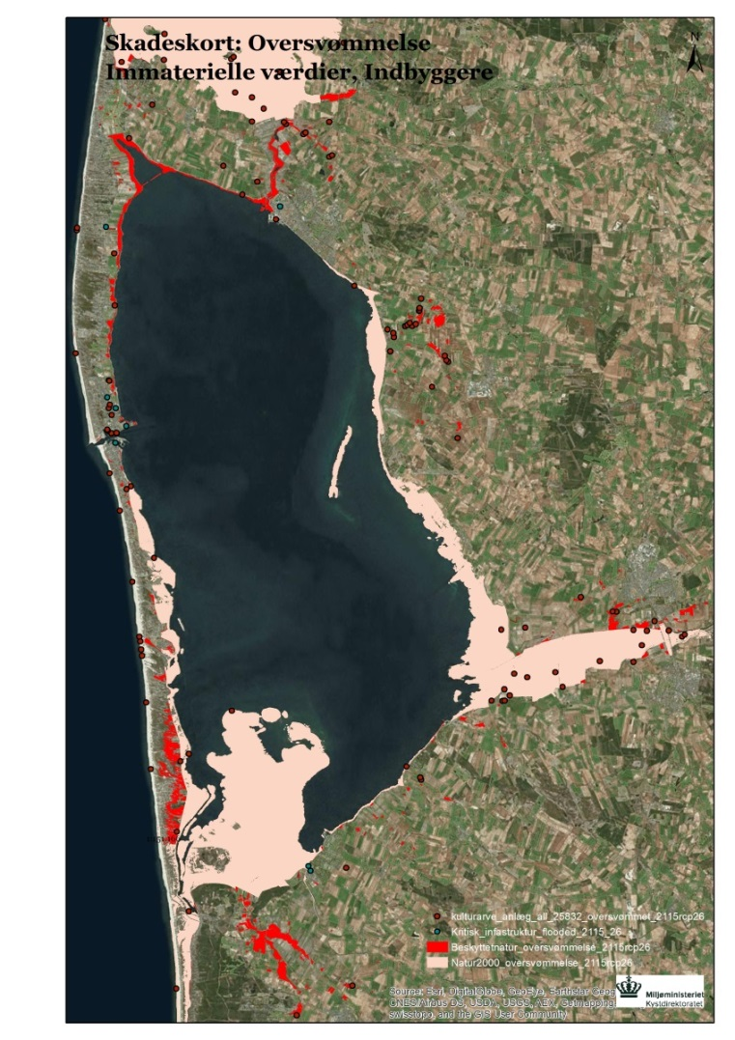
Figure 2 Extent of damage from flooding.

Two cities that are often flooded during storm are Ringkøbing and Hvide Sande. On map XX and xx the land use of the two places are depicted. These areas as well as the protected nature benefit from flood protection. Furthermore, tourism and infrastructure such as roads are also protected by flood installments.
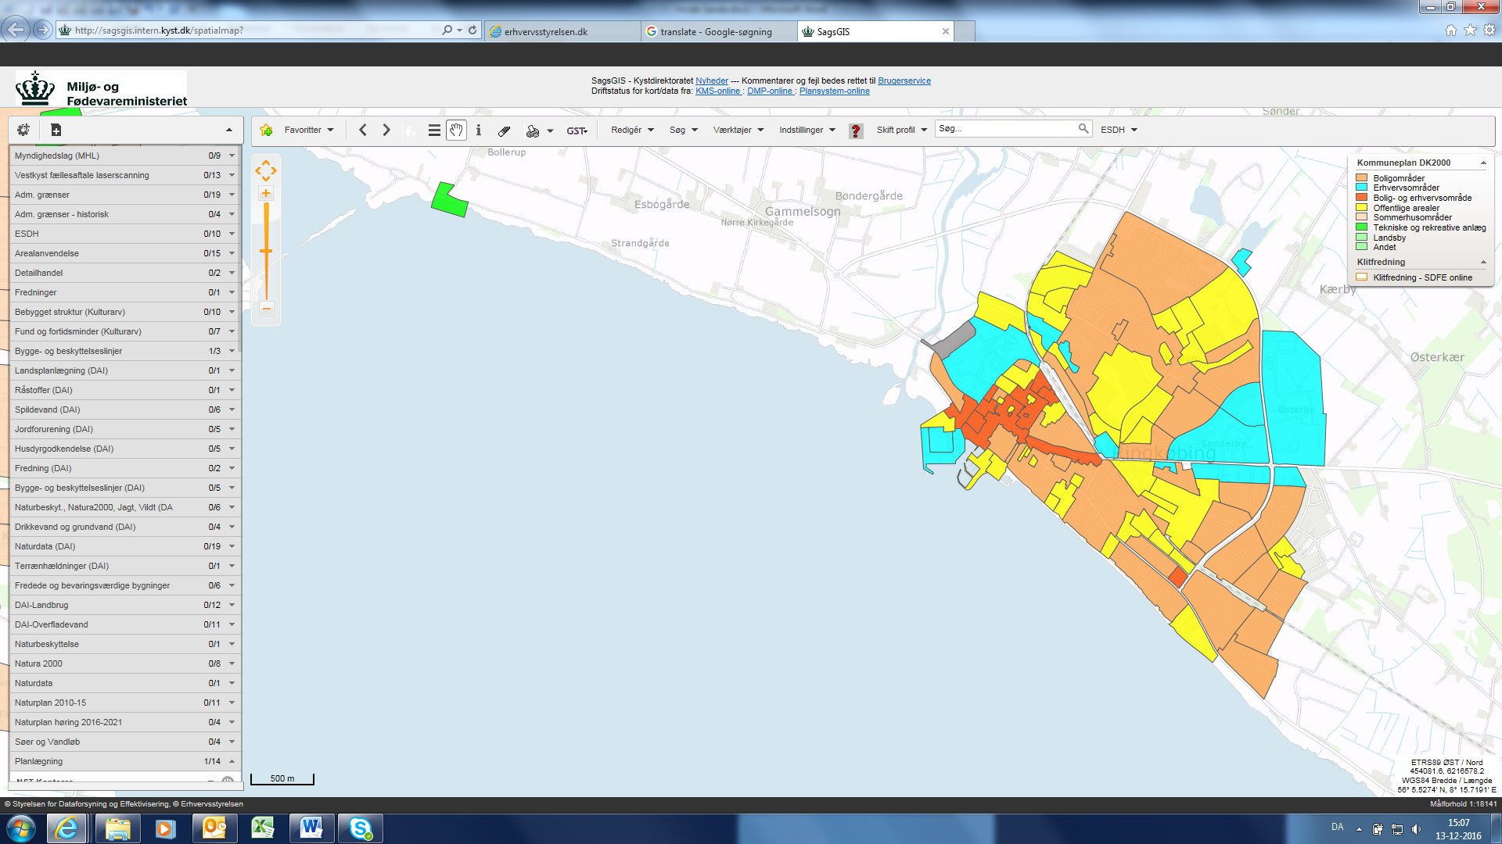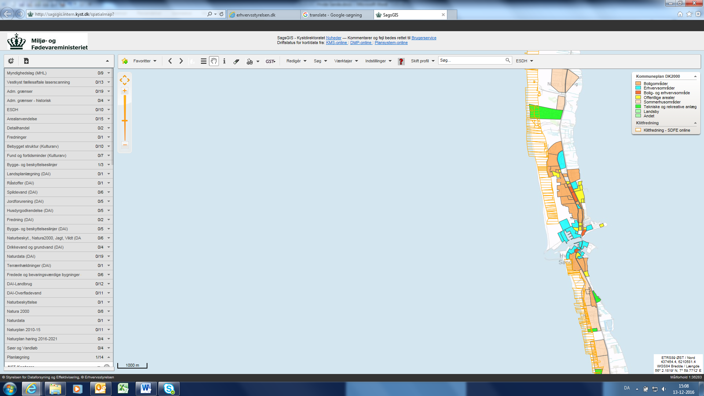
Figure 3 Land-use for Ringkøbing left and for Hvide Sande right where orange is residential areas, yellow is public areas, blue is industrial areas and red is a mix of residential and industry.
It is a wide range of activities and infrastructure that are currently and will in the future benefit from flood protection infrastructure.

2.2 Historical floods
Problems with floods in the eastern part of the fjord have occurred, in particular in the winter months, because the water is stowed at the smaller creeks outlet to the fjord (Ringkøbing -Skjern kommune, 2012). Incidents with extreme water levels occurs as a combination of increased discharge from the inland creeks due to melting snow or heavy rain and sluice gates closed due to high sea water level or longer periods with no possibility for discharge of the fjord. With raising water levels in the fjord and a storm from west floods is the result in particular in the cities of Ringkøbing and Bork (Ringkøbing -Skjern kommune, 2012).
A report on historical storm floods in Denmark up until 1981 has been prepared by DMI and it was gathered that a few storm floods have been recorded in the area of Ringkøbing fjord. In 1807 a larger storm flood hit Hovvig just north of Søndervig and a breach of the dunes occurred. In 1928 another storm flood hit Ringkøbing harbor as well as floods along the fjord. In 1936 the first dune row at Søndervig was breached as well as flooding in Hvide Sande at 2.50 m over DNN. A similar storm flood occurred in 1973 with flooding of the harbor in Hvide Sande at 2.50 m above DNN and significant damage of the dunes. Lastly a very large storm flood hit in 1981 with water at 3.58 m DNN in Hvide Sande (DMI, stormfloder, 1991). Several more recent storm floods have hit Ringkøbing fjord and the storm council have records from 1991-2009 on floods they deem to be of the category storm floods. Four floods occurred in that time span; 25.01.1993, 03.12.1999, 29.01.2000 and 08.01.2005. The two first storm floods only hit the southern part of Ringkøbing fjord whereas the last two affected the entire fjord (Stormrådet, 2009). The storm Gorm hit Denmark November 29th 2015 and went ashore in Hvide Sande and the Ringkøbing fjord area first. The storm is described as having almost lifted Ringkøbing fjord allowing water to run in the streets of Hvide Sande and Bork. In both locations the harbor is particularly exposed and is traditionally affected during a storm. (Binderup, 2015) (Kjærsgaard, 2016)
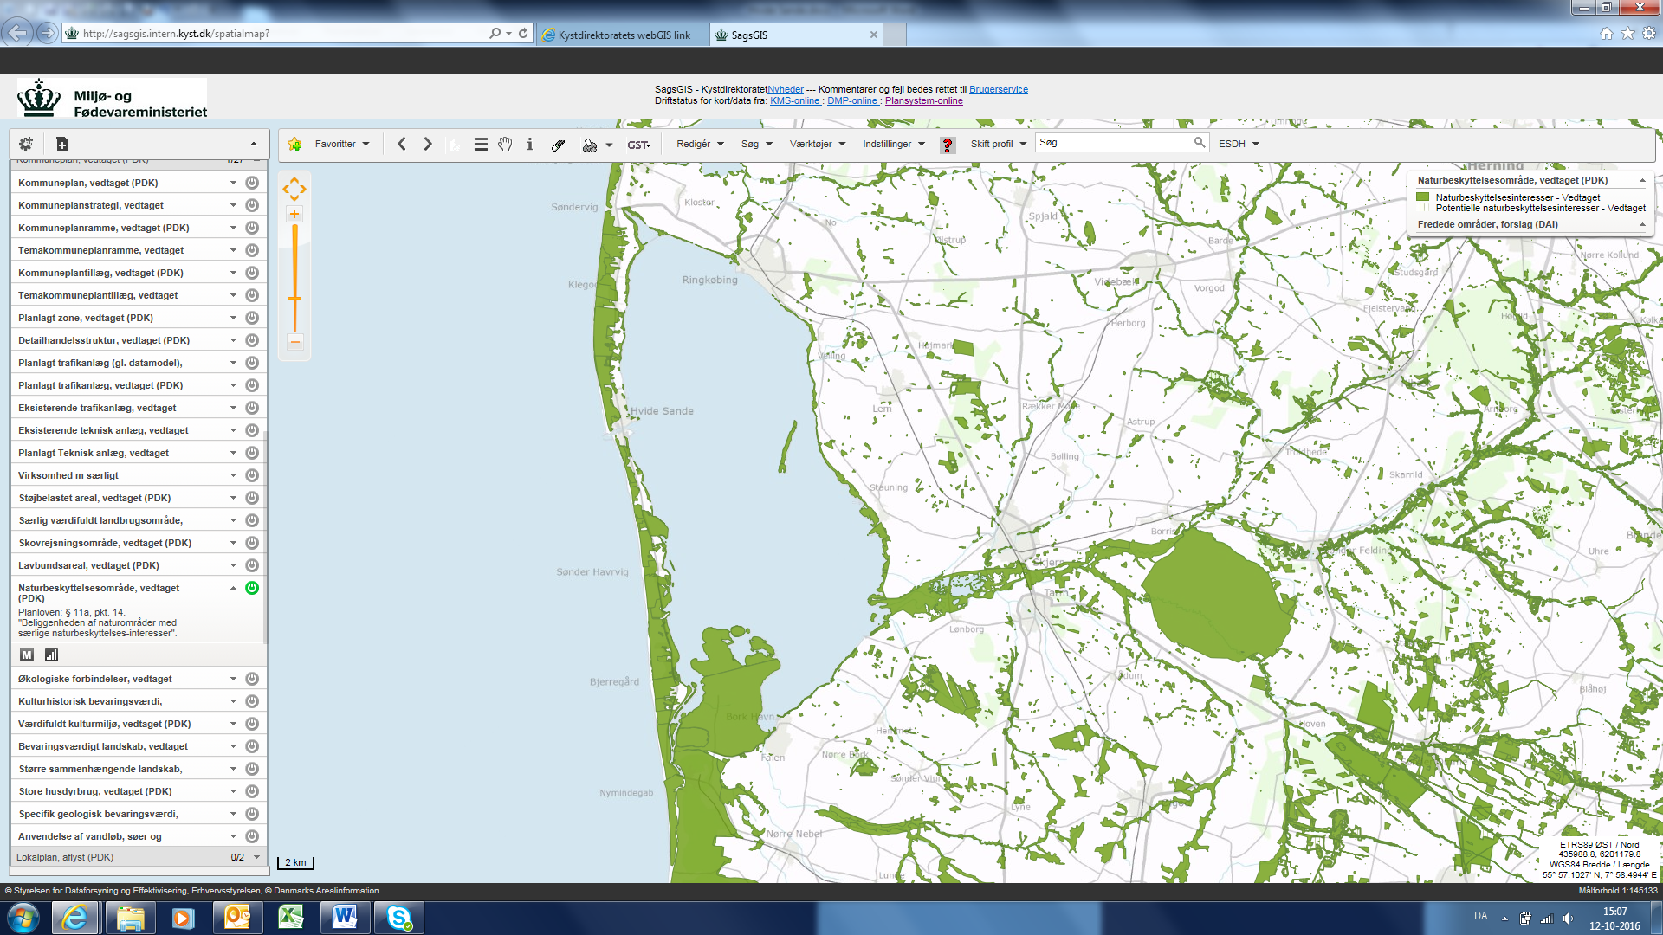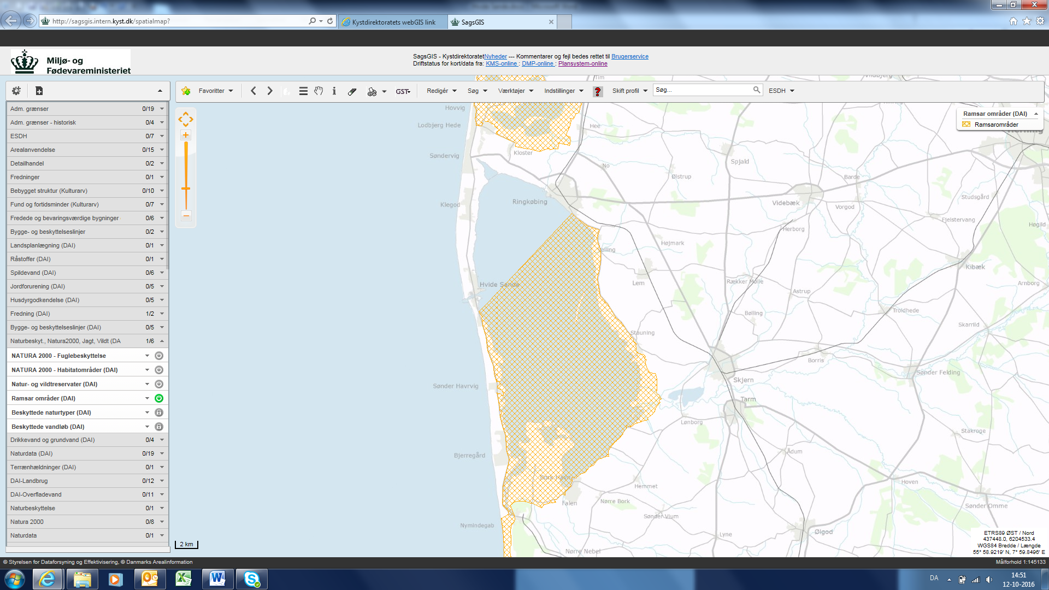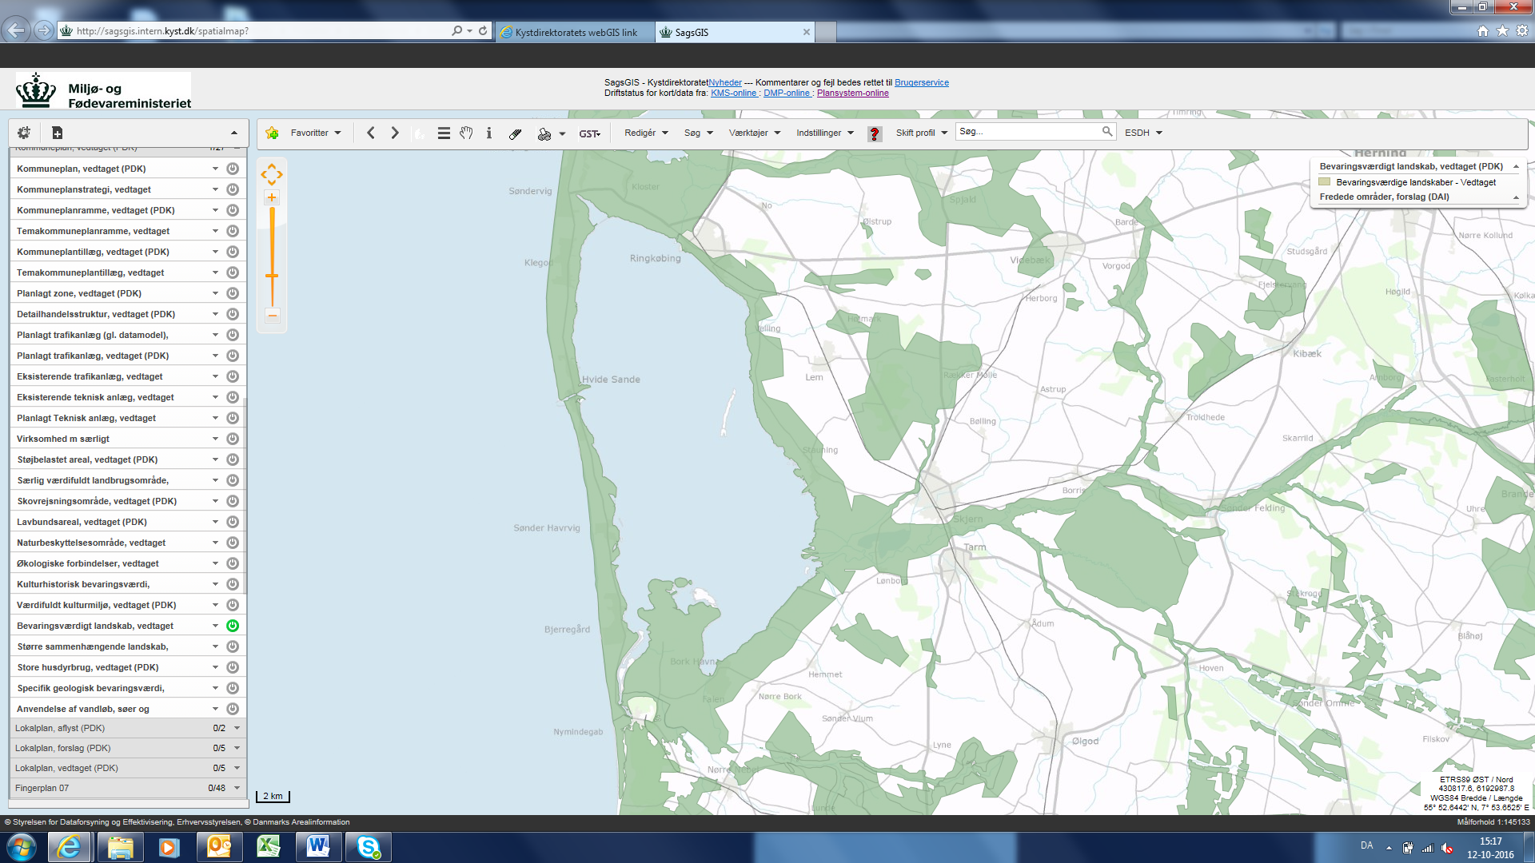
Figure 4 Nature conservation interests. Map X: Ramsar area. The Natura2000 protected areas cover the same stretch of the fjord. Figure 6: Preserving worthy landscapes.

The first project around Ringkøbing Fjord that will combine flood protection and tourism is the pumping station at “KRAFT”. The pumping station will be encased in glass to function as a showcase for the mechanics of such pumps. None other projects in this area have combined flood protection with other functions. However, the municipality intends to incorporate different features in flood protection in future projects to enhance the value of these projects for the society.
In Ringkøbing Fjord there are several urban communities such as Ringkøbing, Hvide Sande, Søndervig and Bork that are all threatened by floods. It is therefore highly likely that the sluice will require improvements to become multifunctional. It is expected that the sluice need to be able to pump water from the fjord to the sea.
There are currently some challenges with the interaction between agriculture and fishing interests.
Around 7.5% of the land in the municipality is artificially drained by pumps. Some of this area contains agricultural land, vacation homes and also newer development is planned within the drained areas. Some of the vacation homes are in elevation 0 and in Rødklit new lots are being developed despite the flood risk due to need of constant pumping of water. These drainage guilds and the pumps are not owned by the municipality but privately owned. Therefore the upkeep and maintenance of the pumps are the responsibility of the owners and the majority of the pumping stations require repairs to function fully.
The municipality express that their largest challenge with flood protection is Ringkøbing and the vacation homes areas.

3. Data Foundation
The data used for the analysis is collected from Ringkøbing Fjord and Skjern (Å?) stream.

3.1 Ringkøbing Fjord
There are two fjord harbors in Ringkøbing Fjord: Ringkøbing Harbor (north) and Bork Harbor (south). Between the Sea and Ringkøbing Fjord is Hvide Sande. Hvide Sande has a water level measuring instrument on the sea-side of the sluice. The sluice is typically closed when the water level in the sea is higher than the water level in the Fjord. The highest recorded event water level in Hvide Sande is 359 cm (in 1981) for Ringkøbing harbor it is 119 cm (in 1981) and for Bork it is 142 cm (in 1999).
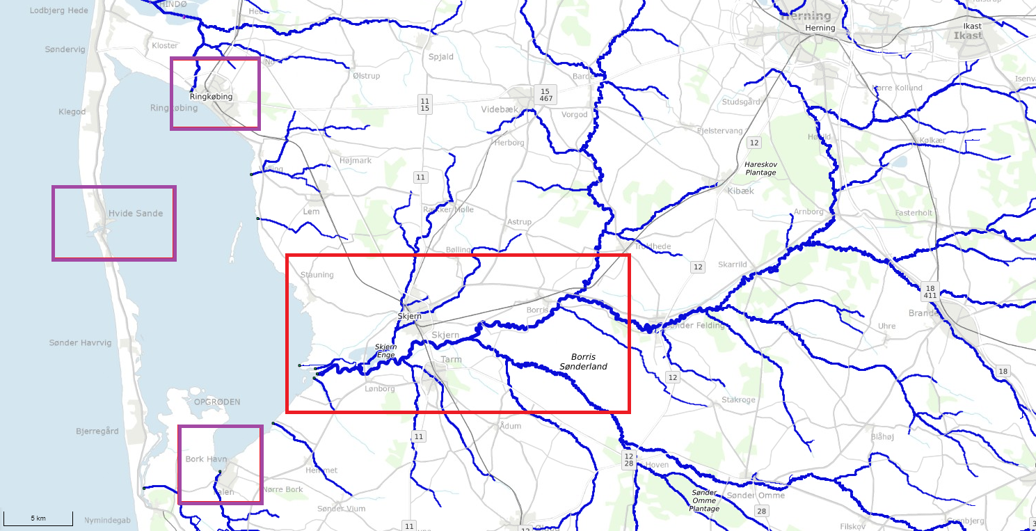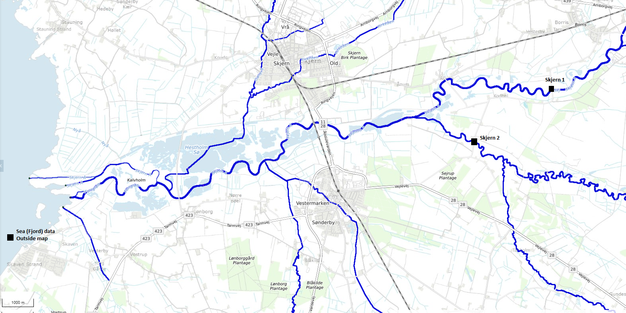
Figure 5 shows where the harbors and the streams are located. Below a zoom of Skjern Å with the stream stations positioned.

3.1.1 Bork Harbor
Data from Bork Harbor runs from 01.01.2000 (dd.mm.yyyy) until 13.09.2017 with approximately 44 years of data. There are some removal of outliers resulting in a little shorter data available than the full measuring period.

3.1.2 Ringkøbing Harbor
Data from Ringkøbing Harbor runs from 01.01.1971 (dd.mm.yyyy) until 13.09.2017 with approximately 46 years of data. There are some removal of outliers resulting in a little shorter data available than the full measuring period.

3.1.3 Hvide Sande Harbor
Data from Hvide Sande is available from 06.12.1931 (dd.mm.yyyy) until 12.01.2017 with approximately 85 years of data. There are some removal of outliers resulting in a little shorter data available than the full measuring period.

3.2 Skjern Å
Below in table X and X are shown the following: minimum/maximum flow (l/s) and catchment size (km²).

3.2.1 Skjern 1 (No. 250097 Gjaldbæk Bro)
Data period: 01.01.2005 – 01.01.2019
Date | Maximum Flow (l/s) | Date | Minimum Flow (l/s) | Catchment size (km²)
21.01.2007 | 71053 | 02.11.2005 | 10018 | 1450
Table 1

3.2.2 Skjern 2 (No. 250082 Alergårde)

Data period: 01.01.2005 – 01.04.2019
Date | Maximum Flow (l/s) | Date | Minimum Flow (l/s) | Catchment size (km²)
28.12.2015 | 54079 | 23.03.2005 | 4894 | 970
Table 2

4. Return Period Combination Selection Methods
In the previous two reports (The Joint Probability Method Report and A Joint Probability Analysis in Konge Å and Ribe Å) it is mentioned that the statistics alone do not provide a visual understanding of the flood extent. One of the key tasks in these analyses is to find a way to reduce flooding caused by sources colliding (Sea and Stream). A complete process of finding areas that are not protected against floods, of a certain size, from the joint collisions consists of:
- Finding the joint probability (The Joint Probability Method Report)
- Finding the worst flood extent (A Joint Probability Analysis in Konge Å and Ribe Å)
- Screening of Combined Events in Relation to Flood Extent (This Report)
In this report an introduction to a tool for screening flood extent (a simple hydrological model) is provided. The model of interest comes from SCALGO which is a simple model that fills in water in cells where the terrain is below the chosen water level. This report will not provide a full analysis of how the flood extent changes with different MTs but merely provide a method for further analysis.
Examples will be shown for the following combinations:
- Sea MT20 combined with Stream MT20
- Sea MT50 combined with Stream MT100
In the A Joint Probability Analysis in Konge Å and Ribe Å report the “transformation” system of bivariate MTs into corresponding univariate MTs is introduced. This transformation takes actual combined event sizes (bivariate statistics) and finds the corresponding MT in the univariate statistics. The reason for the need of transformation of MT is that a) the statistical method is bias towards sea data resulting in a typical underestimation of stream data and b) the data series is only the lengths of overlap between both sources. b) is especially important to pay attention to because the length of the sea data typically is much longer than the stream data length which has a tendency to highly influence the return values. Tables XX and XX are showing the transformation of sea and stream data into
STREAM DATA - Skjern 1 |  |  |  | STREAM DATA - Skjern 2
MT (Years) | Bivariate (l/s/km^2) | Univariate (l/s/km^2) | Approx. Corresponding Univariate (MT) | MT (Years) | Bivariate  (m) | Univariate  (m) | Approx. Corresponding Univariate (MT)
20 | 51 | 50 | 22 | 20 | 51 | 56 | 5
50 | 57 | 53 | 300 | 50 | 58 | 59 | 45
100 | 62 | 55 | 2500 | 100 | 64 | 62 | 200
Table 3
SEA DATA – Bork Harbor (Skjern 1 & Skjern 2)
MT (Years) | Bivariate | Univariate | Approximate Corresponding Univariate
 | (m) | (m) | (Return Period MT)
20 | 0.92 | 1.23 | 22
50 | 1.02 | 1.31 | 300
100 | 1.09 | 1.36 | 2500
Table 4
The SCALGO tool should be used with considerable care because of the very few restrictions in the model. In the results section below the flooding maps are presented, however they are to be looked at with skepticism. The input data of both sea and stream are from different areas than the area in focus. In figure 5 the placement of the stream water flow instrument is shown and it is clear that the station is rather far upstream from i.e. Skjern town. The same goes for the sea data. Bork Harbor is positioned south of our area of interest. Because this is the only useful data available this is used with the assumptions that they are representative for our area of interest. This assumption is, however, not backed up by any evidence. This type of analysis should only be performed on areas with local data to ensure representable model data. All results should be evaluated carefully with the model input in mind.

5. Results
The results section presents the results of bivariate statistical analysis for Skjern Å 1 and 2 (5.1) and the results of the SCALGO screening tool. Below is table X which includes the following information (from left to right): The stream station name, Referring name, Data period, Sampling Method (AM) (2/yr = 2 Annual Maxima values are sampled), Distribution Function Sea, Distribution Function Stream, The Copula (the joint distribution function) and Tau/Theta (Tau = fit between Sea and Stream data, Theta = Copula fit).
Stream Station | Script | Data period  (dd.mm.yyyy) | Sampling Method (AM) | Distribution SEA | Distribution STREAM | Copula | Fit (τ & ϴ)
Skjern Å,  Gjaldbæk Bro | Skjern 1 | 01.01.2005 - 09.04.2019 | 2/yr | LogNormal | LogNormal | Frank | 0.297 – 2.023
Skjern Å, Alergårde | Skjern 2 | 01.01.2005 - 09.04.2019 | 2/yr | LogNormal | LogNormal | Frank | 0.312 – 2.552
Table 5
The results consist of:
- Sample pool (VAR.1.SEA and UNI.STAT.STREAM)
- Return Plots (Marginal Distribution Functions for SEA/STREAM data and UNI.STAT.STREAM)
- Copula Plots (The Joint Probability Plot – VAR.1.SEA)
- SCALGO Screening Tool (Visualization of Flood Extent – A Simple Hydrological Model)

5.1 Skjern 1 (No. 250097 Gjaldbæk Bro)

5.1.1 Bivariate statistics – SEA and STREAM

5.1.1.1 Sample – VAR.1.SEA
 | Date | Hydro. Year | Sea (m) | Stream (l/s) | Date |  | Hydro. Year | Sea (m) | Stream (l/s)
1 | 21-01-2005 01:00 | 2005 | 0.72 | 53456 | 13 | 13-01-2005 19:00 | 2005 | 0.65 | 50674
2 | 17-12-2005 00:00 | 2006 | 0.42 | 29006 | 14 | 15-11-2005 14:00 | 2006 | 0.40 | 38235
3 | 22-01-2007 06:00 | 2007 | 0.84 | 73436 | 15 | 12-01-2007 03:00 | 2007 | 0.82 | 64494
4 | 01-03-2008 13:00 | 2008 | 0.78 | 46417 | 16 | 09-11-2007 07:00 | 2008 | 0.68 | 30634
5 | 16-11-2008 17:00 | 2009 | 0.57 | 54347 | 17 | 20-11-2008 17:00 | 2009 | 0.55 | 48578
6 | 27-03-2010 19:00 | 2010 | 0.98 | 25644 | 18 | 18-11-2009 16:00 | 2010 | 0.53 | 39241
7 | 09-08-2011 23:00 | 2011 | 0.45 | 21766 | 19 | 07-02-2011 23:00 | 2011 | 0.40 | 45954
8 | 05-01-2012 16:00 | 2012 | 0.63 | 55587 | 20 | 31-03-2012 04:00 | 2012 | 0.63 | 26978
9 | 22-05-2013 11:00 | 2013 | 0.43 | 22047 | 21 | 07-11-2012 02:00 | 2013 | 0.41 | 50970
10 | 20-12-2014 15:00 | 2015 | 0.70 | 53057 | 22 | 01-04-2015 08:00 | 2015 | 0.56 | 49456
11 | 29-11-2015 21:00 | 2016 | 0.60 | 57359 | 23 | 04-12-2015 08:00 | 2016 | 0.57 | 49933
12 | 04-01-2017 05:00 | 2017 | 0.63 | 39188 | 24 | 26-12-2016 22:00 | 2017 | 0.49 | 45921
Table 6

5.1.1.2 Return Plots – VAR.1.SEA
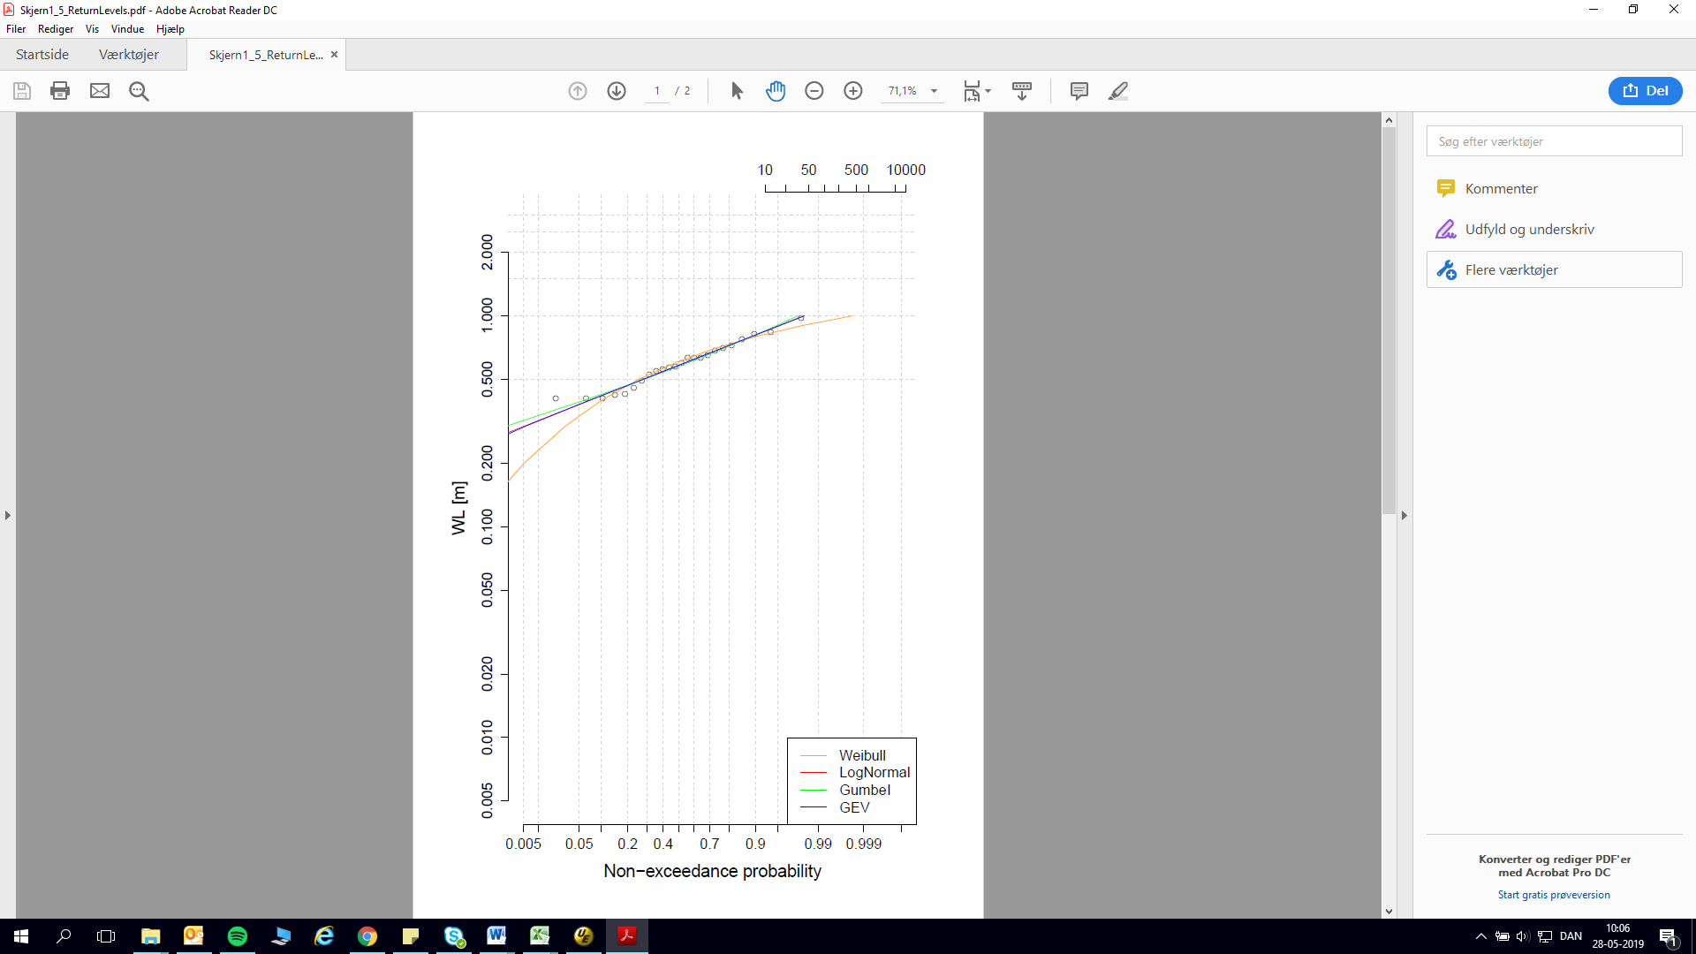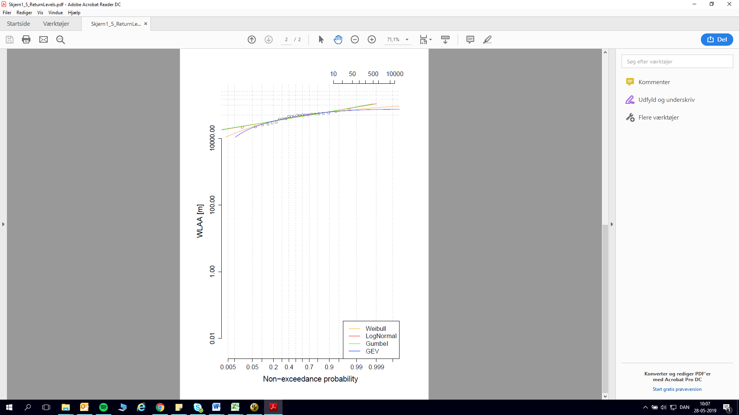
Figure 6 and Figure 7 SKAL UDSKIFTES MED RAGNHILD GRAFER

5.1.1.3 Copula Plot - VAR.1.SEA
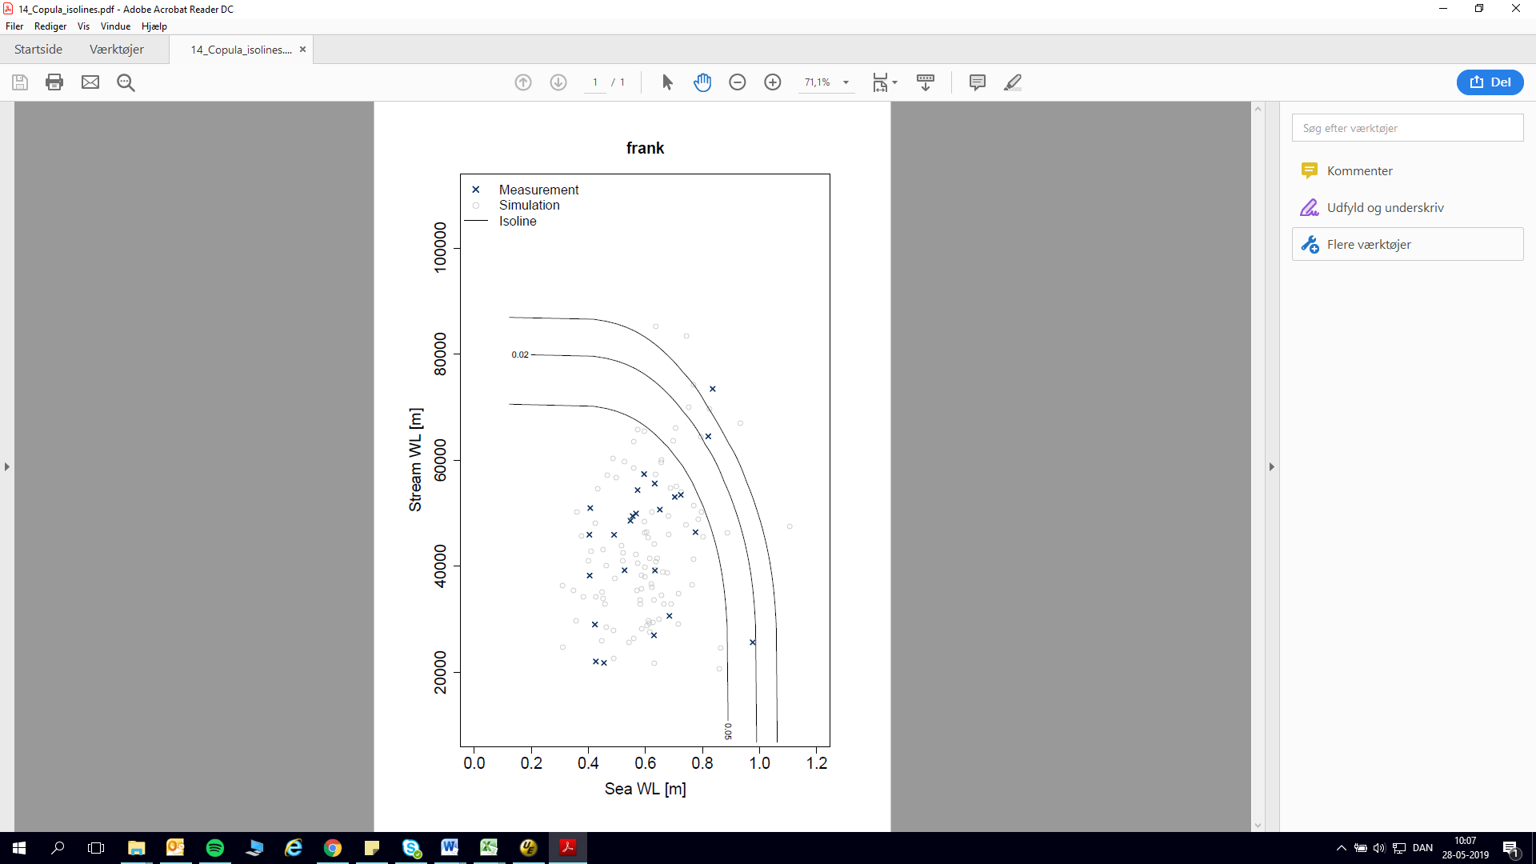
Figure 8
– RAGNHILD FIGUR?

5.1.2 Univariate Statistics - STREAM

5.1.2.1 Sample – UNI.STAT.STREAM
 | Date | Hydro. Year | Stream (l/s) |  | Date | Hydro. Year | Stream (l/s)
1 | 09-02-2006 04:00 | 2006 | 47992 | 14 | 22-04-2006 23:00 | 2006 | 46027
2 | 21-01-2007 22:00 | 2007 | 73439 | 15 | 13-12-2006 05:00 | 2007 | 70413
3 | 17-01-2008 18:00 | 2008 | 53170 | 16 | 14-03-2008 18:00 | 2008 | 51160
4 | 13-11-2008 17:00 | 2009 | 59256 | 17 | 28-10-2008 10:00 | 2009 | 57651
5 | 28-11-2009 20:00 | 2010 | 50726 | 18 | 25-11-2009 17:00 | 2010 | 49599
6 | 16-01-2011 20:00 | 2011 | 65909 | 19 | 10-01-2011 00:00 | 2011 | 64416
7 | 07-01-2012 02:00 | 2012 | 57900 | 20 | 24-02-2012 15:00 | 2012 | 51527
8 | 02-01-2013 16:00 | 2013 | 59774 | 21 | 04-11-2012 14:00 | 2013 | 58718
9 | 26-12-2013 07:00 | 2014 | 59673 | 22 | 11-01-2014 13:00 | 2014 | 58285
10 | 23-12-2014 23:00 | 2015 | 61555 | 23 | 10-01-2015 23:00 | 2015 | 56837
11 | 29-12-2015 00:00 | 2016 | 67940 | 24 | 07-12-2015 15:00 | 2016 | 67687
12 | 01-03-2017 17:00 | 2017 | 55742 | 25 | 22-11-2016 05:00 | 2017 | 50654
13 | 04-01-2018 21:00 | 2018 | 55162 | 26 | 26-01-2018 00:00 | 2018 | 50801
Table 7

5.1.2.2 Return Plot – UNI.STAT.STREAM
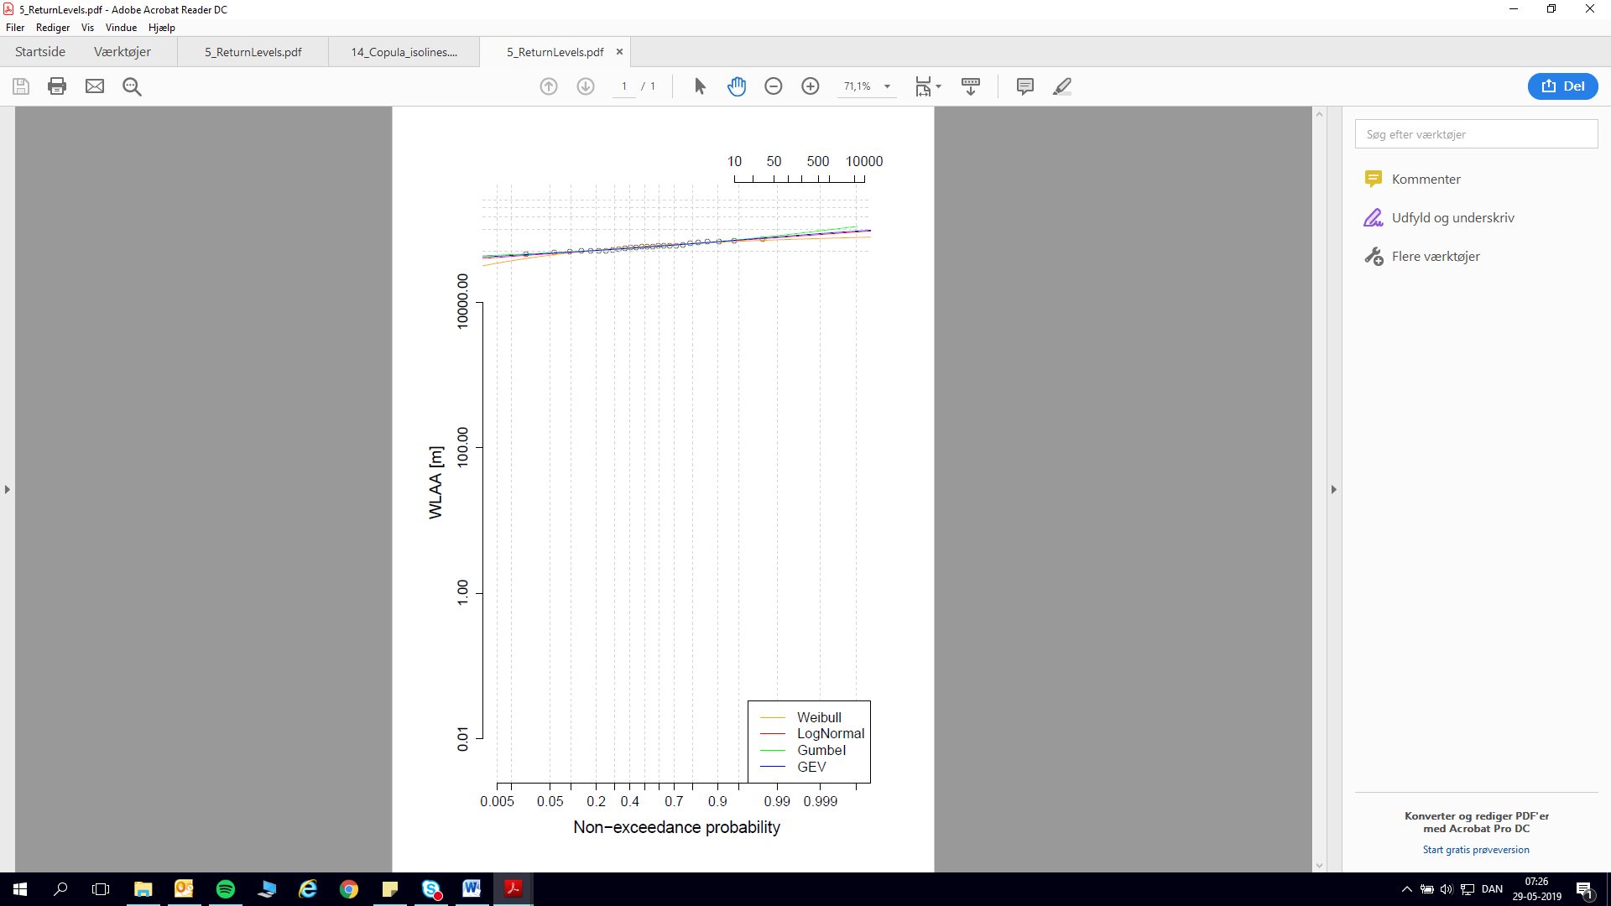
Figure 9

5.1.3 The Joint Probability Table for Skjern 1

Skjern Å | SEA (m) |  |  | STREAM (l/s)
 | MT20 | MT50 | MT100 | MT20 | MT50 | MT100
VAR.1.SEA | 0.92 | 1.02 | 1.09 | 73541 | 82858 | 89786
UNI.STAT.SEA/STREAM | 1.23 | 1.31 | 1.36 | 73034 | 76612 | 79139
Table 8 VAR.1.SEA are the bivariate statistics and UNI.STAT.SEA/STREAM is the univariate statistics.

5.2 Skjern 2 (No. 250082 Alergårde)

5.2.1 Bivariate statistics – SEA and STREAM

5.2.1.1 Sample - VAR.1.SEA

 | Date | Hydro. Year | Sea (m) | Stream (l/s) | Date |  | Hydro. Year | Sea (m) | Stream (l/s)
1 | 21-01-2005 01:00 | 2005 | 0.72 | 33357 | 13 | 13-01-2005 19:00 | 2005 | 0.65 | 29272
2 | 17-12-2005 00:00 | 2006 | 0.42 | 17573 | 14 | 15-11-2005 14:00 | 2006 | 0.40 | 21272
3 | 22-01-2007 06:00 | 2007 | 0.84 | 52670 | 15 | 12-01-2007 03:00 | 2007 | 0.82 | 43388
4 | 01-03-2008 13:00 | 2008 | 0.78 | 30424 | 16 | 09-11-2007 07:00 | 2008 | 0.68 | 17982
5 | 16-11-2008 17:00 | 2009 | 0.57 | 31523 | 17 | 20-11-2008 17:00 | 2009 | 0.55 | 27146
6 | 27-03-2010 19:00 | 2010 | 0.98 | 15841 | 18 | 18-11-2009 16:00 | 2010 | 0.53 | 23454
7 | 09-08-2011 23:00 | 2011 | 0.45 | 13757 | 19 | 07-02-2011 23:00 | 2011 | 0.40 | 28783
8 | 05-01-2012 16:00 | 2012 | 0.63 | 39343 | 20 | 31-03-2012 04:00 | 2012 | 0.63 | 17177
9 | 22-05-2013 11:00 | 2013 | 0.43 | 13255 | 21 | 07-11-2012 02:00 | 2013 | 0.41 | 31429
10 | 20-12-2014 15:00 | 2015 | 0.70 | 33911 | 22 | 01-04-2015 08:00 | 2015 | 0.56 | 32760
11 | 29-11-2015 21:00 | 2016 | 0.60 | 35907 | 23 | 04-12-2015 08:00 | 2016 | 0.57 | 28387
12 | 04-01-2017 05:00 | 2017 | 0.63 | 23200 | 24 | 26-12-2016 22:00 | 2017 | 0.49 | 26793
Table 9

5.2.1.2 Return Plots - VAR.1.SEA
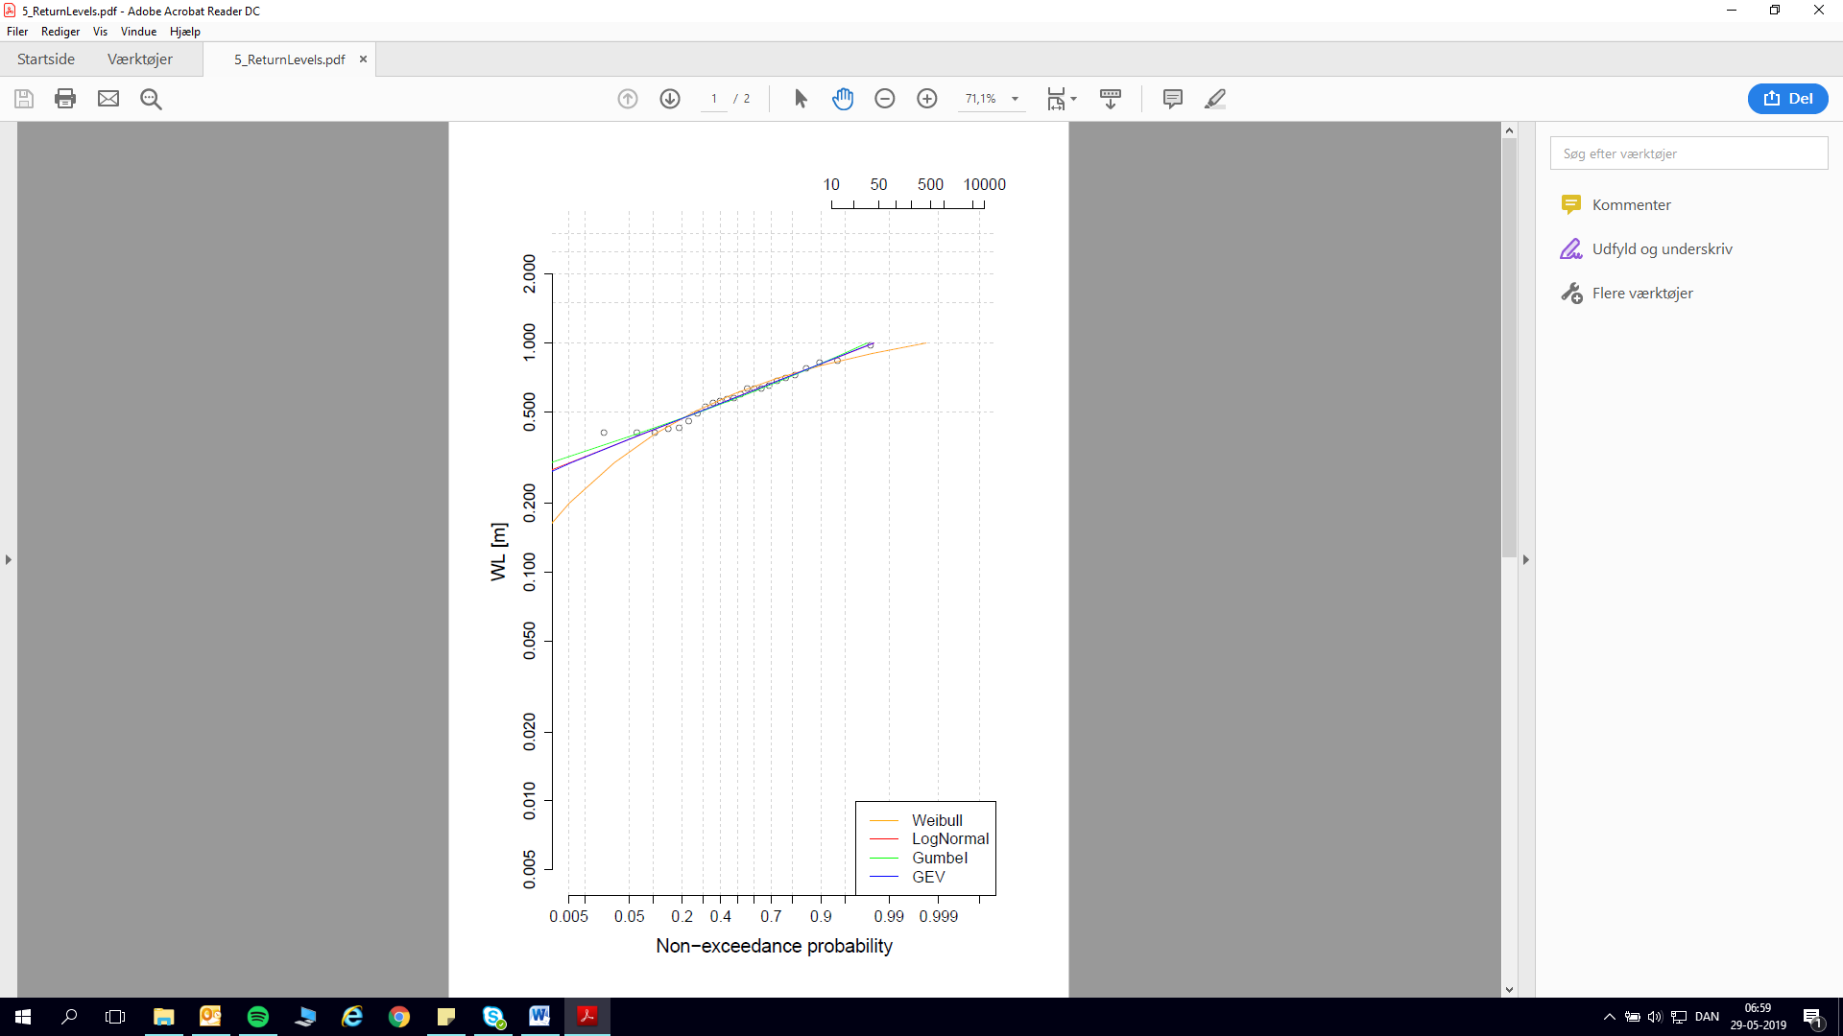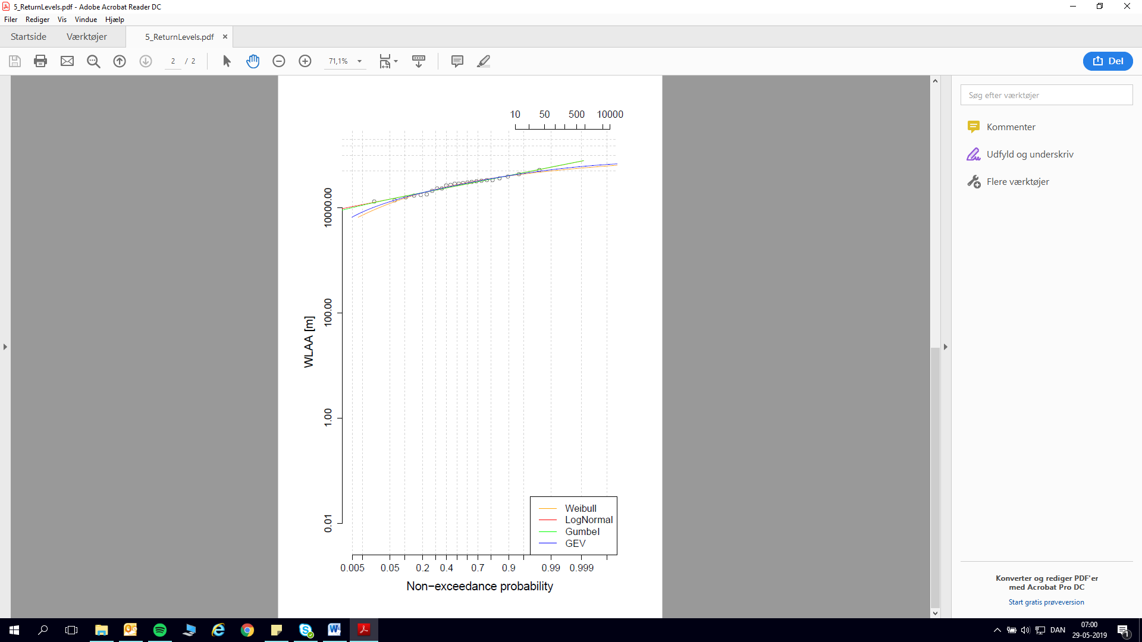
Figure 10 and Figure 11

5.2.1.3 Copula Plot - VAR.1.SEA
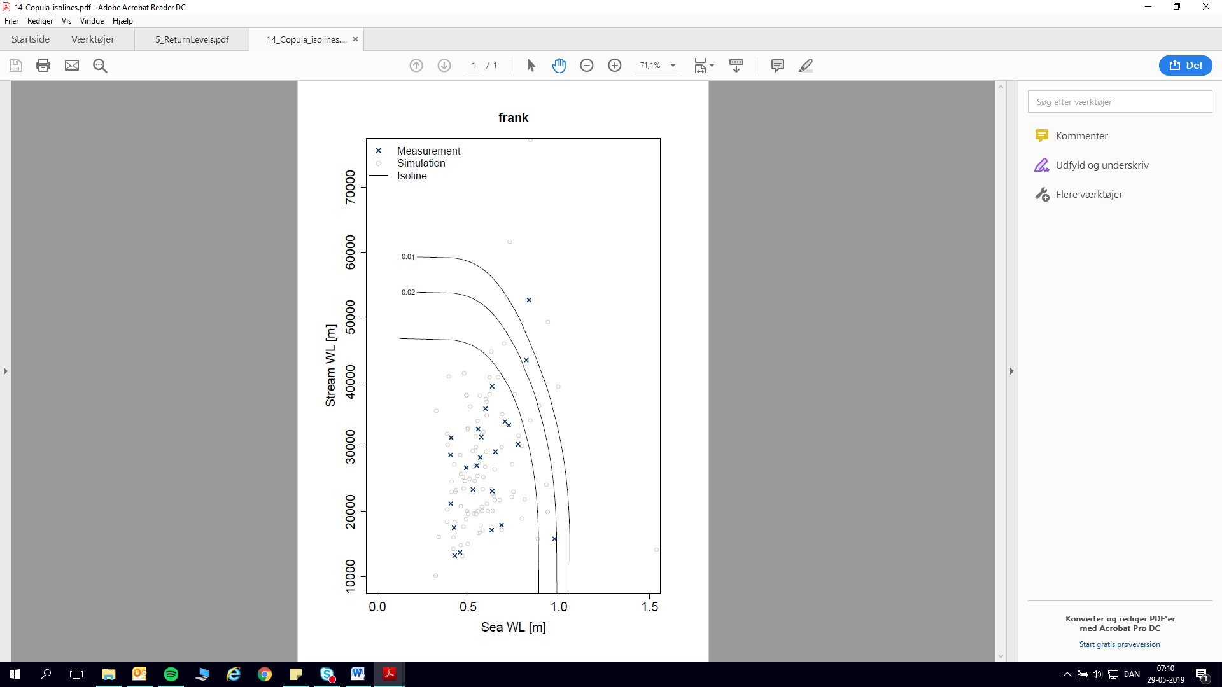
Figure 12

5.2.2 Univariate Statistics – STREAM

5.2.2.1 Sample – UNI.STAT.STREAM
 | Date | Hydro. Year | Stream (l/s) |  | Date | Hydro. Year | Stream (l/s)
1 | 21-01-2007 19:00 | 2007 | 52670 | 13 | 13-01-2007 09:00 | 2007 | 46267
2 | 17-01-2008 17:00 | 2008 | 40513 | 14 | 03-02-2008 02:00 | 2008 | 37845
3 | 28-10-2008 07:00 | 2009 | 40733 | 15 | 13-11-2008 21:00 | 2009 | 36303
4 | 28-11-2009 23:00 | 2010 | 34010 | 16 | 25-11-2009 12:00 | 2010 | 32489
5 | 16-01-2011 22:00 | 2011 | 50750 | 17 | 09-01-2011 20:00 | 2011 | 48201
6 | 06-01-2012 23:00 | 2012 | 41645 | 18 | 24-02-2012 16:00 | 2012 | 34281
7 | 02-01-2013 14:00 | 2013 | 42519 | 19 | 04-11-2012 12:00 | 2013 | 40308
8 | 26-12-2013 04:00 | 2014 | 44225 | 20 | 11-01-2014 15:00 | 2014 | 40919
9 | 23-12-2014 19:00 | 2015 | 44406 | 21 | 10-01-2015 23:00 | 2015 | 37830
10 | 28-12-2015 20:00 | 2016 | 54364 | 22 | 07-12-2015 15:00 | 2016 | 46682
11 | 01-03-2017 14:00 | 2017 | 37828 | 23 | 15-09-2017 05:00 | 2017 | 33091
12 | 04-01-2018 19:00 | 2018 | 42284 | 24 | 25-01-2018 18:00 | 2018 | 33906
Table 10

5.2.2.2 Return Plot – UNI.STAT.STREAM

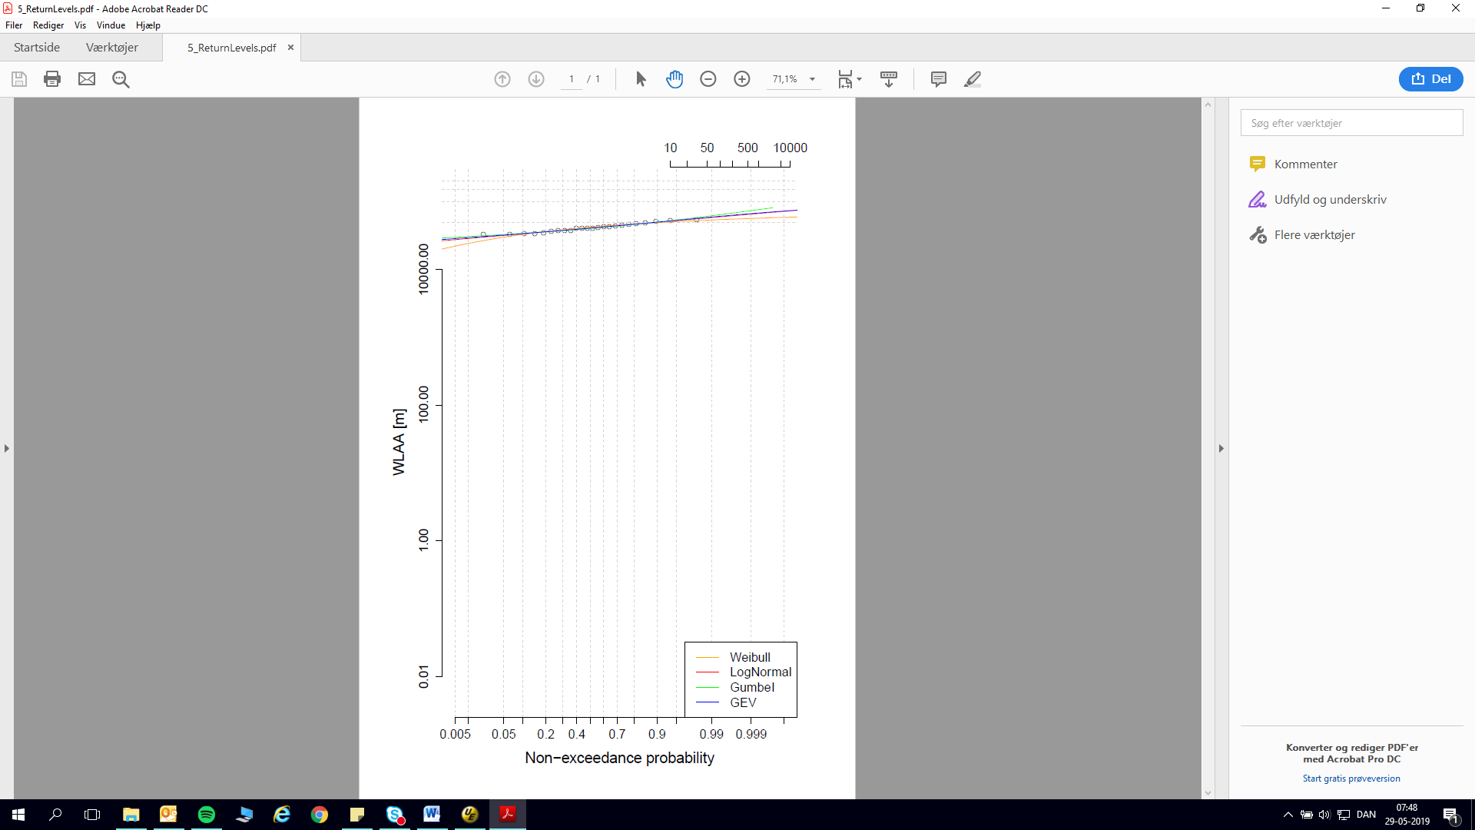
Figure 13

5.2.3 The Joint Probability Table for Skjern 2

Skjern Å | SEA (m) |  |  | STREAM (l/s)
 | MT20 | MT50 | MT100 | MT20 | MT50 | MT100
VAR.1.SEA | 0.92 | 1.02 | 1.09 | 48988 | 56183 | 61614
UNI.STAT.SEA/STREAM | 1.23 | 1.31 | 1.36 | 54418 | 57660 | 59963
Table 11

5.3 Return Period Combination Selection Methods

5.3.1 Skjern 1
Univariate SCALGO models.
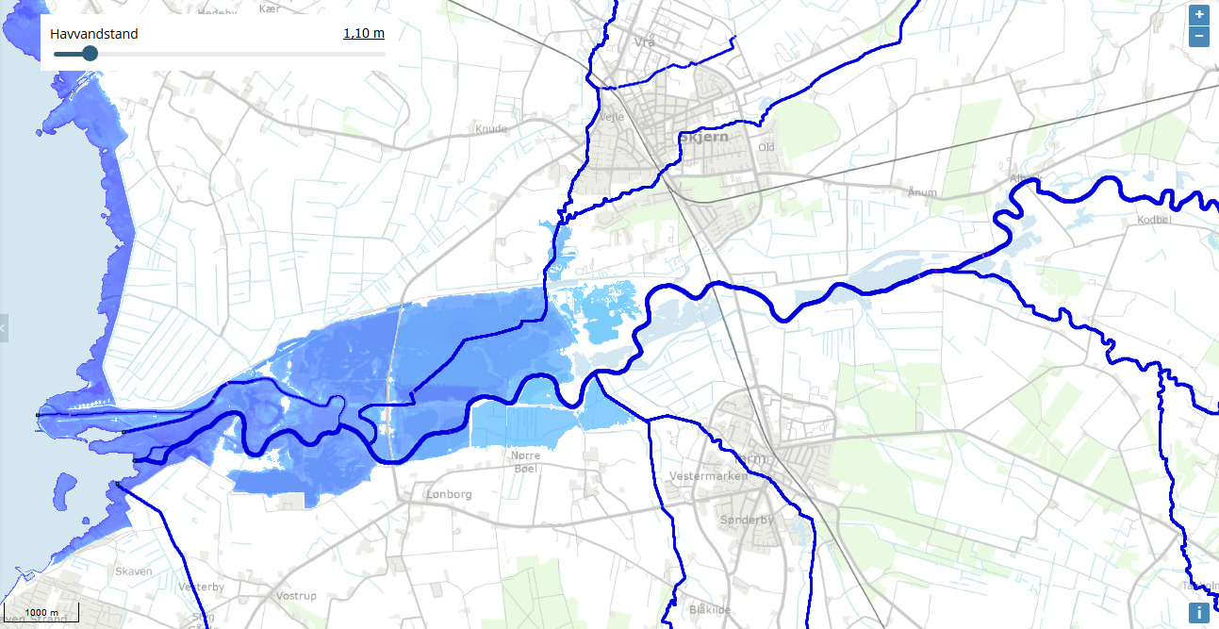
Figure 14 - Sea MT20 = 1.10 m

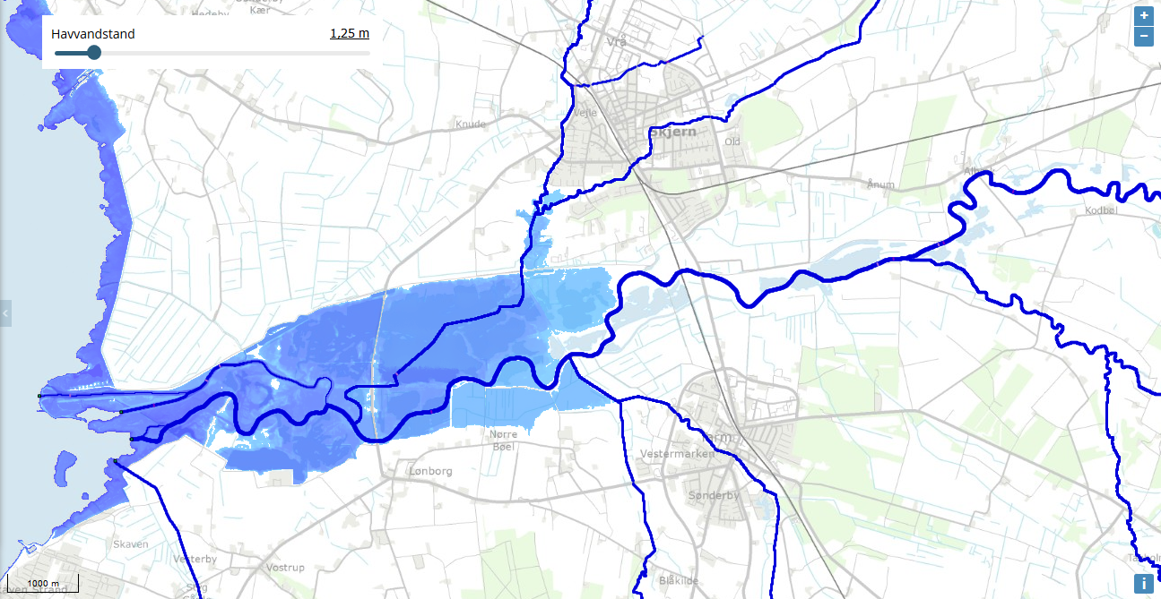
Figure 15 - Sea MT50 = 1.25 m
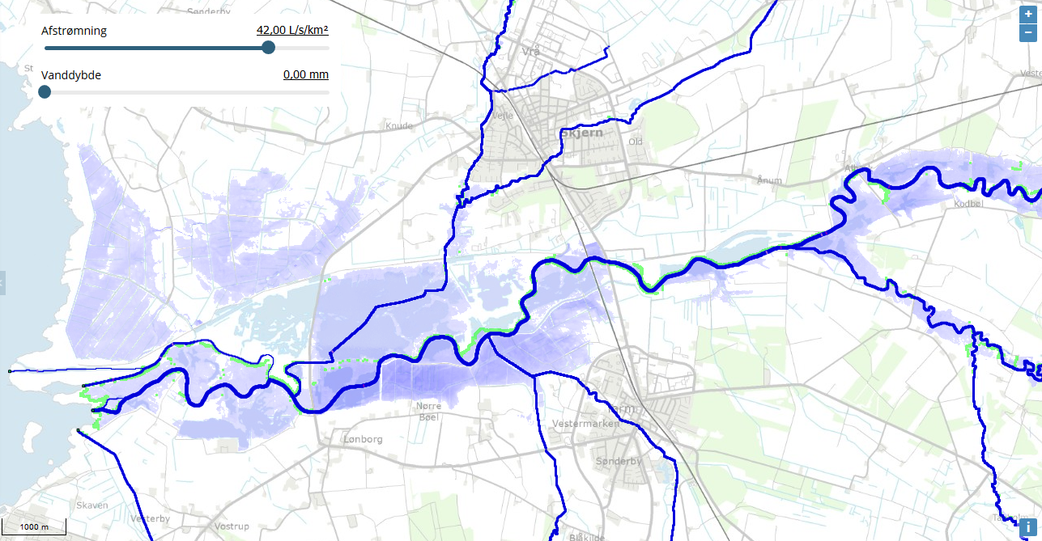
Figure 16 – Stream MT20 = 42 l/s/km²

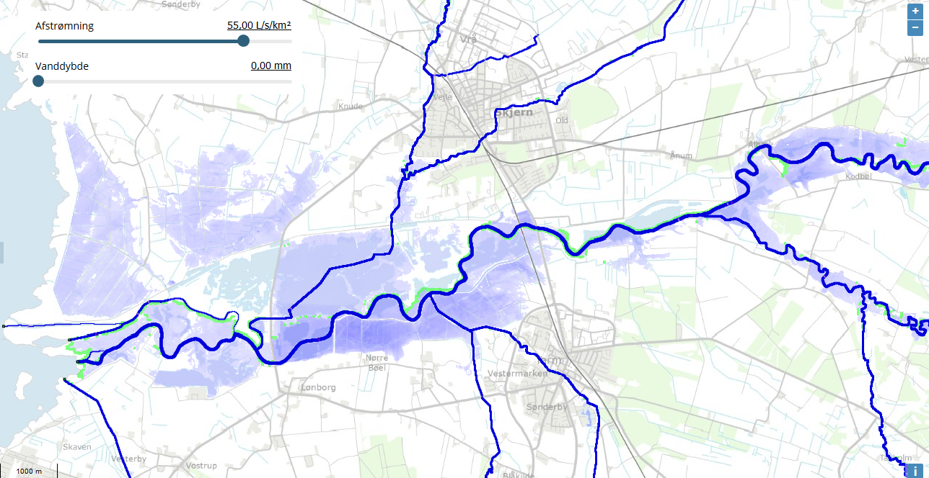
Figure 17 – Stream MT100 = 55 l/s/km²
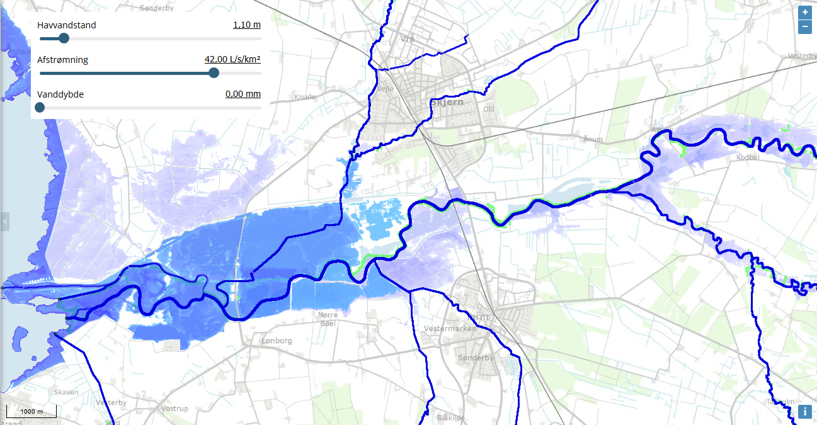
Figure 18 – Sea MT20 (1.10 m) and Stream MT20 (42 l/s/km²)

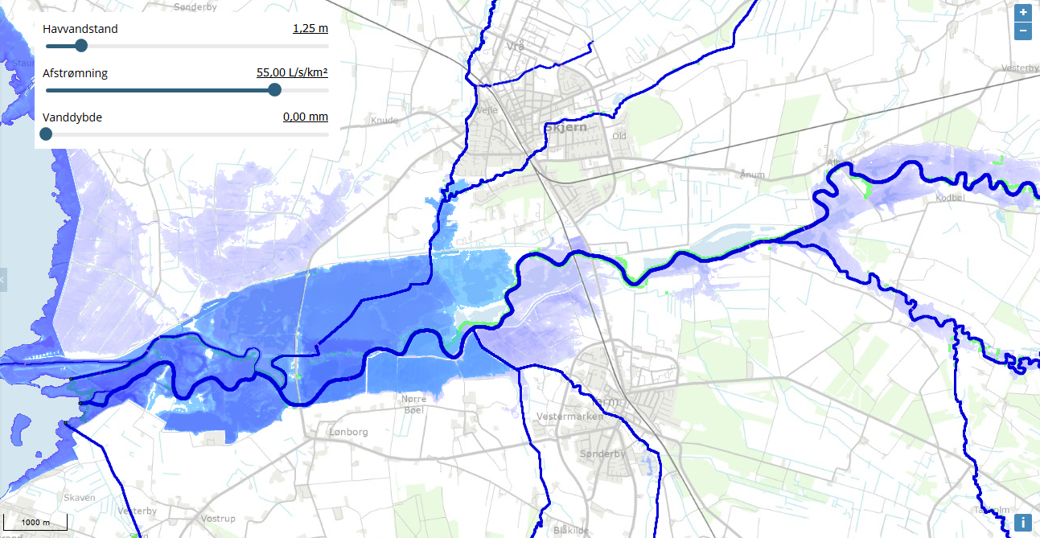
Figure 19 – Sea MT50 (1.25 m) and Stream MT100 (55 l/s/km²)

7. Discussion

7.1 Why is the UNI.STAT.STREAM value not larger than the stream data from VAR.1.SEA (Skjern 1)?
The results of the univariate and bivariate analysis show a different pattern than what has been seen in the previous two reports which have been the tendency in UNI.STAT.SEA/STREAM results having a higher return value than any VAR.1.SEA/STREAM analysis.

Figure 20
Figure 21
To try and find an answer to the strange tendency mentioned above, a simple comparison test was performed. In the test the statistics were calculated once more but this time both series were using the same data length. This means that the limited length of the bivariate statistics (VAR.1.SEA) is being used for the univariate statistics (UNI.STAT.STREAM) instead of the long full data series.
 |  | Skjern 1 (S1) |  | Skjern 2 (S2) |  | BORK SEA
 |  | From | Until | From | Until | From | Until
VAR.1.SEA data period  (yyyy-mm-dd hh:mm): |  | 2005-01-01 00:00 | 2017-09-13 13:00 | 2005-01-01 00:00 | 2017-09-13 13:00 | x | x
UNI.STAT.STREAM data period(yyyy-mm-dd hh:mm): |  | 2005-01-01 00:00 | 2019-01-09 09:00 | 2005-01-01 00:00 | 2019-04-09 09:00 | 1991-12-30 12:00 | 2017-09-13 13:00
Table 12

 |  | Original Calculations (O) [l/s] |  |  | New Calculations (N) [l/s]
 | Sampling Type | MT20 (O) | MT50 (O) | MT100 (O) | MT20 (N) | MT50 (N) | MT100 (N)
Skjern 1 (S1) | S1_VAR.1.SEA (stream)* | 73541 | 82858 | 89786 | 77972 | 87753 | 95073
 | S1_UNI.STAT.STREAM | 73034 | 76612 | 79139 | 75028 | 78608 | 81138
Skjern 2 (S2) | S2_VAR.1.SEA (stream)* | 48988 | 56183 | 61614 | 52111 | 59801 | 65650
 | S2_UNI.STAT.STREAM | 54418 | 57660 | 59963 | 55472 | 58753 | 61086
Table 13
Figure 22
Table 13 shows the results of the data length test. The original calculations (O) are shown to the left while the new calculations (N) are to the right. Figure 28 illustrates the same results just graphically. The analysis/test itself does not seem to produce an answer to the question as to why VAR.1.SEA (stream) statistical return values are bigger than UNI.STAT. return values. In fact, the tendency is very similar in both cases. This would imply that the answer is not with the data length or number of extremes but possibly with the use of the copula function in the joint probability calculations. IS THERE ANY WAY TO TEST THIS? – COPULA VS NO COPULA

7.2 Why should the return values be transformed into a new univariate return period?
There are two parts to that question:
a) Bias in the sample selection
When we calculate the bivariate return values the data pairs are chosen on account of the highest annual events (2 events) from the sea data. This means that high sea and a stream value of low to medium size is "covered". However, this sample selection does not allow us to see a combination of high stream - medium sea. In the second report (A Joint Probability Analysis of Konge Å and Ribe Å) we analyzed different sampling methods and found that sea data is the more sensitive variable and should therefore be kept as the first variable (VAR.1.SEA). But as we decide to keep the sea as the first variable we also know that the stream data is underestimated. See table XX and XX for comparison between the bivariate and univariate results. In an attempt to balance out the underestimation this transformation is suggested. This means: a return value of 100 from a bivariate analysis MT20 is equal to a value of 120 in a univariate (same MT20), then the calibrated new bivariate return value of 100 now corresponds to a MT18.
MT | Bivariate water level (m) | Univariate Water level (m) | New transformed MT
20 | 100 | 120 | 16
Table 14 shows an example of how a MT20 return period is transformation into a MT16 return period.
b) Data length
The second reason for the need to find a way to balance out data has to do with the length of the data series. Take Bork harbors data for example:
Data | Sea: 2005-2017 | Sea: 2000-2017
MT (yrs) | Bivariate (m) | Univariate (m)
20 | 0.92 | 1.23
50 | 1.02 | 1.31
100 | 1.09 | 1.36
Table 15 OBS BEREGN UNISTAT SELV OG SE FORHOLD! HUSK HVS17 SAMPLE (POT) MENS VORES ER (BM)

Table XX show exactly how different the statistics become when a data series is shorten. But why are the data series not the same length? That is because of the need for overlap between the two sources in the bivariate analysis. The univariate analysis has approximately 5 more years of data (2000-2005), which changes the return value for a 20 years return period (MT20) from 0.92 m into 1.23 m, a difference of 31 cm!

7.3 The SCALGO Tool Performance
The tool/model should only be used for the opportunity to perform a visual check before a more advanced hydrological model is used. The primary goal is to find a way to easily decide which combinations (sea and stream events) to model. Depending on what purpose the model is serving the choice of combinations should vary.
The analyses tool cannot combine the sea water and the stream water analyses, which would have been ideal. Because only one analysis can be reviewed at a time (i.e. figure 14 and 16), the best option would be to make a map with the two analyses on top of each other (figure 18). This does not show a combined event, only the two sources individual flood extent. It can then be assumed that the extent of both analyses plotted is a minimum flood extent. This would imply that the screening would underestimate the combined flood extent.
Another limitation is that the tool does not specify or restrain the data input making it problematic to determine whether the data from Bork Harbor is representative for the region. Any analysis performed on Bork Harbor data should only contain specifics on the southern part of Ringkøbing Fjord. For any analysis on the northern part of the fjord should be based on Ringkøbing Harbor data. Should there be an interest in analyzing what happens during a "break of" the dikes, then the data from Hvide Sande harbor should be used. As mentioned in the beginning of the report the largest event size was measured in 1981 and was at a level of 3.59 m (DVR90). If one enters a water level of such size a significant amount of land east of the fjord is flooded, however it is recommended to evaluate whether a water level of that particulate size is realistic - since that would mean that the whole fjord would have to have a similar water level. Using simple hydrological models as this caution is advised. The model will in most cases overestimate the flood extent (because there is no time dimension) from the sea as well as overestimate the stream water Q in areas where stream and sea collides.

7.4 Modeling Options – MIKE
Because the SCALGO tool does not show the combined event flood extent another visualization tool is needed. Therefore the advanced MIKE model is taken into account. If it is possible then the MIKE model will be used to identify weaknesses and strengths in the SCALGO tool. The main problem with the SCALGO tool (in case of a combined event) is that the validity of the flood extent is impossible to verify. For this reason we recommend to compare a good hydrological model with the screening model and check for unreliable results. The purpose of the screenings tool is to prevent unnecessary modeling in the time consuming advanced hydrological models. However, without a review of the screening tool there is very little guarantying that the results are representative of a real life combined event scenario.

8. Conclusion

9. Suggested Work
- Further studies on how to implement more sources also which parameters to pay close attention to when performing a statistical multivariate analysis is advised. This can be done by testing the change in extent (%) between different MT intervals and then finding the point of tipping (in regard to sensitivity). The close parameters should be examined closely. They will vary from one location to another but the classical (data series length, marginal distribution function and copula) should be ranked high.
- An analysis of the SCALGO tool in regard to the MIKE model would be beneficial, even necessary to be able to use the screening tool for any combined event analyses.
- MORE?

9. References

Binderup, J. (29.. November 2015). Tv2. Hentede 17.. Oktober 2016 fra Gorm går i land i Hvide Sande: Store oversvømmelser truer cafeer: http://nyheder.tv2.dk/2015-11-29-gorm-gaar-i-land-i-hvide-sande-store-oversvoemmelser-truer-cafeer
Johannesen, E. (1993). Danmark rundt langs kysterne. Gylling: Narayana Press.
Kjærsgaard, K. (25.. Januar 2016). BORK: To oversvømmelser på fem år . Ugeavisen.dk, s. 1.
Naturstyrelsen. (2016). LIFE sårbar natur langs vestkysten. Hentede 13.10.2016. Oktober 2016 fra Miljø- og Fødevareministeriet: http://naturstyrelsen.dk/naturbeskyttelse/naturprojekter/life-saarbar-natur-langs-vestkysten/
Realdania By & Byg. (2016). Klimatilpasning i byudvikling – Fem løsninger med merværdi for byen. København V: Realdania By & Byg.
Ringkøbing -Skjern kommune. (19.. juni 2012). Handleplan 2011-2015 for klimatilpasning. Hentede 17.. Oktober 2016 fra Klimatilpasning.dk: http://www.klimatilpasning.dk/media/817172/ringk_bing-skjern.pdf
Ringkøbing Skjern kommune. (29.. Marts 2016). Naturens Rige - Ringkøbing-Skjern kommune. Hentede 13.. Oktober 2016 fra Referat: 29. marts 2016 kl. 14:00: http://www.rksk.dk/om-kommunen/politiske-udvalg/teknik--og-miljoeudvalget/dag-ref-teknik--og-miljoeudvalget?AgendaID=1128#54233c23-6866-4aa5-bb55-b4916a907e47
Stormrådet. (2009). Stormflods skadestatistik - maj 2009. Stormrådet .
Danish Meteorological Institute (1991). Stormfloder. Ib Gram-Jensen

Hej,
Jeg har nu læst rapporten. Det hele ser virkelig godt ud. Jeg synes, at du er begyndt at skrive meget mere fokuseret og effektiv!
- Den 1. kapitel, med systembeskrivelsen, mener jeg ikke at vi skal bekymre os om. Jeg tænker faktisk at vi kan skrive systembeskrivelsen pænt og udgive den som selvstændig dokument og henvise til den i den nuværende rapport. Hvad synes du? FINT MED MIG (Bare det ikke bliver min opgave)
- Mht. diskussionen. Jeg mener, du har nogle gode point, og at du skal nu bruge tiden på at designe nogle tests for at udelukke nogle af de hypoteser ved 7.1 (som du selv nævner) – Vi kan teste uni.stat. med bi.stat. data længde!
- Virkelig god ide med at vise usikkerheden i en tabel
Og nogle andre kommentarer:
- Du laver et virkelig godt arbejde med det her!
- Har du brug for, at vi kigger på/tilpasser scriptsene? Har du brug for flere værktøj? Det kan enten være i R, Excel eller MatLab. Hvis du har nogle ideer eller ønsker, begynd gerne at notere hvad et nyt værktøj skal kunne.

