A Joint Probability Analysis in Skjern Å (Ringkøbing Fjord?)

1. Introduction 1

2. Location 2

2.1 Hinterland 4

2.2 Historical floods 6

3. Data Foundation 8

3.1 Ringkøbing Fjord 8

3.1.1 Bork Harbor 8

3.1.2 Ringkøbing Harbor 8

3.1.3 Hvide Sande Harbor 8

3.2 Skjern Å 9

3.2.1 Skjern 1 (No. 250097 Gjaldbæk Bro) 9

3.2.2 Skjern 2 (No. 250082 Alergårde) 9

References 11

1. Introduction
2. Location
3. Data Foundation
   1. Ringkøbing Fjord
      1. Bork Harbor
      2. Hvide Sande Harbor
   2. Skjern Å
      1. Skjern 1 No. 250097 Gjaldbæk Bro
      2. Skjern 2 No. 250082 Alergårde
4. Results
   1. Bivariate Statistical Analysis - Sea Water Level at Bork Harbor and Water Flow in Skjern Å
5. Return Period Combination Selection Methods
6. Discussion
   1. Choosing Return Period Combinations based on SCALGO and GIS analyses
7. Conclusion
8. Suggested Work

# 1. Introduction

A flood caused by one source (e.g. from a storm surge) is understood and in most cases protective structures are put into place to prevent a flood in a given area, however handling flooding from two or more sources can be abstract and difficult to handle. That is why The Danish Coastal Authority aim to develop a tool for cities/municipals to use so that they may get a better picture of how a flood would look like (flood extent) when e.g. a storm surge results in high/extreme water level in the sea and a long precipitation ultimately leading to more water flow in the streams occurs simultaneously.

This report is the third in a series of reports meant to create, evaluate and improve a method for finding the joint probability of flood sources colliding. The project FAIR and the EU’s Flood Directive aims to reduce the risk of flooding.

The first report *The Joint Probability Method Report, DCA 2019* introduces the statistical method and identifies some weaknesses in the method. In the second report *A Joint Probability Analysis in Konge Å and Ribe Å*, *DCA 2019* the weaknesses are analyzed and the best method is found. This report analæyse3s the complications in determining which combinations of events (in Sea and Stream respectively) to take into a hydrological model. It also provides suggestions as to how to determine which events to combine to find the largest flood extent.

This report provides 1) A joint probability analysis of Ringkøbing Fjord (sea) and Skjern Å (stream) and 2) The expected issues with the sluice and other flood protection constructions that will arise with changing climate, over time.

2. Location

Ringkøbing Fjord - MIE’S SYSTEMBESKRIVELSE

Ringkøbing fjord is located on the Danish North Sea coast, which can be seen on map 1. This area has been chosen as one of two pilot sites for the Danish Coastal Authority’s contribution to the InterReg project FAIR. Some of the rationalizations for selecting the area of Ringkøbing fjord are the need for upgrading worn-out flood infrastructure, the ongoing urban development in flood prone areas and the in effect grade II listed nature in flood prone areas. These challenges make for an interesting pilot site where different aspects are necessary to consider when handling flood infrastructure asset management.

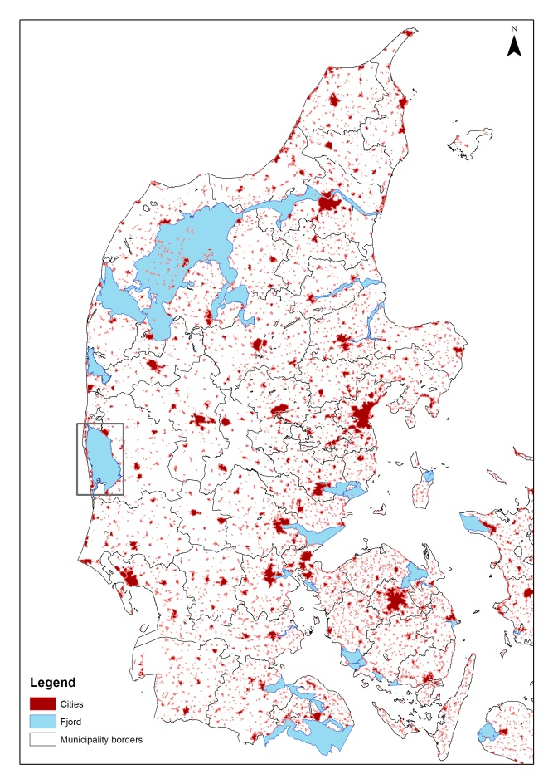

Map X: Project area Ringkøbing fjord

Ringkøbing Fjord is 30 km long and approximately 10 to 12 km wide with a water area of 290 km2 (+0,1DVR). The average depth of water is 1.8 meter and at a water level of 0.1 m DVR the water volume is 560 million m3. The catchment to Ringkøbing Fjord is 3.470 km2 and daily runoff to the fjord is between 2 and 12 million m3.

The possible flooding sources in this pilot are water from the ocean, from Ringkøbing fjord and from surface runoff to Ringkøbing fjord from the water basin. Additional possible flood sources include groundwater and torrential rain. In this pilot the potential source of flooding that will be operated with is primarily the fjord due to storm and surface runoff. The flood threat from the sea will be managed through supervision of dune safety and corresponding nourishment activities. Hvide Sande has a dewatering sluice that is 120 m long and 24 m wide with 14 openings. Every opening is 6.25 m wide with a depth of 4.1 m DVR. One of the main causes for floods is sluice practice during high water level. This results in flooding of the fjord and creeks given that it is impossible for the water at high level to run-off to the sea. The water is instead gathered along the creeks and an overflowing of the low-lying areas occurs. A local phenomenon that occurs is when the fjord tilt during a combination of a longer period with the sluicegates closed, wind from west and increased run-off from the water basin to the fjord. If the wind changes direction from west to north-west the water is pressed to the southern part of the fjord where the city Bork is located. The city experience floods due to this occurrence. In the future the municipality is expecting to have increasing challenges with percolating of rain, wastewater and general discharge of rain in creeks, which is not focused on in this project.

Some places along the fjord minor dikes protect low-lying farmland and plains. The dikes in the northern part of Ringkøbing Fjord are at 1.40 DVR and the dikes at the southern side are 1.70 DVR. Furthermore, the sand dunes along the coast near Hvide Sande have been enhanced over several occasions to maintain a safety level against coastal erosion and a breach.   
 In the future larger areas around the fjord will be flood prone, including areas located behind existing dikes. Sea level rise equals shorter periods for dewatering through the sluice resulting in more frequent high water situations and difficulties in the fjord. Also higher levels of discharge from nearby creeks due to a changing climate could become problematic. Those two combined are expected to result in more frequent floods in the area, which will be examined further in the project. Furthermore, the municipality has struggled with pollution in the fjord so it was decided to decrease the pollution by letting in saltwater from the sea to blend with the fresh water in the fjord. This has affected the salinity in the fjord as well as the water temperature and quality. The sluice is not only currently used to regulate water level but also quality. This may affect the lifespan of the sluice. Also, challenges occur if the sluice in the future has to be closed over longer periods of time due to high water level in the ocean because the water quality then changes. It is necessary that the fresh water is mixed with sea water during stormy weather to prevent pollution affecting the fjord.

## 2.1 Hinterland

The landscape is considerably made up of heaths, which was created during the last ice age by meltwater. Extensive dune areas are along the west coast of the fjord and furthest west marine sediments exist. Skjern stream is a prominent feature in the landscape. The soil in the catchment is dominantly sand and coarse soil. Around Ringkøbing Fjord large reclaimed areas are being dewatered for agricultural purposes (Styrelsen for Vand- og Naturforvaltning, 2015). Ringkøbing Fjord is located in the mid-western part of Denmark. The fjord has a large supply of freshwater with a catchment of around 8 % of the areal of Denmark. Almost 70% of the freshwater is supplemented through Skjern Stream and 15% through Vonå. Several cities of varying sizes are situated by the fjord. Hvide Sande is a minor town sited in the middle of the barrier island heading the North Sea. Currently 3059 people inhabit the city. Furthermore, larger cities like Ringkøbing with 9890 habitants, Søndervig with around 5000 inhabitants in the summer season and Bork with 430 inhabitants are also located within the project area. Here around 600 vacation homes are within a drainage guild. One of the main assets of this pilot site, a dewatering sluice, is located in Hvide Sande.

Holmslands Klit, where Hvide Sande is located, is a spit that has grown in front of an earlier bay at the coast. The spit is built completely of rock and sand, which the waves have washed up. Afterwards the wind has blown the sand in dune formations. The sluice is located at the middle of the spit where it since 1931 has regulated the water level and salinity in Ringkøbing fjord. It is predicted by the DCA that the current sluice practise is sufficient till 2100 under normal weather conditions and the existing climate change scenarios. The infrastructure is however in need of upgrading or renovation to withstand the challenges in the future. It is predicted that the sluice is required to be multifunctional to meet the future requirements.

The western shore of the fjord is mainly low lying salt marshes. Reed beds have spread along the shores of the fjord after the installation of the sluice. Previously the fjord was connected with Stadil fjord and Vest Stadil fjord but due to a dewatering project where land was drained for agriculture they are no longer linked. (Johannesen, 1993)   
 Low lying infrastructure is at risk of flooding as well as residential activities along the fjord shores. Part of the harbour in Hvide Sande is also located within the flood zone. If a breach of a dike occurs along the fjord shore or if they are overflowed then farmland will be flooded. Primarily livelihood is based on fishing activity and agriculture. A somewhat smaller fishing and offshore harbour is situated in the town of Hvide Sande. There are also non-residential housing and income from tourists. Some of the attractions are a cable park and fishing activities located by the waterfront.

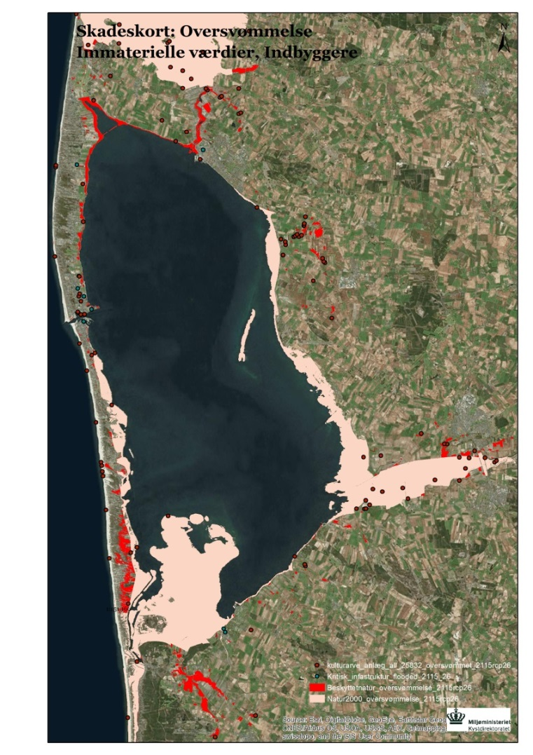

Figure X: Extent of damage from flooding.

Two cities that are often flooded during storm are Ringkøbing and Hvide Sande. On map XX and xx the land use of the two places are depicted. These areas as well as the protected nature benefit from flood protection. Furthermore, tourism and infrastructure such as roads are also protected by flood installments.

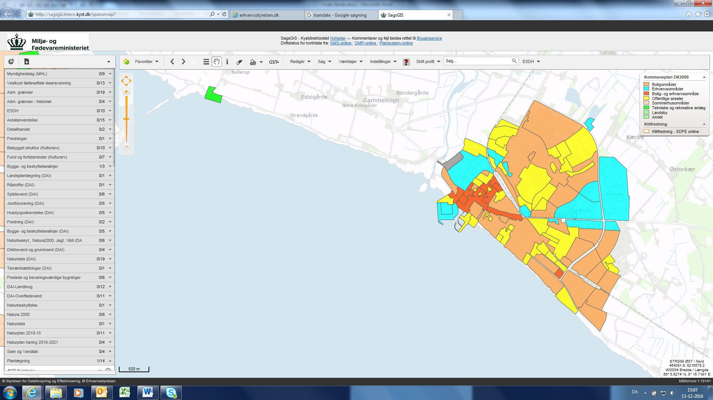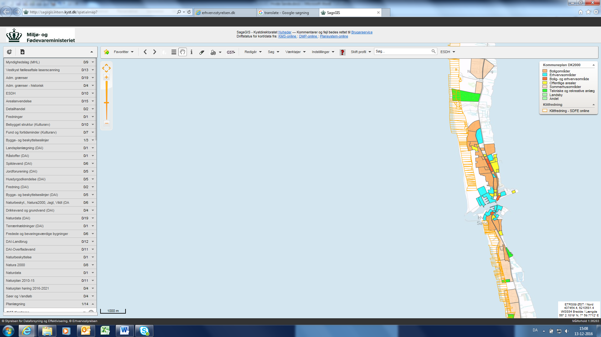

Figure X: Land-use for Ringkøbing left and for Hvide Sande right where orange is residential areas, yellow is public areas, blue is industrial areas and red is a mix of residential and industry.

It is a wide range of activities and infrastructure that are currently and will in the future benefit from flood protection infrastructure.

## 2.2 Historical floods

Problems with floods in the eastern part of the fjord have occurred, in particular in the winter months, because the water is stowed at the smaller creeks outlet to the fjord (Ringkøbing -Skjern kommune, 2012). Incidents with extreme water levels occurs as a combination of increased discharge from the inland creeks due to melting snow or heavy rain and sluice gates closed due to high sea water level or longer periods with no possibility for discharge of the fjord. With raising water levels in the fjord and a storm from west floods is the result in particular in the cities of Ringkøbing and Bork (Ringkøbing -Skjern kommune, 2012).

A report on historical storm floods in Denmark up until 1981 has been prepared by DMI and it was gathered that a few storm floods have been recorded in the area of Ringkøbing fjord. In 1807 a larger storm flood hit Hovvig just north of Søndervig and a breach of the dunes occurred. In 1928 another storm flood hit Ringkøbing harbor as well as floods along the fjord. In 1936 the first dune row at Søndervig was breached as well as flooding in Hvide Sande at 2.50 m over DNN. A similar storm flood occurred in 1973 with flooding of the harbor in Hvide Sande at 2.50 m above DNN and significant damage of the dunes. Lastly a very large storm flood hit in 1981 with water at 3.58 m DNN in Hvide Sande (DMI, stormfloder, 1991).Several more recent storm floods have hit Ringkøbing fjord and the storm council have records from 1991-2009 on floods they deem to be of the category storm floods. Four floods occurred in that time span; 25.01.1993, 03.12.1999, 29.01.2000 and 08.01.2005. The two first storm floods only hit the southern part of Ringkøbing fjord whereas the last two affected the entire fjord (Stormrådet, 2009). The storm Gorm hit Denmark November 29th 2015 and went ashore in Hvide Sande and the Ringkøbing fjord area first. The storm is described as having almost lifted Ringkøbing fjord allowing water to run in the streets of Hvide Sande and Bork. In both locations the harbor is particularly exposed and is traditionally affected during a storm. (Binderup, 2015) (Kjærsgaard, 2016)

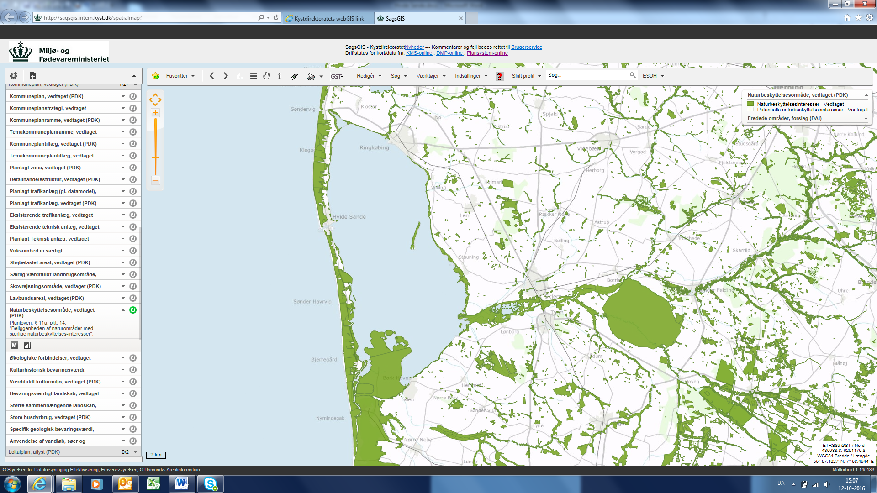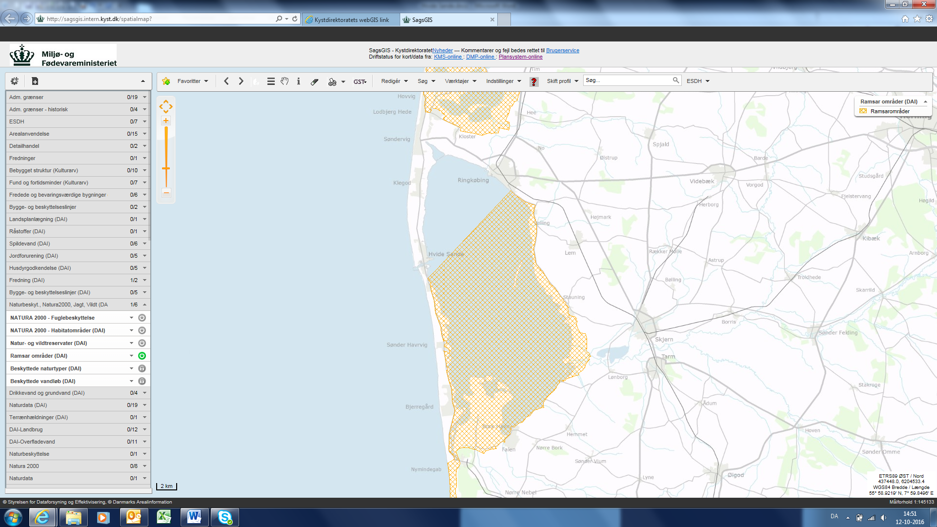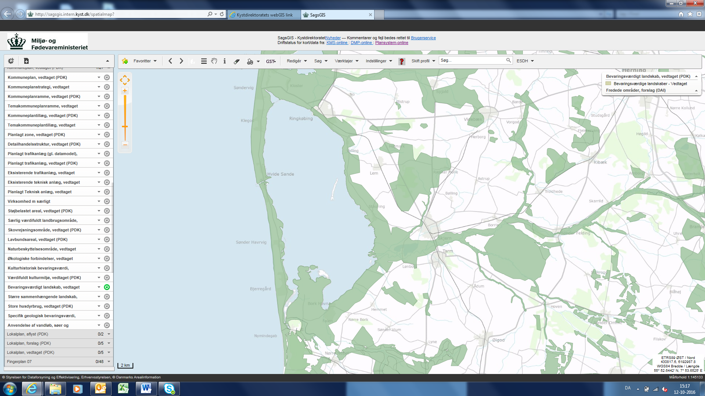

Figure X: Nature conservation interests. Map X: Ramsar area. The Natura2000 protected areas cover the same stretch of the fjord. Figure 6: Preserving worthy landscapes.

The first project around Ringkøbing Fjord that will combine flood protection and tourism is the pumping station at “KRAFT”. The pumping station will be encased in glass to function as a showcase for the mechanics of such pumps. None other projects in this area have combined flood protection with other functions. However, the municipality intends to incorporate different features in flood protection in future projects to enhance the value of these projects for the society.

In Ringkøbing Fjord there are several urban communities such as Ringkøbing, Hvide Sande, Søndervig and Bork that are all threatened by floods. It is therefore highly likely that the sluice will require improvements to become multifunctional. It is expected that the sluice need to be able to pump water from the fjord to the sea.

There are currently some challenges with the interaction between agriculture and fishing interests.

Around 7.5% of the land in the municipality is artificially drained by pumps. Some of this area contains agricultural land, vacation homes and also newer development is planned within the drained areas. Some of the vacation homes are in elevation 0 and in Rødklit new lots are being developed despite the flood risk due to need of constant pumping of water. These drainage guilds and the pumps are not owned by the municipality but privately owned. Therefore the upkeep and maintenance of the pumps are the responsibility of the owners and the majority of the pumping stations require repairs to function fully.  
The municipality express that their largest challenge with flood protection is Ringkøbing and the vacation homes areas.

# 3. Data Foundation

The data used for the analysis is collected from Ringkøbing Fjord and Skjern (Å?) stream.

## 3.1 Ringkøbing Fjord

There are two fjord harbors in Ringkøbing Fjord: Ringkøbing Harbor (north) and Bork Harbor (south). Between the Sea and Ringkøbing Fjord is Hvide Sande. Hvide Sande has a water level measuring instrument on the sea-side of the sluice. The sluice is typically closed when the water level in the sea is higher than the water level in the Fjord. The highest recorded event water level in Hvide Sande is 359 cm (in 1981) for Ringkøbing harbor it is 119 cm (in 1981) and for Bork it is 142 cm (in 1999).

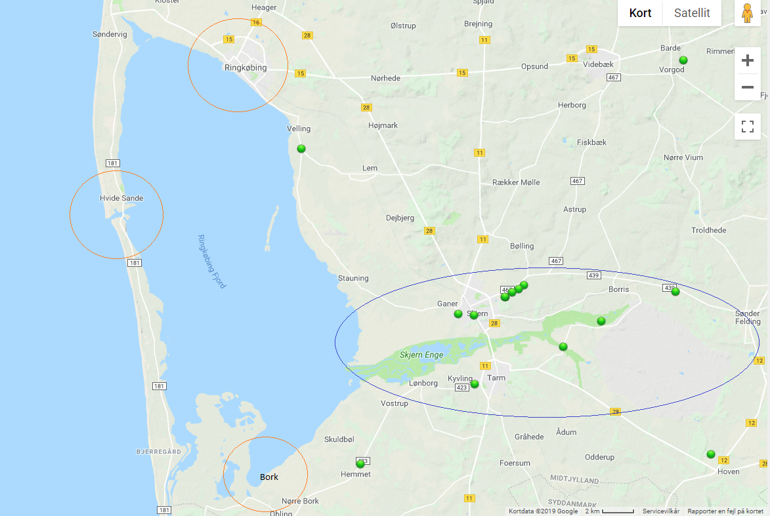  
Figure XX shows where the harbors and the streams are located.

### 3.1.1 Bork Harbor

Data from Bork Harbor runs from 01.01.2000 (dd.mm.yyyy) until 13.09.2017 with approximately 44 years of data. There are some removal of outliers resulting in a little shorter data available than the full measuring period.

### 3.1.2 Ringkøbing Harbor

Data from Ringkøbing Harbor runs from 01.01.1971 (dd.mm.yyyy) until 13.09.2017 with approximately 46 years of data. There are some removal of outliers resulting in a little shorter data available than the full measuring period.

### 3.1.3 Hvide Sande Harbor

Data from Hvide Sande is available from 06.12.1931 (dd.mm.yyyy) until 12.01.2017 with approximately 85 years of data. There are some removal of outliers resulting in a little shorter data available than the full measuring period.

## 3.2 Skjern Å

Below in table X and X are shown the following: minimum/maximum flow (l/s) and catchment size (km2).

### 3.2.1 Skjern 1 (No. 250097 Gjaldbæk Bro)

|  |  |  |  |  |
| --- | --- | --- | --- | --- |
| Data period: 01.01.2005 – 01.01.2019 | | | | |
| Date | **Maximum Flow (l/s)** | **Date** | **Minimum Flow (l/s)** | **Catchment size (km2)** |
| 21.01.2007 | 71053 | 02.11.2005 | 10018 | 1450 |

Table X

### 3.2.2 Skjern 2 (No. 250082 Alergårde)

|  |  |  |  |  |
| --- | --- | --- | --- | --- |
| Data period: 01.01.2005 – 01.04.2019 | | | | |
| Date | **Maximum Flow (l/s)** | **Date** | **Minimum Flow (l/s)** | **Catchment size (km2)** |
| 28.12.2015 | 54079 | 23.03.2005 | 4894 | 970 |

Table X

# 4. Return Period Combination Selection Methods

In the previous two reports (*The Joint Probability Method Report* and *A Joint Probability Analysis in Konge Å and Ribe Å*) it is mentioned that the statistics alone do not provide a visual understanding of the flood extent. One of the key tasks in these analyses is to find a way to reduce flooding caused by sources colliding (Sea and Stream). A complete process of finding areas that are not protected against floods, of a certain size, from the joint collisions consists of:

1. Finding the joint probability *(The Joint Probability Method Report)*
2. Finding the worst flood extent *(A Joint Probability Analysis in Konge Å and Ribe Å)*
3. Screening of Combined Events in Relation to Flood Extent *(This Report)*

In this report an introduction to a tool for screening flood extent (a simple hydrological model) is provided. The model of interest comes from SCALGO which is a simple model that fills in water in cells where the terrain is below the chosen water level. This report will not provide a full analysis of how the flood extent changes with different MTs but merely provide a method for further analysis.

Examples will be shown for the following combinations:

1. Sea MT20 combined with Stream MT20
2. Sea MT50 combined with Stream MT100

In the *A Joint Probability Analysis in Konge Å and Ribe Å* report the “transformation” system of bivariate MTs into corresponding univariate MTs is introduced. This transformation takes actual combined event sizes (bivariate statistics) and finds the corresponding MT in the univariate statistics. The reason for the need of transformation of MT is that a) the statistical method is bias towards sea data resulting in a typical underestimation of stream data and b) the data series is only the lengths of overlap between both sources. b) is especially important to pay attention to because the length of the sea data typically is much longer than the stream data length which has a tendency to highly influence the return values. Tables XX and XX are showing the transformation of sea and stream data into

|  |  |  |  |  |  |  |  |
| --- | --- | --- | --- | --- | --- | --- | --- |
| STREAM DATA - Skjern 1 | | | | STREAM DATA - Skjern 2 | | | |
| MT (Years) | **Bivariate (l/s/km^2)** | **Univariate (l/s/km^2)** | **Approx. Corresponding Univariate (MT)** | **MT (Years)** | **Bivariate**  **(m)** | **Univariate**  **(m)** | **Approx. Corresponding Univariate (MT)** |
| 20 | 51 | 50 | 22 | **20** | 51 | 56 | 5 |
| 50 | 57 | 53 | 300 | **50** | 58 | 59 | 45 |
| 100 | 62 | 55 | 2500 | **100** | 64 | 62 | 200 |

Table xx

|  |  |  |  |
| --- | --- | --- | --- |
| **SEA DATA - Skjern 1 & Skjern 2** | | | |
| **MT (Years)** | **Bivariate** | **Univariate** | **Approximate Corresponding Univariate** |
| **(m)** | **(m)** | **(Return Period MT)** |
| **20** | 0.92 | 1.23 | 22 |
| **50** | 1.02 | 1.31 | 300 |
| **100** | 1.09 | 1.36 | 2500 |

Table xx

# 5. Results

The results section presents the results of bivariate statistical analysis for Skjern Å 1 and 2 (5.1) and the results of the SCALGO screening tool. Below is table X which includes the following information (from left to right): The stream station name, Referring name, Data period, Sampling Method (AM) (2/yr = 2 Annual Maxima values are sampled), Distribution Function Sea, Distribution Function Stream, The Copula (the joint distribution function) and Tau/Theta (Tau = fit between Sea and Stream data, Theta = Copula fit).

|  |  |  |  |  |  |  |  |
| --- | --- | --- | --- | --- | --- | --- | --- |
| **Stream Station** | **Script** | **Data period**  **(dd.mm.yyyy)** | **Sampling Method (AM)** | **Distribution SEA** | **Distribution STREAM** | **Copula** | **Fit (τ & ϴ)** |
| Skjern Å,  Gjaldbæk Bro | Skjern 1 | 01.01.2005 - 09.04.2019 | 2/yr | LogNormal | LogNormal | Frank | 0.297 – 2.023 |
| Skjern Å, Alergårde | Skjern 2 | 01.01.2005 - 09.04.2019 | 2/yr | LogNormal | LogNormal | Frank | 0.312 – 2.552 |

Table X

The results consist of:

* Sample pool (VAR.1.SEA and UNI.STAT.STREAM)
* Return Plots (Marginal Distribution Functions for SEA/STREAM data and UNI.STAT.STREAM)
* Copula Plots (The Joint Probability Plot – VAR.1.SEA)
* SCALGO Screening Tool (Visualization of Flood Extent – A Simple Hydrological Model)

## 5.1 Skjern 1 (No. 250097 Gjaldbæk Bro)

## 5.1.1 Bivariate statistics – SEA and STREAM

### 5.1.1.1 Sample – VAR.1.SEA

|  |  |  |  |  |  |  |  |  |  |
| --- | --- | --- | --- | --- | --- | --- | --- | --- | --- |
|  | Date | Hydro. Year | Sea (m) | Stream (l/s) | Date | | Hydro. Year | Sea (m) | Stream (l/s) |
| 1 | 21-01-2005 01:00 | 2005 | 0.72 | 53456 | **13** | 13-01-2005 19:00 | 2005 | 0.65 | 50674 |
| 2 | 17-12-2005 00:00 | 2006 | 0.42 | 29006 | **14** | 15-11-2005 14:00 | 2006 | 0.40 | 38235 |
| 3 | 22-01-2007 06:00 | 2007 | 0.84 | 73436 | **15** | 12-01-2007 03:00 | 2007 | 0.82 | 64494 |
| 4 | 01-03-2008 13:00 | 2008 | 0.78 | 46417 | **16** | 09-11-2007 07:00 | 2008 | 0.68 | 30634 |
| 5 | 16-11-2008 17:00 | 2009 | 0.57 | 54347 | **17** | 20-11-2008 17:00 | 2009 | 0.55 | 48578 |
| 6 | 27-03-2010 19:00 | 2010 | 0.98 | 25644 | **18** | 18-11-2009 16:00 | 2010 | 0.53 | 39241 |
| 7 | 09-08-2011 23:00 | 2011 | 0.45 | 21766 | **19** | 07-02-2011 23:00 | 2011 | 0.40 | 45954 |
| 8 | 05-01-2012 16:00 | 2012 | 0.63 | 55587 | **20** | 31-03-2012 04:00 | 2012 | 0.63 | 26978 |
| 9 | 22-05-2013 11:00 | 2013 | 0.43 | 22047 | **21** | 07-11-2012 02:00 | 2013 | 0.41 | 50970 |
| 10 | 20-12-2014 15:00 | 2015 | 0.70 | 53057 | **22** | 01-04-2015 08:00 | 2015 | 0.56 | 49456 |
| 11 | 29-11-2015 21:00 | 2016 | 0.60 | 57359 | **23** | 04-12-2015 08:00 | 2016 | 0.57 | 49933 |
| 12 | 04-01-2017 05:00 | 2017 | 0.63 | 39188 | **24** | 26-12-2016 22:00 | 2017 | 0.49 | 45921 |

Table xxx

### **5.1.1.2 Return Plots – VAR.1.SEA**

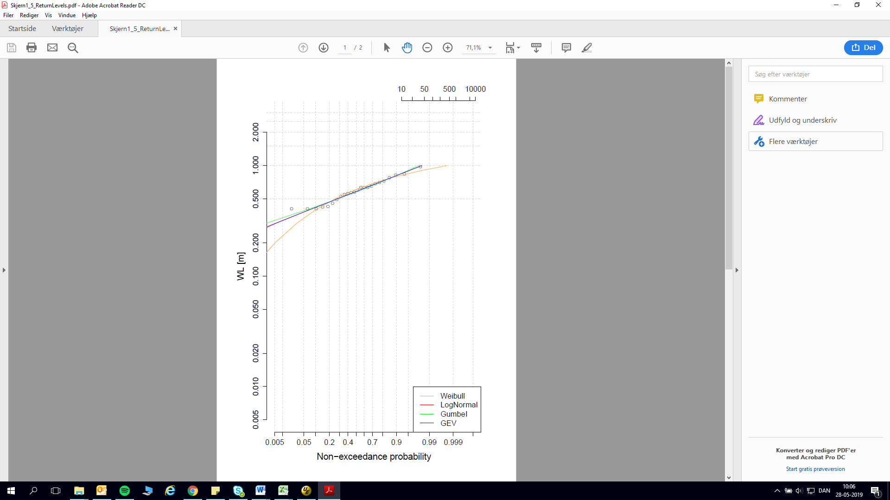 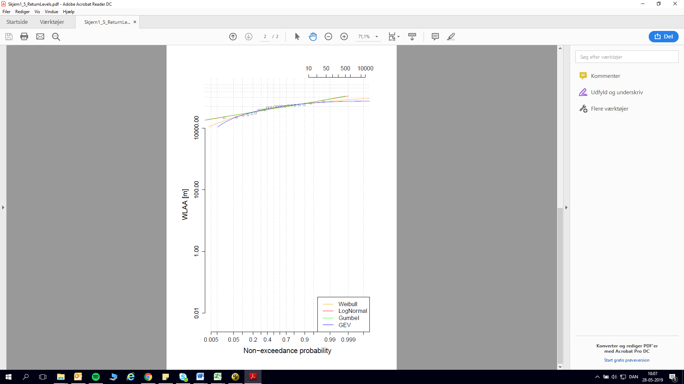

Figure X and X SKAL UDSKIFTES MED RAGNHILD GRAFER

### 5.1.1.3 Copula Plot - **VAR.1.SEA**

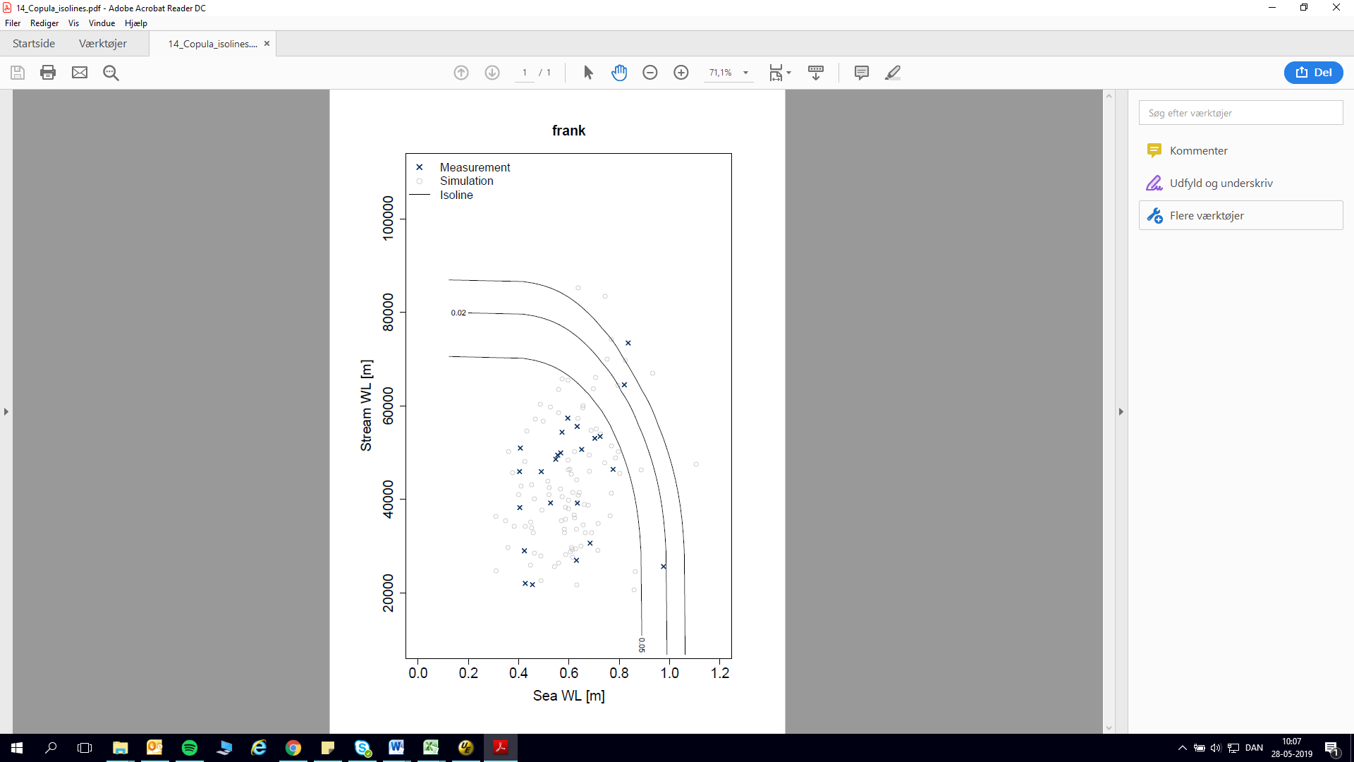

Figure XX – RAGNHILD FIGUR?

### 5.1.1.4 The Joint Probability Table for Skjern 1

|  |  |  |  |  |  |  |
| --- | --- | --- | --- | --- | --- | --- |
| Skjern Å | SEA (m) | | | STREAM (l/s) | | |
| MT20 | MT50 | MT100 | MT20 | MT50 | MT100 |
| VAR.1.SEA | 0.92 | 1.02 | 1.09 | 73541 | 82858 | 89786 |
| UNI.STAT.SEA/STREAM | 1.23 | 1.31 | 1.36 | 73034 | 76612 | 79139 |

Table xx

## 5.1.2 Univariate Statistics - STREAM

### 5.1.2.1 Sample – UNI.STAT.STREAM

|  |  |  |  |  |  |  |  |
| --- | --- | --- | --- | --- | --- | --- | --- |
|  | Date | Hydro. Year | Stream (l/s) |  | Date | Hydro. Year | Stream (l/s) |
| 1 | 09-02-2006 04:00 | 2006 | 47992 | **14** | 22-04-2006 23:00 | 2006 | 46027 |
| 2 | 21-01-2007 22:00 | 2007 | 73439 | **15** | 13-12-2006 05:00 | 2007 | 70413 |
| 3 | 17-01-2008 18:00 | 2008 | 53170 | **16** | 14-03-2008 18:00 | 2008 | 51160 |
| 4 | 13-11-2008 17:00 | 2009 | 59256 | **17** | 28-10-2008 10:00 | 2009 | 57651 |
| 5 | 28-11-2009 20:00 | 2010 | 50726 | **18** | 25-11-2009 17:00 | 2010 | 49599 |
| 6 | 16-01-2011 20:00 | 2011 | 65909 | **19** | 10-01-2011 00:00 | 2011 | 64416 |
| 7 | 07-01-2012 02:00 | 2012 | 57900 | **20** | 24-02-2012 15:00 | 2012 | 51527 |
| 8 | 02-01-2013 16:00 | 2013 | 59774 | **21** | 04-11-2012 14:00 | 2013 | 58718 |
| 9 | 26-12-2013 07:00 | 2014 | 59673 | **22** | 11-01-2014 13:00 | 2014 | 58285 |
| 10 | 23-12-2014 23:00 | 2015 | 61555 | **23** | 10-01-2015 23:00 | 2015 | 56837 |
| 11 | 29-12-2015 00:00 | 2016 | 67940 | **24** | 07-12-2015 15:00 | 2016 | 67687 |
| 12 | 01-03-2017 17:00 | 2017 | 55742 | **25** | 22-11-2016 05:00 | 2017 | 50654 |
| 13 | 04-01-2018 21:00 | 2018 | 55162 | **26** | 26-01-2018 00:00 | 2018 | 50801 |

Table xx

### 5.1.2.2 Return Plot – UNI.STAT.STREAM

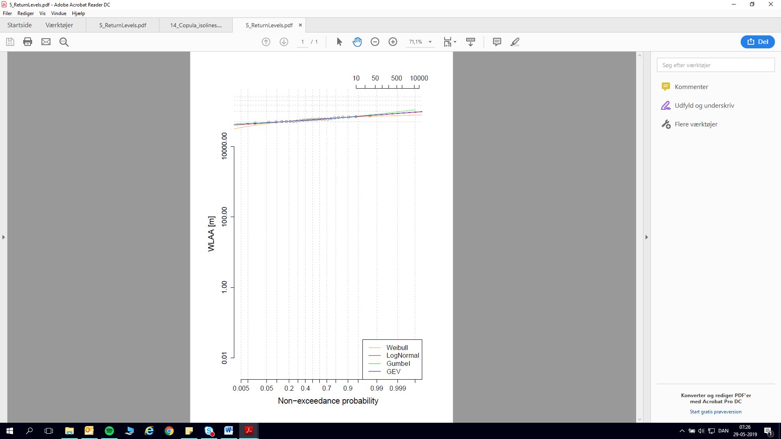

Figure XXX

## 5.2 Skjern 2 (No. 250082 Alergårde)

## 5.2.1 Bivariate statistics – SEA and STREAM

### 5.2.1.1 Sample - VAR.1.SEA

|  |  |  |  |  |  |  |  |  |  |
| --- | --- | --- | --- | --- | --- | --- | --- | --- | --- |
|  | Date | Hydro. Year | Sea (m) | Stream (l/s) | Date | | Hydro. Year | Sea (m) | Stream (l/s) |
| 1 | 21-01-2005 01:00 | 2005 | 0.72 | 33357 | **13** | 13-01-2005 19:00 | 2005 | 0.65 | 29272 |
| 2 | 17-12-2005 00:00 | 2006 | 0.42 | 17573 | **14** | 15-11-2005 14:00 | 2006 | 0.40 | 21272 |
| 3 | 22-01-2007 06:00 | 2007 | 0.84 | 52670 | **15** | 12-01-2007 03:00 | 2007 | 0.82 | 43388 |
| 4 | 01-03-2008 13:00 | 2008 | 0.78 | 30424 | **16** | 09-11-2007 07:00 | 2008 | 0.68 | 17982 |
| 5 | 16-11-2008 17:00 | 2009 | 0.57 | 31523 | **17** | 20-11-2008 17:00 | 2009 | 0.55 | 27146 |
| 6 | 27-03-2010 19:00 | 2010 | 0.98 | 15841 | **18** | 18-11-2009 16:00 | 2010 | 0.53 | 23454 |
| 7 | 09-08-2011 23:00 | 2011 | 0.45 | 13757 | **19** | 07-02-2011 23:00 | 2011 | 0.40 | 28783 |
| 8 | 05-01-2012 16:00 | 2012 | 0.63 | 39343 | **20** | 31-03-2012 04:00 | 2012 | 0.63 | 17177 |
| 9 | 22-05-2013 11:00 | 2013 | 0.43 | 13255 | **21** | 07-11-2012 02:00 | 2013 | 0.41 | 31429 |
| 10 | 20-12-2014 15:00 | 2015 | 0.70 | 33911 | **22** | 01-04-2015 08:00 | 2015 | 0.56 | 32760 |
| 11 | 29-11-2015 21:00 | 2016 | 0.60 | 35907 | **23** | 04-12-2015 08:00 | 2016 | 0.57 | 28387 |
| 12 | 04-01-2017 05:00 | 2017 | 0.63 | 23200 | **24** | 26-12-2016 22:00 | 2017 | 0.49 | 26793 |

Table x

### **5.2.1.2 Return Plots** - **VAR.1.SEA**

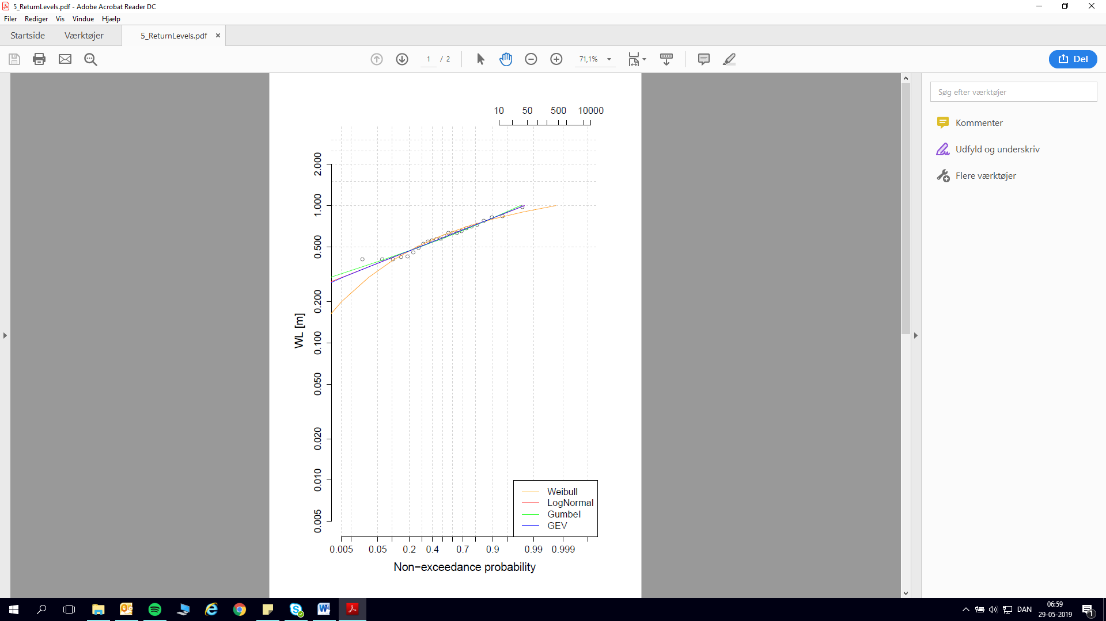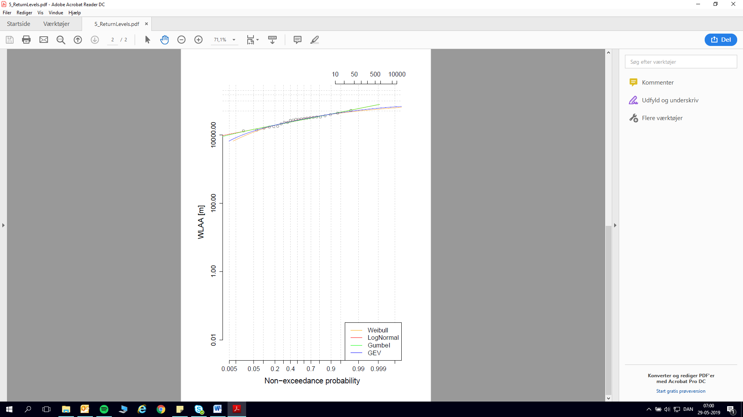  
Figure XX

### 5.2.1.3 Copula Plot - **VAR.1.SEA**

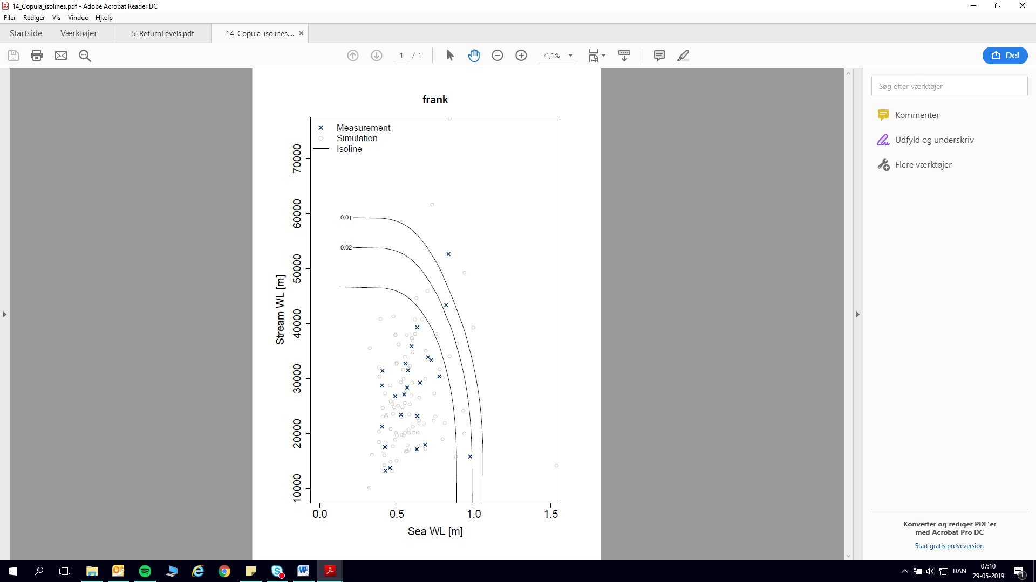

Figure XX

### 5.2.1.4 The Joint Probability Table for Skjern 2

|  |  |  |  |  |  |  |
| --- | --- | --- | --- | --- | --- | --- |
| Skjern Å | SEA (m) | | | STREAM (l/s) | | |
| MT20 | MT50 | MT100 | MT20 | MT50 | MT100 |
| VAR.1.SEA | 0.92 | 1.02 | 1.09 | 48988 | 56183 | 61614 |
| UNI.STAT.SEA/STREAM | 1.23 | 1.31 | 1.36 | 54418 | 57660 | 59963 |

Table xx

## 5.2.2 Univariate Statistics – STREAM

### 5.2.2.1 Sample – UNI.STAT.STREAM

|  |  |  |  |  |  |  |  |
| --- | --- | --- | --- | --- | --- | --- | --- |
|  | Date | Hydro. Year | Stream (l/s) |  | Date | Hydro. Year | Stream (l/s) |
| 1 | 21-01-2007 19:00 | 2007 | 52670 | **13** | 13-01-2007 09:00 | 2007 | 46267 |
| 2 | 17-01-2008 17:00 | 2008 | 40513 | **14** | 03-02-2008 02:00 | 2008 | 37845 |
| 3 | 28-10-2008 07:00 | 2009 | 40733 | **15** | 13-11-2008 21:00 | 2009 | 36303 |
| 4 | 28-11-2009 23:00 | 2010 | 34010 | **16** | 25-11-2009 12:00 | 2010 | 32489 |
| 5 | 16-01-2011 22:00 | 2011 | 50750 | **17** | 09-01-2011 20:00 | 2011 | 48201 |
| 6 | 06-01-2012 23:00 | 2012 | 41645 | **18** | 24-02-2012 16:00 | 2012 | 34281 |
| 7 | 02-01-2013 14:00 | 2013 | 42519 | **19** | 04-11-2012 12:00 | 2013 | 40308 |
| 8 | 26-12-2013 04:00 | 2014 | 44225 | **20** | 11-01-2014 15:00 | 2014 | 40919 |
| 9 | 23-12-2014 19:00 | 2015 | 44406 | **21** | 10-01-2015 23:00 | 2015 | 37830 |
| 10 | 28-12-2015 20:00 | 2016 | 54364 | **22** | 07-12-2015 15:00 | 2016 | 46682 |
| 11 | 01-03-2017 14:00 | 2017 | 37828 | **23** | 15-09-2017 05:00 | 2017 | 33091 |
| 12 | 04-01-2018 19:00 | 2018 | 42284 | **24** | 25-01-2018 18:00 | 2018 | 33906 |

Table xx

### 5.2.2.2 Return Plot – UNI.STAT.STREAM

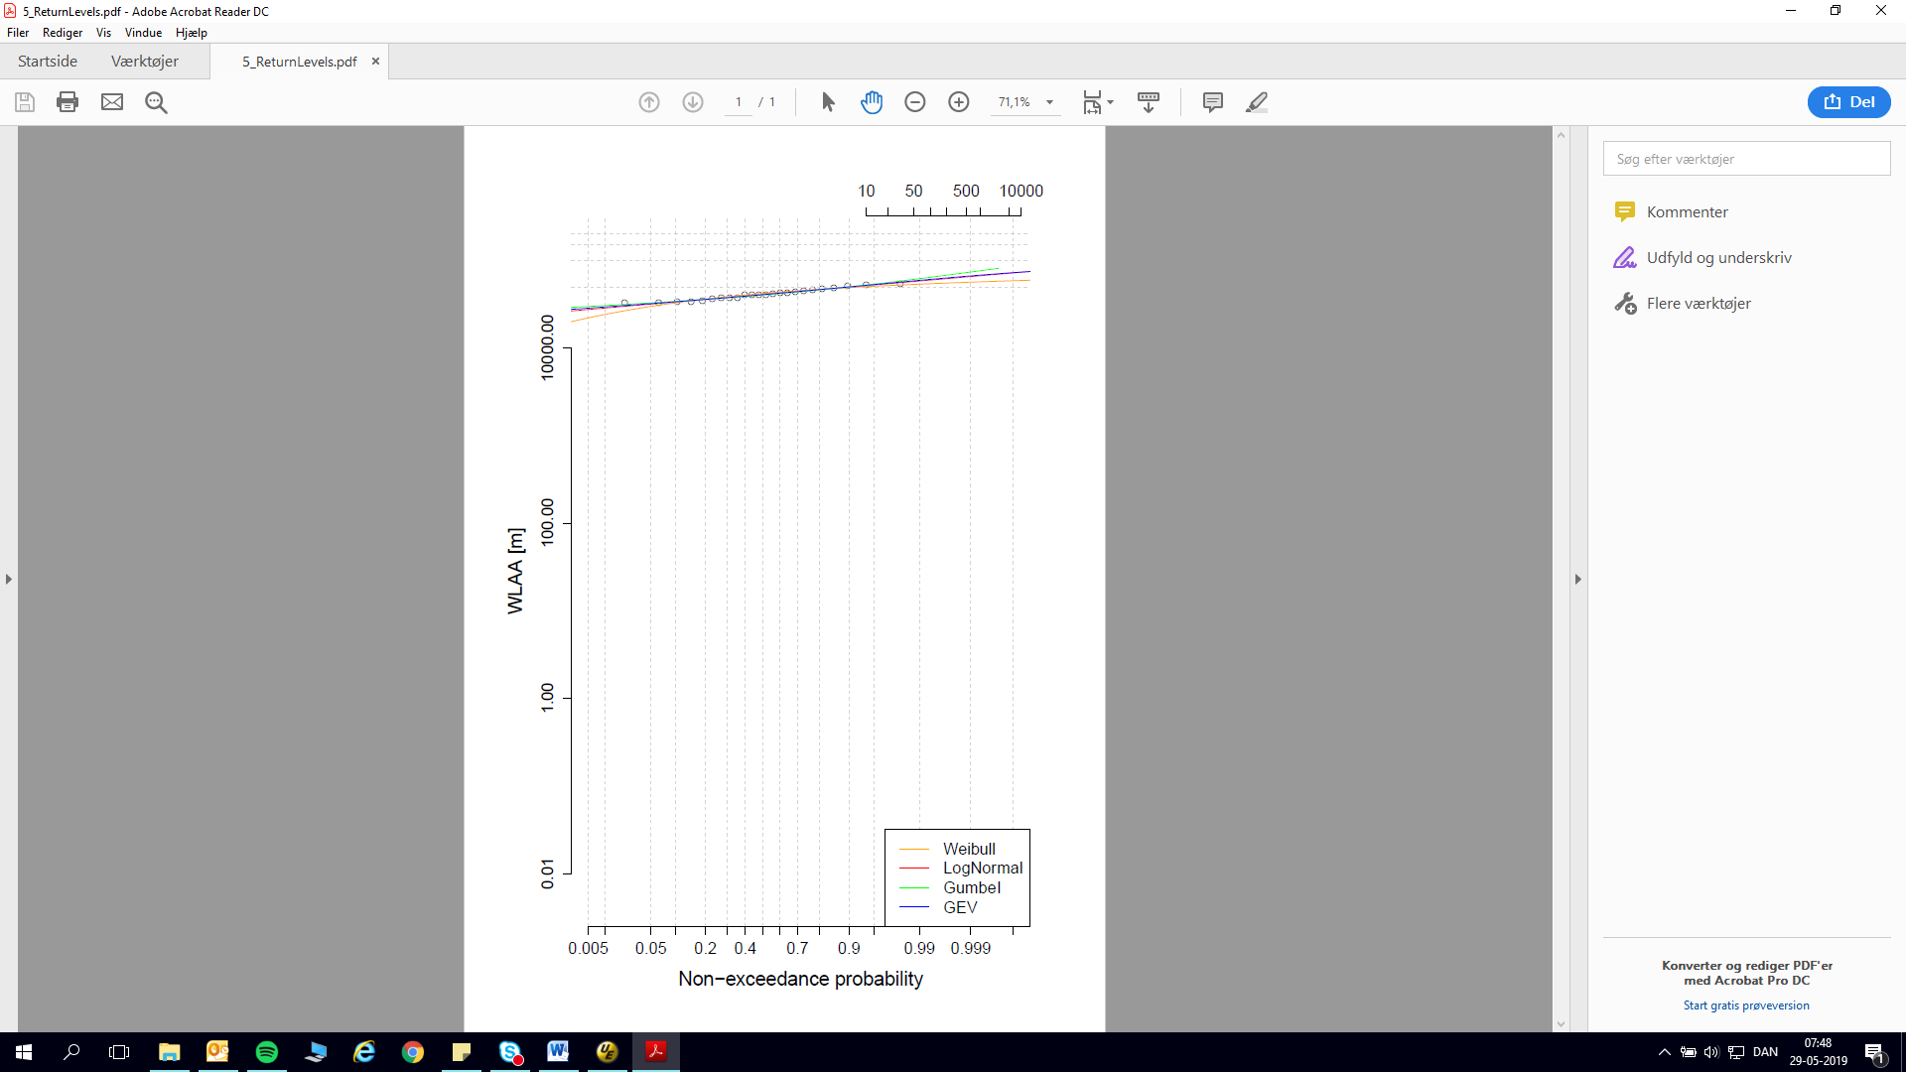

Figure xx

## 5.3 Return Period Combination Selection Methods

# 7. Discussion

## 7.1 Choosing Return Period Combinations based on SCALGO and GIS analyses

# 8. Conclusion

# 9. Suggested Work

# 9. References

Binderup, J. (29.. November 2015). *Tv2*. Hentede 17.. Oktober 2016 fra Gorm går i land i Hvide Sande: Store oversvømmelser truer cafeer: http://nyheder.tv2.dk/2015-11-29-gorm-gaar-i-land-i-hvide-sande-store-oversvoemmelser-truer-cafeer

Johannesen, E. (1993). *Danmark rundt langs kysterne.* Gylling: Narayana Press.

Kjærsgaard, K. (25.. Januar 2016). BORK: To oversvømmelser på fem år . *Ugeavisen.dk*, s. 1.

Naturstyrelsen. (2016). *LIFE sårbar natur langs vestkysten*. Hentede 13.10.2016. Oktober 2016 fra Miljø- og Fødevareministeriet: http://naturstyrelsen.dk/naturbeskyttelse/naturprojekter/life-saarbar-natur-langs-vestkysten/

Realdania By & Byg. (2016). *Klimatilpasning i byudvikling – Fem løsninger med merværdi for byen.* København V: Realdania By & Byg.

Ringkøbing -Skjern kommune. (19.. juni 2012). *Handleplan 2011-2015 for klimatilpasning.* Hentede 17.. Oktober 2016 fra Klimatilpasning.dk: http://www.klimatilpasning.dk/media/817172/ringk_bing-skjern.pdf

Ringkøbing Skjern kommune. (29.. Marts 2016). *Naturens Rige - Ringkøbing-Skjern kommune*. Hentede 13.. Oktober 2016 fra Referat: 29. marts 2016 kl. 14:00: http://www.rksk.dk/om-kommunen/politiske-udvalg/teknik--og-miljoeudvalget/dag-ref-teknik--og-miljoeudvalget?AgendaID=1128#54233c23-6866-4aa5-bb55-b4916a907e47

Stormrådet. (2009). *Stormflods skadestatistik - maj 2009.* Stormrådet .

Danish Meteorological Institute (1991). *Stormfloder*. Ib Gram-Jensen