A Joint Probability Analysis in Konge Å and Ribe Å

Sampling Methods Test

22-05-2019

The Danish Coastal Authority

Charlotte Ditlevsen

*Summary* 2

1. Introduction 3

2.1 Data Foundation 3

2.2 Criteria 4

2.3 Assumptions 4

2.4 Uncertainties 4

3. Method 4

4. Hydrodynamic modelling in MIKE 7

4.1 Projection of data 7

4.2 Climate contribution 7

4.3 Model setup 8

5. Results 8

5.1 Three Different Sampling Methods 8

5.1.1 KONGE Å 9

5.1.2 RIBE Å 10

5.2 KONGE Å (Stream) – RIBE SEA (First Variable) 10

5.2.1 Sample – VAR.1.SEA 11

5.2.2 Return Plots 11

5.2.3 Copula Plot 11

5.2.4 Joint Probability Table 12

5.3 RIBE Å (stream) – RIBE SEA (First Variable) 12

4.3.1 Sample 12

5.3.2 Return Plot 13

5.3.3 Copula Plot 14

5.3.4 Joint Probability Table 14

5.4 Model Univariat 14

5.5 Model Bivariat 14

6. Discussion 14

6.1 Potential Method Weaknesses 14

6.2 The Results and Discussion of the Different Sampling Methods in the Two Locations 15

6.2.1 KONGE Å 15

6.2.2 RIBE Å 16

6.4 The Link between Konge Å and Ribe Å 17

6.5 The Results and Discussion of the Models 17

7. Conclusion 17

8. Suggested work 17

Incorporation of Projected Climate Changes 17

Use Joint Probability to Calculate Bivariate Probability - Look at Marginal Extremes for Values 18

Include more Sources in the Analyses 18

Critical Water Masses - Modeling 18

Appendix A. - Samples from the Different Sampling Methods 19

KONGE Å VAR.1.SEA Sample Pairs 19

KONGE Å VAR.1.STREAM Sample Pairs 19

KONGE Å UNI.STAT.STREAM Sample Pairs 19

RIBE Å VAR.1.SEA Sample Pairs 1

RIBE Å VAR.1.STREAM Sample Pairs 1

RIBE Å UNI.STAT.STREAM Sample Pairs 1

Appendix B - Projection of data (how to) 1

# *Summary*

This report is a sequel to the *Joint Probability Method Report* (Kystdirektoratet 2019), which presents a “raw”, “unquestioned” statistical method for calculating the joint probability of a storm surge and a high discharge event occurring simultaneously. The report also presents some concerns regarding the “raw” method, which are tested and presented in this report and the Skjern Å report.

Three sampling methods are investigated with the purpose of finding the most stable and robust method. There is a clear tendency in the three sampling methods, demonstrating that of the two water sources, sea data is more sensitive to changes in sampling method. This suggests that sea data should remain the first variable (VAR.1.SEA), when doing the statistical calculations.

The models show……mere!!!

A Joint Probability Analysis in Konge Å

1. Introduction  
This report extends the previous research area surrounding the stream, Ribe Å, from the *Joint Probability Method Report (JMP report)*, to the stream and the area surrounding Konge Å north of Ribe.

This analysis aims to provide a better understanding of the parameters affecting the joint probability method and to provide a useful tool to reduce the risk of flooding.   
In an addition to the Joint Probability Method Report, which presents results based on water levels in both sea and stream, an analysis based on discharge in Konge Å and Ribe Å is presented here.

The current research consists of bivariate analyses between water flow data from Konge Å, Ribe Å and sea data from Ribe sea station (see figure 1). For information on the method, please see the *Joint Probability Method Report, KDI 2019*.  
  
2. Area and Data Foundation

For area descriptions, please refer to the Joint Probability Method Report, which includes area descriptions of both Ribe Å and Konge Å.

## 2.1 Data Foundation

For the analysis on Konge Å, it was only possible to work with discharge from one station (Konge Å, Vilslev Spang) in the stream. Because Konge Å does not have its own sea station, Ribe sea station data is used for the sea analysis. However, because of the close proximity of Konge Å to the Ribe sea station measurer and the similarity of coastal conditions the assumption is that Ribe sea station data is also representative for Konge Å. Figure 1, is a map of Ribe and surrounding areas and it shows the location of the measuring instruments in both Ribe sea, Ribe Å and Konge Å.

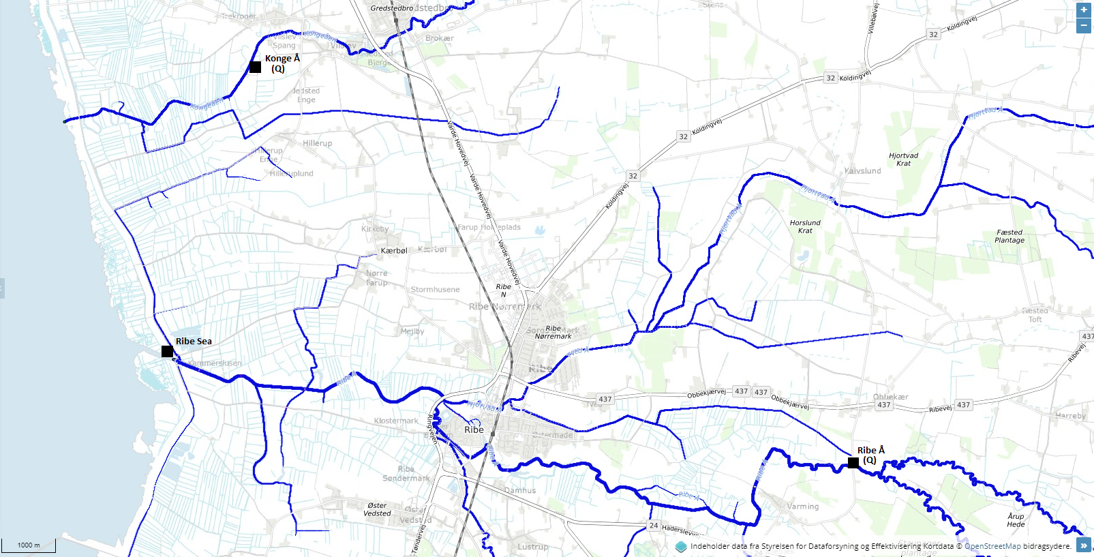

Figure 1. shows Konge Å (northernmost positioned stream) and Ribe Å (southernmost positioned stream).

Table 1 shows the water stations, coordinates and lengths of data series.

|  |  |  |
| --- | --- | --- |
| Station | Coordinates (ETRS89-UTM Zone32) | Data series length (dd.mm.yyyy) |
| Konge Å, Vilslev Spang | X: 481205.944, Y: 6138722.807 | 01.01.1990 – 04.11.2014 |
| Ribe Å, Stavnager | X: 482163.939, Y: 6130704.847 | 01.01.2004 – 31.12.2017 |
| Ribe Sea | X: 479449.156, Y: 6132678.192 | 01.01.2004 – 31.12.2017 |

Similar to the data used in the *Joint Probability Method Report* there are certain criteria, assumptions and known uncertainties that must be taken into account, when using data from Ribe Sea and Konge Å. They are listed below.

## 2.2 Criteria

* The tide gauge data series from Ribe is approximately 98 years long (measurements started 5th of December 1919), but only overlapping date and time data between sea and stream are included in any calculation of joint probability.
* The second criterion is a minimum time series length of five years, or rather, five hydrological years. The hydrological year is defined as the period from the 1st of October to the 1st of April, which is the season that has the highest frequency of storm surges and heavy precipitation.
* The third criterion is that a minimum of 75 % of a hydrological year must be represented in the data series. If more than 25 % of the data is missing from any hydrological year, that hydrological year is discarded.
* The fourth criterion is that all outliers should be removed from the data series. It should be carefully considered whether a data point is an outlier caused by an error of measurement or is, indeed, a measurement from an extreme event.

## 2.3 Assumptions

* The measurements are correct or corrected before delivery and use.
* The data series are representative and reflect the long-term behavior within the catchment area. They contain a sufficient number of all types of events (low as well as high) and extreme events, in particular.

## 2.4 Uncertainties

* Some of the shorter series of stream data do not necessarily contain any extreme events  
  The Danish Coastal Authority (DCA) produces extreme statistics on sea data every 5th year. The latest version is from 2017 (Højvandsstatistikker 2017 or HVS17) and contains values for a 20, 50 and 100 year expected return period. However, the statistics in HVS17 are based on much longer data series and are likely to be more representative than the shorter data series used in these calculations. The reason for the shorter sea data series is that only approximately 20 % of the newest sea data series overlap with the existing stream data. Fewer extremes in the actual sea data series analyzed yields a lower and misleading extreme return value. In other words, there is a risk that the return values might not be representative.

# 3. Method

Almost all statistics are calculated in the program R. The one exception is the univariat statistics on Ribe Sea, which originates from DCA’s own report on extreme water level statistics (HVS17).

The method is explained and analyzed in *The Joint Probability Method Report*. Figure 2. below gives a summary of the method.

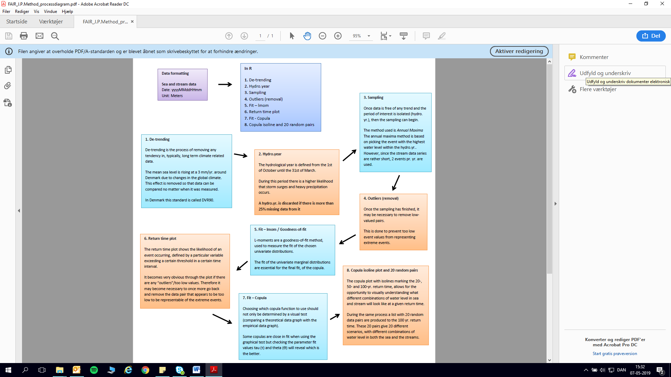

Figure 2. illustrates the different stages of the statistical analysis before and in R. There is, however, additions to this report’s analysis, i.e. the two extra sampling methods (step 3) explained below

This report contains two aspects different from *The Joint Probability Method Report (JPM)*: 1) Data Type and 2) Sampling Method

1. The Stream data consisted of Water Level data in the *JPM* report, whereas this analysis uses water flow data.
2. The JPM report only presented statistics based on sea as first variable. This analysis presents three sampling methods with comparisons to test for sampling stability:
3. Sea as first variable (VAR.1.SEA)
4. Stream as first variable (VAR.1.STREAM)
5. Univariat statistics on both sea and stream (UNI.STAT.SEA/STREAM)

These are the basic requirements of a random sample:

1. All samples must consist of homogeneous data
2. All variables must be identically distributed
3. The events must be independent from each other (there is a minimum of 72 hours between events to ensure that the latter event is not influenced by the former)
4. Stream data is found within +/-12 hours of the stream event (see figure 6 below)
5. No registration errors in the sample
6. The sample should reflect extreme events in its population
7. Stationary dataset

Annual Maxima

For choosing the samples, the Annual Maxima (AM) (or Block Maxima) method is used with two events per year. This method uses the peak event in each year as a sample. Because the data series are short, it can be difficult to get enough data points to make a representative distribution function fit and therefore it can be an advantage to take the two peak events in each year. However, if there is a large difference between the two events and only one is representative for the sample, then the other data pair, or the outlier, can be discarded. For more information on block maxima and extreme data, please refer to *Maximum likelihood estimators for the extreme value index based on the block maxima method* - Dombry, 2013.

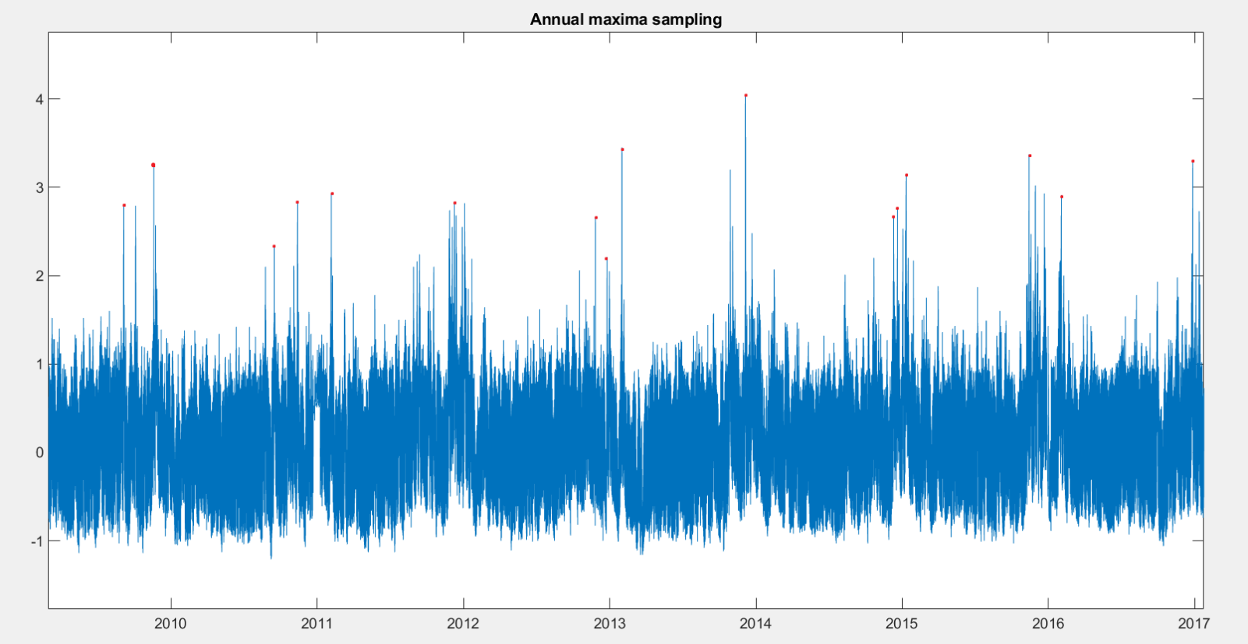

Figure 3. Illustration of the annual sampling. The two annually highest water level peaks are sampled for the statistics.

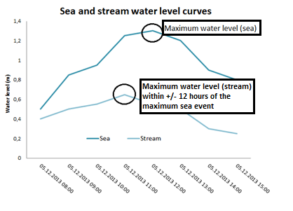

Figure 4. Illustration of the +/- 12 hours requirement of the sampling method

# 4. Hydrodynamic modelling in MIKE

To examine the difference in flood extent hydrodynamic models are produced using the statistical return values. MTXX sea and MTXX streams bivariate statistics are compared with MTXX sea and MTXX streams Univariate statistics model flood extent.

## 4.1 Projection of data

For optimal model results, data is projected upstream to the point of the model boundary. The method is shown in appendix B.

The projected return values are in the table below.

Table 2 presents the return values for the univariate statistics used for the models after the projection of the original data

|  |  |  |  |  |
| --- | --- | --- | --- | --- |
| **Univariate** | **MT50 (2017)** | **MT100 (2017)** | **MT50 w. Climate contribution for 2065** | **MT100 w. Climate contribution for 2115** |
| **Statistics** |
| **Ribe Å** | 42691 | 44825 | 47600 | 54239 |
| **Konge Å** | 24958 | 36333 | 27828 | 31862 |

Table 3 presents the return values for the bivariate statistics used for the models after the projection of the original data

|  |  |  |  |  |
| --- | --- | --- | --- | --- |
| **Bivariate** | **MT50 (2017)** | **MT100 (2017)** | **MT50 w. Climate contribution for 2065** | **MT100 w. Climate contribution for 2115** |
| **Statistics** |
| **Ribe Å** | 39967 | 44055 | 44563 | 53307 |
| **Konge Å** | 25730 | 27147 | 28689 | 32848 |

## 4.2 Climate contribution

For the calculation of scenarios in the future i.e. the 2065 or 2115, a climate factor consisting of a) for sea: averaged sea level rise of 3 mm/year and b) for streams: the averaged increase in precipitation. There are concerns associated with the streams climate contribution due to the direct use of precipitation without taking i.e. evaporation into account.

For all stream scenarios in year 2065, 11.5 % of the original MT are added, and for scenarios in year 2115, 21 % is added.

## 4.3 Model setup

XXXX

# 5. Results

The result chapter will be divided into different sections containing the various analyses performed.

The first section (5.1) presents the three potential samples and illustrates how they differ from one another. This goes for both locations and sea and stream alike.

The second section (5.2 and 5.3) presents the results from the bivariate analysis for Konge Å and Ribe Å, with the sea data as the first variable (VAR.1.SEA). The sample pairs used for the statistics are presented here. The return plots for both sea and stream data, the Copula plot and finally the return period and size of this first variable constellation, as well as the results of an analysis with the stream data as the first variable and the results of a univariate statistic on both sea and stream data.

Below, Table 2. displays the results of the bivariate analyses. This table contains the following information: the sampling (annual maxima with two per year), the marginal distribution functions, the joined copula and the fitting parameters τ and ϴ.

Model xxxx

|  |  |  |  |  |  |
| --- | --- | --- | --- | --- | --- |
| Station | Sampling Method (BM) | Distribution  - Sea | Distribution  - Stream | Copula | Fit  (τ & ϴ) |
| Konge Å, Vilslev Spang | 2/yr | Weibull | LogNormal | Frank | 0.221 - 2.111 |
| Ribe Å, Stavnager | 2/yr | Weibull | LogNormal | Frank | 0.152 - 1.002 |

Table 2. Contains sample method (Block Maxima, with two values/year), the marginal distribution functions, the joined distribution function and the fit parameters τ – describing the relation between sea and stream data and ϴ - giving the fit of the chosen copula on the two steam stations.

## 5.1 Three Different Sampling Methods

For each source, three different sampling methods are applied.

1. Bivariate statistics with sea data as the first variable (VAR.1.SEA) from which the sample is determined (Only overlapping date and time data between Sea and Stream are included in these calculations)
2. Bivariate statistics with stream data as the first variable (VAR.1.STREAM) from which the sample is determined (Only overlapping date and time data between Sea and Stream are included in these calculations, univariate statistics (UNI.STAT.*SEA* or *STREAM*) for both sources (the total data length is used for these calculations)

The purpose of presenting all three sampling methods is to attempt to address the fact that no matter which sampling method is used, at least one of the two sources will be statistically underestimated.

### 5.1.1 KONGE Å

Figure 5a. illustrates a comparison between the three different sampling methods in Konge Å. There appears to be a significant difference between VAR.1.SEA and the other two methods (VAR.1.STREAM and UNI.STAT.STREAM statistics).

Figure 5b. shows the same comparison for sea data. In this case variations between the methods are more pronounced.

### 5.1.2 RIBE Å

Figure 6a. illustrates a comparison between the three different sampling methods in Ribe Å.

For further information on sampling considerations please see The Joined Probability Method Report (DCA, 2018/19) which presents the method dilemma.

Figure 6b. shows the three sampling methods for the sea data. There are large variations in return values between the different methods.

## 5.2 KONGE Å (Stream) – RIBE SEA (First Variable)

These sections presents the joint probability results for Konge Å.

### 5.2.1 Sample – VAR.1.SEA

|  |  |  |  |  |  |  |  |  |  |
| --- | --- | --- | --- | --- | --- | --- | --- | --- | --- |
|  | **Date**  **dd-mm-yyyy hh:mm** | **Hydro. Year** | **Sea (m)** | **Stream (l/s)** | **Date**  **dd-mm-yyyy hh:mm** | | **Hydro. Year** | **Sea (m)** | **Stream (l/s)** |
| **1** | 08-01-2005 16:00 | 2005 | 3.96 | 13911 | **11** | 18-11-2004 05:00 | 2005 | 3.18 | 9846 |
| **2** | 26-10-2005 07:00 | 2006 | 2.00 | 9841 | **12** | 15-11-2005 01:00 | 2006 | 1.99 | 8498 |
| **3** | 12-01-2007 07:00 | 2007 | 3.13 | 21775 | **13** | 18-03-2007 15:00 | 2007 | 2.88 | 14926 |
| **4** | 01-03-2008 19:00 | 2008 | 3.31 | 15261 | **14** | 01-02-2008 09:00 | 2008 | 3.04 | 14934 |
| **5** | 04-09-2009 13:00 | 2009 | 2.76 | 8348 | **15** | 10-11-2008 11:00 | 2009 | 2.43 | 14105 |
| **6** | 18-11-2009 15:00 | 2010 | 3.22 | 12131 | **16** | 04-10-2009 03:00 | 2010 | 2.75 | 9119 |
| **7** | 05-02-2011 04:00 | 2011 | 2.90 | 12426 | **17** | 12-11-2010 19:00 | 2011 | 2.81 | 12017 |
| **8** | 09-12-2011 12:00 | 2012 | 2.80 | 15632 | **18** | 03-01-2012 22:00 | 2012 | 2.79 | 15894 |
| **9** | 31-01-2013 03:00 | 2013 | 3.42 | 18692 | **19** | 25-11-2012 23:00 | 2013 | 2.63 | 13147 |
| **10** | 05-12-2013 16:00 | 2014 | 4.02 | 12041 | **20** | 28-10-2013 16:00 | 2014 | 3.18 | 10988 |

Table 3. shows the 20 data pair samples from which the joint probability calculations have been performed in Konge Å.

The sample for VAR.1.SEA consists of twenty data pairs. The twenty data pairs consist of the two sea peak events per year and the maximum stream water flow within a +/- 12 hours window of the sea peak. To see the sample for VAR.1.STREAM and UNI.STAT, please go to **appendix A.**

5.2.2 Return Plots  
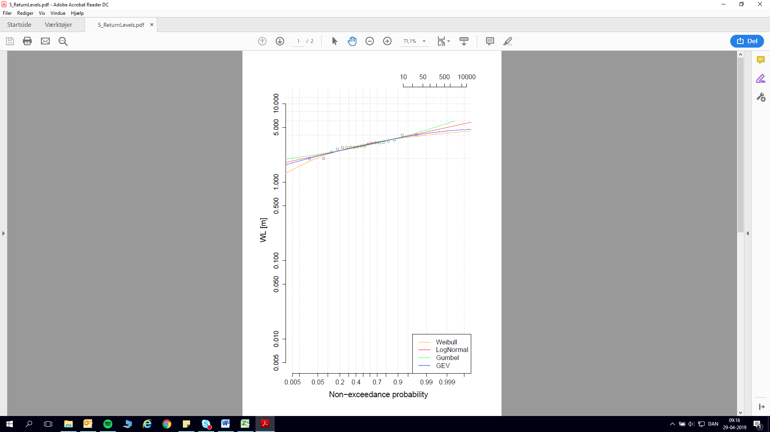 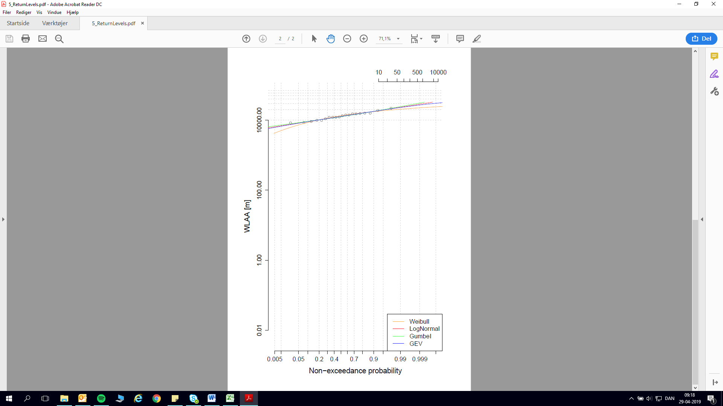  
Figure 7a. (left) and 7b. (right) shows the return plot of a. Ribe Sea and b. Konge Å data, respectively.

### 5.2.3 Copula Plot

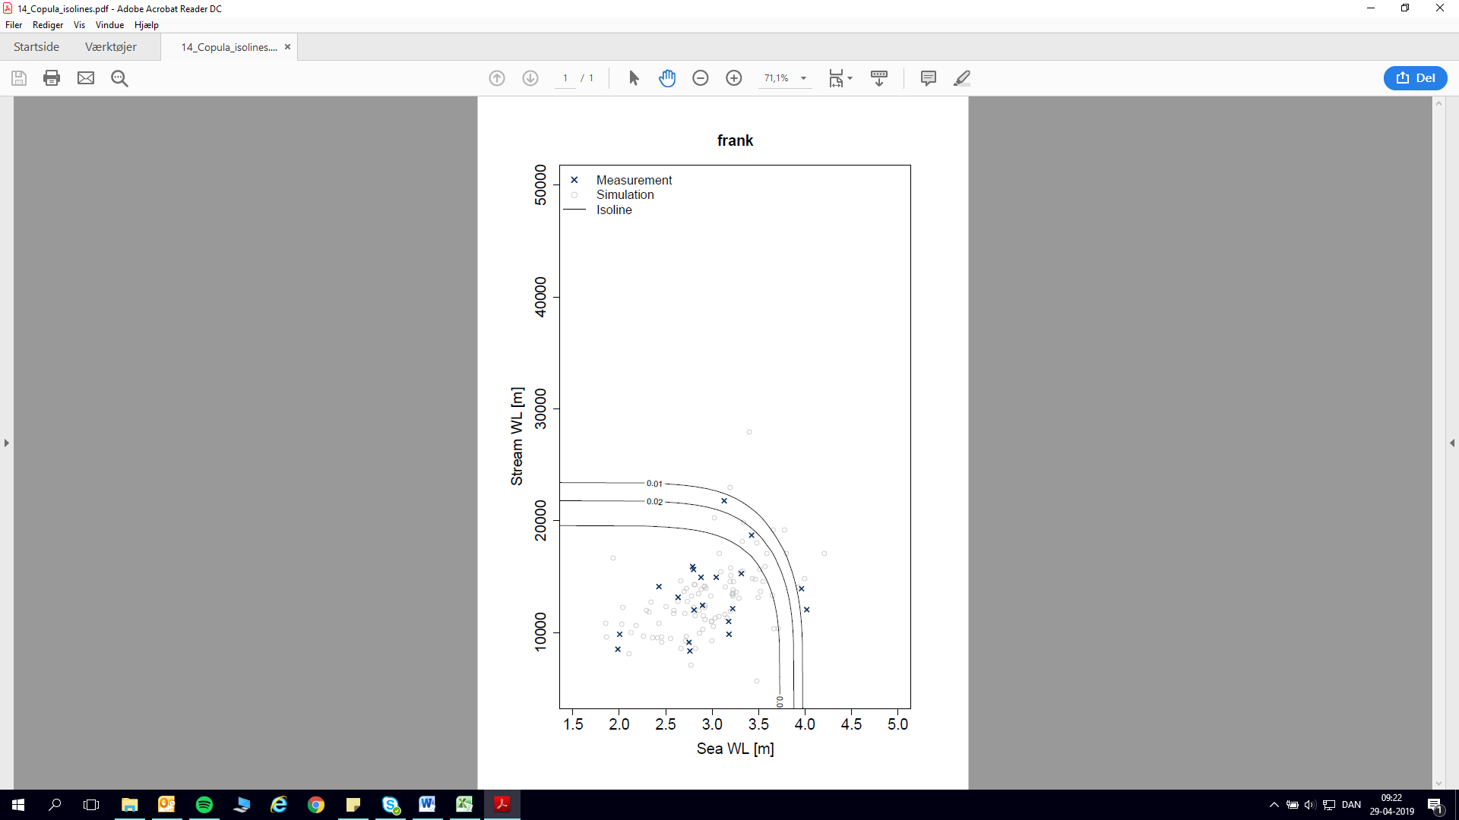

Figure 8. shows the copula plot for Ribe Sea and Konge Å joined probability data. The sample is plotted in black crosses while the circles are simulated model data. The three curves are isolines for MT20 (0.05), MT50 (0.02) and MT100 (0.01), respectively.

### 5.2.4 Joint Probability Table

|  |  |  |  |  |  |  |
| --- | --- | --- | --- | --- | --- | --- |
| Konge Å | SEA (m) | | | STREAM (l/s) | | |
| **MT20** | **MT50** | **MT100** | **MT20** | **MT50** | **MT100** |
| VAR.1.SEA | 3.79 | 3.93 | 4.02 | 20481 | 22661 | 24261 |
| VAR.1.STREAM | 1.61 | 1.75 | 1.84 | 23577 | 25818 | 27383 |
| UNI.STAT.SEA/STREAM | 4.41 (x) | 4.70 (x) | 4.88 (x) | 23697 (y) | 25730 (y) | 27147 (y) |

Table 4. displays the return value for three different “perspectives” using the same methods.   
VAR.1.SEA: Sea data is the first variable. All sample pairs are chosen based onVAR.1 annual maxima peaks. Only overlapping date and time data between Sea and Stream are included in these calculations.  
VAR.1.STREAM: Stream data is the first variable. All sample pairs are chosen based on VAR.1 annual maxima peaks. Only overlapping date data between Sea and Stream data are included in these calculations.  
UNI.STAT: Univariate statistics performed on the full data length of the individual sources.   
x. UNI.STAT for the Sea data comes from DCA’s own Extreme Water Level Statistical Analysis from February 2018 (HVS17). The statistics are based on almost 100 years’ data. The sampling method: Peak over threshold. The distribution function used is LogNormal.   
y. UNI.STAT. for Konge Å is based on data from 1990-2004 which compared to the joint probability calculations reaching from 2004-2017 adds an additional approximately 10 years, resulting in more ”extremes” (higher water flow) and therefore a higher return value.

## 5.3 RIBE Å (stream) – RIBE SEA (First Variable)

These sections presents the joint probability results for Ribe Å.

### 4.3.1 Sample

|  |  |  |  |  |  |  |  |  |  |  |  |
| --- | --- | --- | --- | --- | --- | --- | --- | --- | --- | --- | --- |
|  | **Date**  **dd-mm-yyyy hh:mm** | **Hydro. Year** | **Sea (m)** | **Stream (l/s)** | **Date**  **dd-mm-yyyy hh:mm** | | **Hydro. Year** | **Sea (m)** | | **Stream (l/s)** | |
| **1** | 08-01-2005 16:00 | 2005 | 3.96 | 20772 | **13** | 18-11-2004 05:00 | 2005 | | 3.18 | | 12806 | |
| **2** | 26-10-2005 07:00 | 2006 | 2.00 | 12740 | **14** | 15-11-2005 01:00 | 2006 | | 1.99 | | 11763 | |
| **3** | 12-01-2007 07:00 | 2007 | 3.13 | 29777 | **15** | 18-03-2007 15:00 | 2007 | | 2.88 | | 22424 | |
| **4** | 01-03-2008 19:00 | 2008 | 3.31 | 19766 | **16** | 01-02-2008 09:00 | 2008 | | 3.04 | | 19423 | |
| **5** | 04-09-2009 13:00 | 2009 | 2.76 | 4839 | **17** | 10-11-2008 11:00 | 2009 | | 2.43 | | 14747 | |
| **6** | 18-11-2009 15:00 | 2010 | 3.22 | 14974 | **18** | 04-10-2009 03:00 | 2010 | | 2.75 | | 5265 | |
| **7** | 05-02-2011 04:00 | 2011 | 2.90 | 19368 | **19** | 12-11-2010 19:00 | 2011 | | 2.81 | | 16700 | |
| **8** | 09-12-2011 12:00 | 2012 | 2.80 | 26218 | **20** | 03-01-2012 22:00 | 2012 | | 2.79 | | 26078 | |
| **9** | 31-01-2013 03:00 | 2013 | 3.42 | 29281 | **21** | 25-11-2012 23:00 | 2013 | | 2.63 | | 19225 | |
| **10** | 05-12-2013 16:00 | 2014 | 4.02 | 13237 | **22** | 28-10-2013 16:00 | 2014 | | 3.18 | | 12175 | |
| **11** | 11-01-2015 04:00 | 2015 | 3.12 | 22757 | **23** | 20-12-2014 13:00 | 2015 | | 2.74 | | 23024 | |
| **12** | 14-11-2015 04:00 | 2016 | 3.36 | 13387 | **24** | 30-11-2015 03:00 | 2016 | | 3.01 | | 22106 | |

**Table 5.** shows the sample from which the joint probability calculations have been performed in Ribe Å.

The sample for VAR.1.SEA consists of 24 data pairs. For sample for VAR.1.STREAM and UNI.STAT, please see **appendix A.**

### 5.3.2 Return Plot

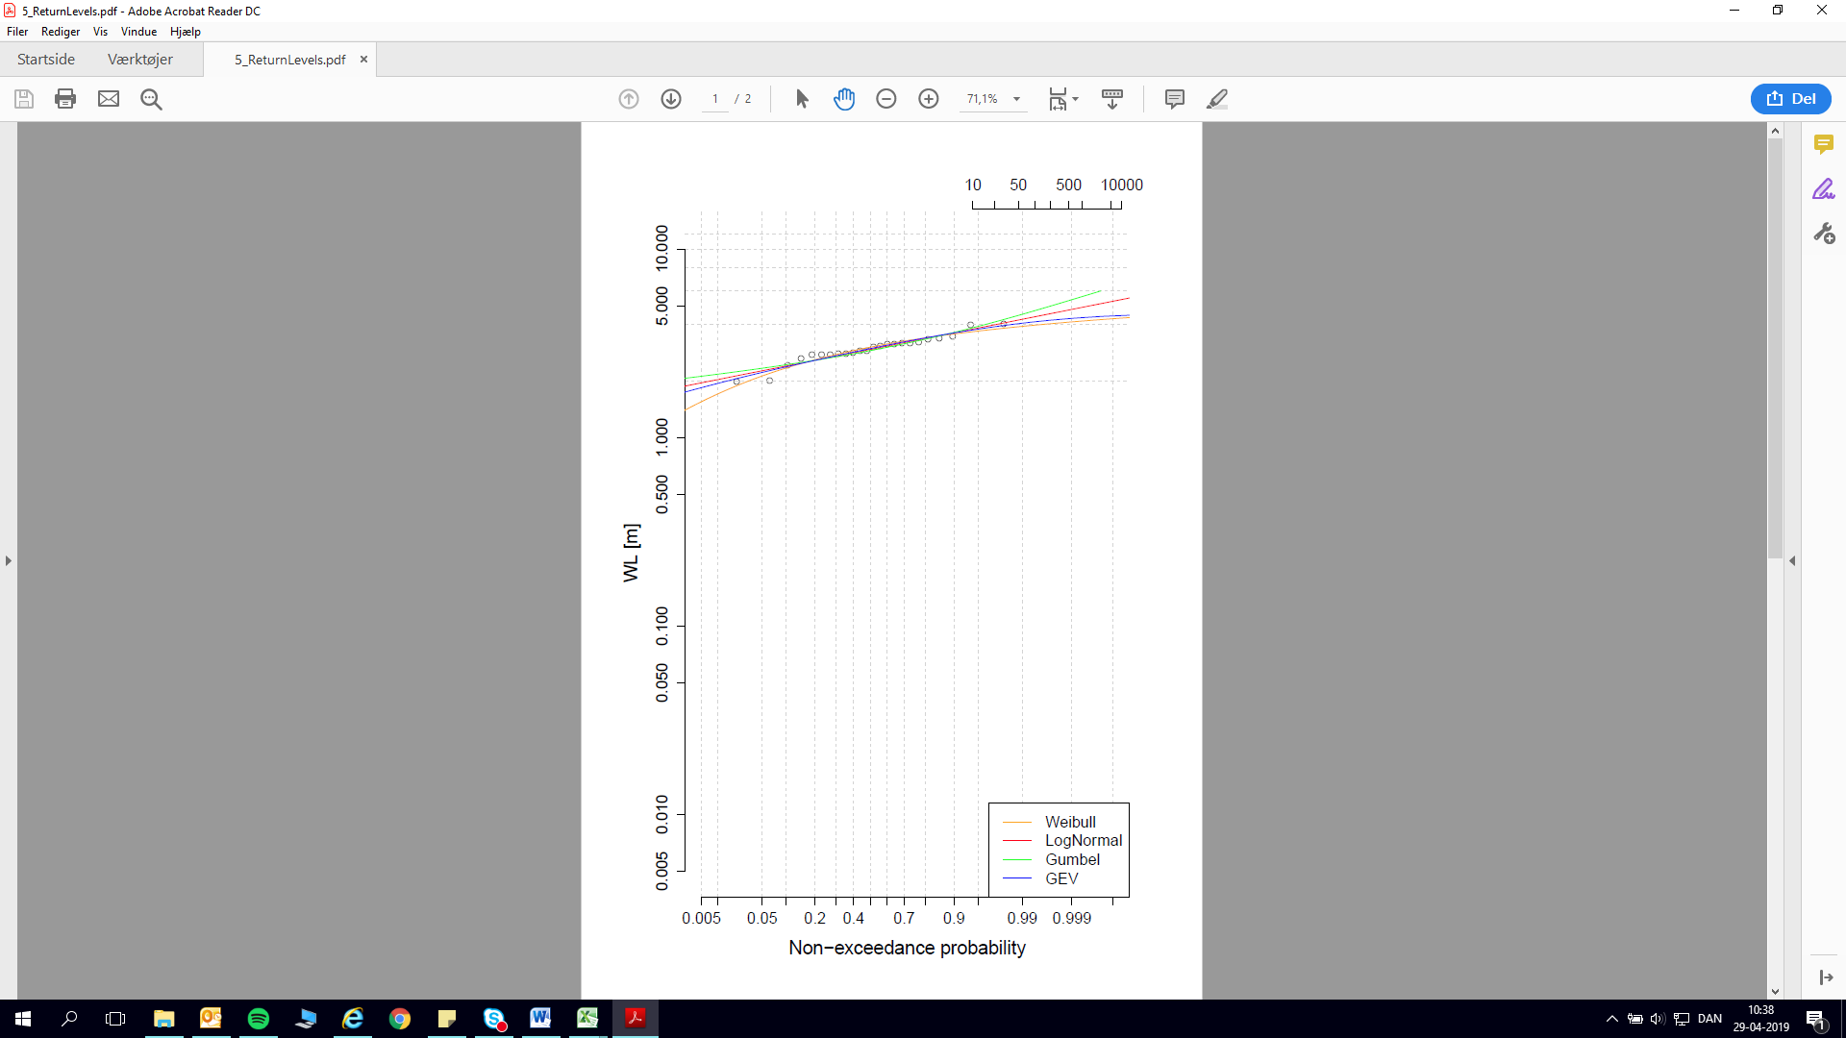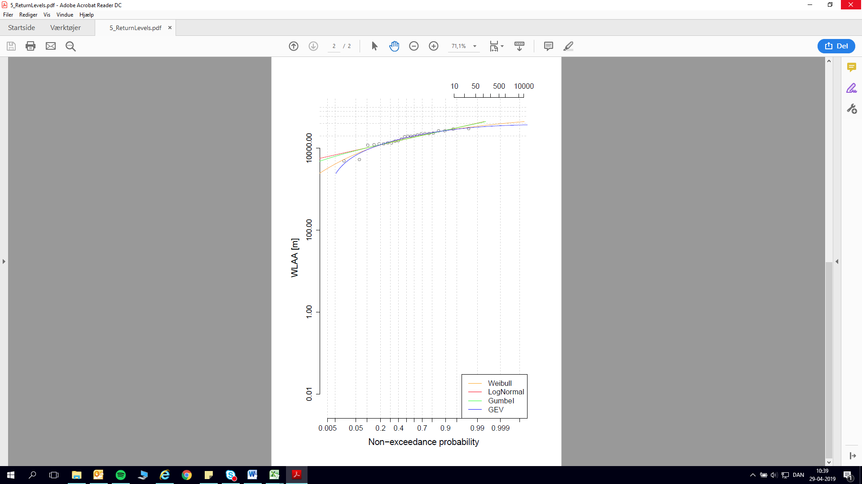

Figure 9a. (left) and 9b. (right) shows the return plot of a. Ribe Sea and b. Ribe Å data, respectively

### 5.3.3 Copula Plot

Figure 10. displays the copula plot for Ribe Sea and Ribe Å joined probability data.

### 5.3.4 Joint Probability Table

|  |  |  |  |  |  |  |
| --- | --- | --- | --- | --- | --- | --- |
| Ribe Å | SEA (m) | | | STREAM (l/s) | | |
| **MT20** | **MT50** | **MT100** | **MT20** | **MT50** | **MT100** |
| VAR.1.SEA | 3.76 | 3.88 | 3.95 | 34620 | 39967 | 44055 |
| VAR.1.STREAM | 1.85 | 2.00 | 2.09 | 40617 | 43890 | 46248 |
| UNI.STAT. | 4.41 | 4.70 | 4.88 | 40131 | 43122 | 45278 |

Table 6. displays the return values from three different “perspectives” using the same methods. For descriptions on the different statistics, see table 4.

## **5.4 Model Univariat**

## 5.5 Model Bivariat

6. Discussion   
There is a couple of questions that arise after the presentation of the results. They are listed below:

1. Does the method have any weaknesses?
2. What does the result of the three different sampling methods show in the two locations?

An attempt to answer these questions or subject them to further scrutiny is presented in section 5.

## 6.1 Potential Method Weaknesses

The statistical return values presented represent a step in the right direction. However, discussing the flood extent of a given combination without a model is hardly feasible. Because the flood extent cannot be discussed, until the statistics are linked to a hydrological model, focus will be on the differences in sampling and the general tendencies seen in Ribe Å and Konge Å.

If these data are to be used for flood risk reduction the weakness of the method needs to be accounted for. One weakness is the bias in sampling. Therefore, it is important to map exactly where and when we expect a less reliable image of reality. If we end up using a method which encompasses the constant estimation of one variable we need to have an idea of how much underestimation we are expecting in the hydrological model later in the process. The three sampling methods and their relation to the other sampling types are presented below. The data in the MT20 column will be used for illustration of the behavior and tendency in the data. The reason for this is that the stream data series are no longer than 13-14 years, which limits stability and robustness in the statistics up until approximately a 40 years return period.

## 6.2 The Results and Discussion of the Different Sampling Methods in the Two Locations

Below is first a short presentation of the results of the three different sampling methods and then a discussion of the results.

### 6.2.1 KONGE Å

The two tables below (tables 7 and 8) present the values for the three different sampling methods.

|  |  |  |  |
| --- | --- | --- | --- |
| STREAM DATA | MT20 (l/s) | MT50 (l/s) | MT100 (l/s) |
| **VAR.1.**SEA | 20481 | 22661 | 24261 |
| **VAR.1.**STREAM | 23577 | **25818** | **27383** |
| **UNI.STAT.**STREAM | **23697** | 25730 | 27147 |

Table 7. presents the return values for the stream data by the various sampling methods.

For stream data (table 7.) the highest return value are found by the univariate statistics (UNI.STAT.STREAM) for a return time of 20 years (MT20). However, for MT50 and MT100 the method that returns the highest values is stream data as the first variable (VAR.1.STREAM). For the MT20 return values the difference between the minimum and maximum return values is 3216 l/s also corresponding to an approximately 13.6 % reduction in size. Appendix A shows all sample tables. The two first tables (for VAR.1.SEA and VAR.1.STREAM) have twenty and nine pairs included in the calculations respectively, and the univariate statistics are based on ten data pairs. The statistics for VAR.1.STREAM are only based on nine data pairs whilst UNI.STAT.STREAM, which we expect to be the same as VAR.1.STREAM, is based on ten data pairs. That extra pair adds (in this case) 120 l/s to the statistical return value.

|  |  |  |  |
| --- | --- | --- | --- |
| SEA DATA | MT20 (m) | MT50 (m) | MT100 (m) |
| **VAR.1.**STREAM | 1.61 | 1.75 | 1.84 |
| **VAR.1.**SEA | 3.79 | 3.93 | 4.02 |
| **UNI.STAT.**SEA | **4.41** | **4.70** | **4.88** |

Table 8. presents the return values for the sea data by the various sampling methods.

Table 8. presents similar data to table 7 with the exception that this table shows the sampling from the sea data perspective. The table shows the variation between the return values in regard to the sampling type. It should be noted that the univariate statistics on Ribe Sea has almost 100 years of data (compared to the approx. 30 years included in the joint probability calculations) which is one of the reasons for the variation between VAR.1.SEA and UNI.STAT.SEA. Using the MT20 data as an example the difference between the minimum and maximum return value is 2.80 m.

### 6.2.2 RIBE Å

|  |  |  |  |
| --- | --- | --- | --- |
| STREAM DATA | MT20 (l/s) | MT50 (l/s) | MT100 (l/s) |
| **VAR.1.**SEA | 34620 | 39967 | 44055 |
| **UNI.STAT.**STREAM | 40131 | 43122 | 45278 |
| **VAR.1.**STREAM | **40617** | **43890** | **46248** |

Table 9. presents the return values for Ribe Å stream data by the various sampling methods.

In table 9. the results show that when stream data is the first variable the return values are highest. In MT20 the difference between the minimum (VAR.1.SEA) and the maximum (VAR.1.STREAM) return value is 5997 l/s (14.8 %).

|  |  |  |  |
| --- | --- | --- | --- |
| SEA DATA | MT20 (m) | MT50 (m) | MT100 (m) |
| **VAR.1.**STREAM | 1.85 | 2.00 | 2.09 |
| **VAR.1.**SEA | 3.76 | 3.88 | 3.95 |
| **UNI.STAT.**SEA | **4.41** | **4.70** | **4.88** |

Table 10. presents the return values for Ribe Å Sea data by the various sampling methods.

Table 10. shows the great variation in return values for the sea data. Depending on which method is used, the return value varies with approximately 2.50 m between the minimum (VAR.1.STREAM) and the maximum (UNI.STAT.STREAM) which also corresponds to a 58 % reduction from highest to lowest.

For both Konge Å and Ribe Å the data display the same tendencies in “First Variable” sensitivity. Both systems have the sea as the most sensitive source with 60-65 % variability in return value compared to 13-14 % in the stream data. The large variation between return values in the sea data indicates that the sea data is much more sensitive to the sampling method compared to the results of the stream data. This finding would support the argument that keeping the sea data as first variable would give the lowest variation.

There should be no difference between VAR.1.STREAM and UNI.STAT.STREAM, but there is a small difference of 120 l/s, which can be explained by a different sampling pool or a removal of an outlier pair from one of the samples. This could indicate that using the sea as first variable is the more stable of the two bivariate statistics but univariate statistics will ultimately be the more reliable. The results of the univariate statistics on the sea data should be the best data to use, due to robustness of the data series length. It is safe to assume that the longer the data series the more accurate the statistics, therefore the results of the univariate statistics are the most reliable. However, the combination from the joint probability statistics, which were performed on the overlapping time series from both sources, returns MT values that are different from the ones obtained by the univariate statistics (as can be seen in table 7-10). Finding the combination MT in the joint probability calculations and then later running models with the combination size from the univariate statistics could be misleading. Therefor we suggest that the bivariate MT is “transformed” into a univariate MT. If this transformation is not performed and the bivariate values are used, the model will be underestimating the water flow, resulting in an underestimation of flood extent. See table 11 below for an example and further explanation.

|  |  |  |  |
| --- | --- | --- | --- |
| Konge Å | | | |
| Bivariate statistics | | **Univariate statistics** | |
| MT (years) | Q (l/s) |  | MT (years) |
| 10: | 18752 | → | ~ 5 |
| 20: | 20481 | → | ~ 8 |
| 50: | 22661 | → | ~ 15 |
| 100: | 24261 | → | ~ 30 |
| 200: | 25836 | → | ~ 50 |

|  |  |  |  |
| --- | --- | --- | --- |
| Ribe Sea | | | |
| Bivariate statistics | | **Univariate statistics** | |
| MT (years) | (m) |  | MT (years) |
| 20: | 3.76 | → | ~8 |
| 50: | 3.88 | → | ~12 |
| 100: | 3.95 | → | ~20 |

Tables 11a and 11b shows Konge Å and Ribe sea data. The example shows how the MT from the bivariate statistics should be transformed into more reliable univariate statistical return times (MT) before they are used in the hydrological models. An example is that a MT10 size from a bivariate statistics corresponds to a MT5 size in the univariate statistics event size in the stream data. From looking at table 11b (sea data) it also appears that using i.e. an MT20 bivariate return period (VAR.1.SEA) corresponds to a MT8 event in the univariate statistics.

6.4 The Link between Konge Å and Ribe Å  
The analysis shows that Konge Å is approximately half of Ribe Å as regards flow. Both streams are controlled by a sluice at their outlets to the sea. The sluices close when the sea level is 2-3 cm higher than the water level in the stream. Very little can be said about the flood tendency or pattern until a model of the two areas is available.

## 6.5 The Results and Discussion of the Models

Kig på:

1) Præsenter de forskellige scenarier (kort: **1.** UNI h100, v50 2017 **2.** BI h100, v50 2017 **3.** BI h50, v50 2017 og **4.** BI h50, v50 2065).

2) Forskel i vandmasser mellem kort 1-2 og 3-4

3) Forskel i udbredelse mellem samme kort som overstående

# 7. Conclusion

The main conclusion of this report is the analysis on sampling methods. Of the two bivariate statistical methods (sea or stream as first variable) sea data appears to be more sensitive and gives a bigger spread in return values than do stream data. Therefor the sea must remain as first variable (VAR.1.) in later analyses. The best way to produce data for the hydrological model is by finding combinations of MT in the bivariate statistics and finding the corresponding univariate MT, based on the value of the MT’s.

Most probably, the difference in UNI.STAT.STREAM and VAR.1.STREAM are due to a small difference in sample composition. There is a chance of outlier removal in the bivariate statistics, which influences the return values.

Regarding the comparison between the Konge Å and the Ribe Å system there is very little to say until a hydrological model is produced. There are similarities between the two streams, such as the sluices, but at the same time, one system has twice the flow (Ribe Å) of the other (Konge Å).

# 8. Suggested work

Incorporation of Projected Climate Changes  
Expected precipitation and sea water levels in 50 years is of interest (because the difference in e.g. precipitation now and in 50 years’ time should be included in any calculations) and important to produce a useful tool, especially if this statistical tool is used for reducing the risk of flooding. This is referred to as projected climate changes.

## Use Joint Probability to Calculate Bivariate Probability - Look at Marginal Extremes for Values

The difference in MT values from VAR.1.STREAM and UNI.STAT.STREAM should be investigated more closely to better have an idea of to which degree a potential flood is under- or overestimated when using one source’s MT values to the same return period.

## Include more Sources in the Analyses

To be able to provide a useful joint probability flood reduction tool we need to include all the sources that contribute to a given flood. This means that, as a minimum, precipitation and groundwater seepage should be included in the analysis.

Critical Water Masses - Modeling  
Once a model is produced, it would be of great interest to explore at which MT combinations each area would be experiencing problematic water masses resulting in flooding. Another important aspect is the flood extent in response to certain combinations.

# Appendix A. - Samples from the Different Sampling Methods

## KONGE Å VAR.1.SEA Sample Pairs

Table 12. Sea sample when sea (Ribe sea) is first variable.

|  |  |  |  |  |
| --- | --- | --- | --- | --- |
| **VAR.1.SEA** | | | | |
|  | **Date** | **Hydrological year** | **Sea (m)** | **Stream (l/s)** |
| **1** | 08-01-2005 16:00 | 2005 | 3.96 | 13911 |
| **2** | 26-10-2005 07:00 | 2006 | 2.00 | 9841 |
| **3** | 12-01-2007 07:00 | 2007 | 3.13 | 21775 |
| **4** | 01-03-2008 19:00 | 2008 | 3.31 | 15261 |
| **5** | 04-09-2009 13:00 | 2009 | 2.76 | 8348 |
| **6** | 18-11-2009 15:00 | 2010 | 3.22 | 12131 |
| **7** | 05-02-2011 04:00 | 2011 | 2.90 | 12426 |
| **8** | 09-12-2011 12:00 | 2012 | 2.80 | 15632 |
| **9** | 31-01-2013 03:00 | 2013 | 3.42 | 18692 |
| **10** | 05-12-2013 16:00 | 2014 | 4.02 | 12041 |
| **13** | 18-11-2004 05:00 | 2005 | 3.18 | 9846 |
| **14** | 15-11-2005 01:00 | 2006 | 1.99 | 8498 |
| **15** | 18-03-2007 15:00 | 2007 | 2.88 | 14926 |
| **16** | 01-02-2008 09:00 | 2008 | 3.04 | 14934 |
| **17** | 10-11-2008 11:00 | 2009 | 2.43 | 14105 |
| **18** | 04-10-2009 03:00 | 2010 | 2.75 | 9119 |
| **19** | 12-11-2010 19:00 | 2011 | 2.81 | 12017 |
| **20** | 03-01-2012 22:00 | 2012 | 2.79 | 15894 |
| **21** | 25-11-2012 23:00 | 2013 | 2.63 | 13147 |
| **22** | 28-10-2013 16:00 | 2014 | 3.18 | 10988 |

## KONGE Å VAR.1.STREAM Sample Pairs

Table 13. Stream sample when stream (Konge Å) is first variable.

|  |  |  |  |  |
| --- | --- | --- | --- | --- |
| **VAR.1.STREAM** | | | | |
|  | **Date** | **Hydrological year** | **Stream (l/s)** | **Sea (m)** |
| **1** | 09-02-2006 02:00 | 2006 | 13724 | 1.93 |
| **2** | 11-09-2011 13:00 | 2011 | 19340 | 1.21 |
| **3** | 07-01-2012 11:00 | 2012 | 22145 | 1.39 |
| **4** | 03-01-2013 07:00 | 2013 | 21478 | 1.15 |
| **5** | 27-12-2013 01:00 | 2014 | 21786 | 1.00 |
| **6** | 20-02-2006 02:00 | 2006 | 11321 | 0.75 |
| **7** | 18-01-2011 11:00 | 2011 | 18466 | 0.91 |
| **8** | 10-01-2012 12:00 | 2012 | 19358 | 1.21 |
| **9** | 05-11-2012 10:00 | 2013 | 19569 | 0.98 |

## KONGE Å UNI.STAT.STREAM Sample Pairs

Table 14. Only stream data (Konge Å) sample

|  |  |  |  |
| --- | --- | --- | --- |
| **UNI.STAT.STREAM** | | | |
|  | **Date** | **Hydrological year** | **Stream (l/s)** |
| **1** | 09-02-2006 02:00 | 2006 | 13724 |
| **2** | 11-09-2011 13:00 | 2011 | 19340 |
| **3** | 07-01-2012 11:00 | 2012 | 22145 |
| **4** | 03-01-2013 07:00 | 2013 | 21478 |
| **5** | 27-12-2013 01:00 | 2014 | 21786 |
| **6** | 20-02-2006 02:00 | 2006 | 11321 |
| **7** | 18-01-2011 11:00 | 2011 | 18466 |
| **8** | 10-01-2012 12:00 | 2012 | 19358 |
| **9** | 05-11-2012 10:00 | 2013 | 19569 |
| **10** | 19-01-2014 12:00 | 2014 | 20557 |

## RIBE Å VAR.1.SEA Sample Pairs

Table 15. Sea sample when sea (Ribe sea) is first variable.

|  |  |  |  |  |
| --- | --- | --- | --- | --- |
| **VAR.1.SEA** | | | | |
|  | **Date** | **Hydrological year** | **Sea (m)** | **Stream (l/s)** |
| **1** | 08-01-2005 16:00 | 2005 | 3.96 | 20772 |
| **2** | 26-10-2005 07:00 | 2006 | 2.00 | 12740 |
| **3** | 12-01-2007 07:00 | 2007 | 3.13 | 29777 |
| **4** | 01-03-2008 19:00 | 2008 | 3.31 | 19766 |
| **5** | 04-09-2009 13:00 | 2009 | 2.76 | 4839 |
| **6** | 18-11-2009 15:00 | 2010 | 3.22 | 14974 |
| **7** | 05-02-2011 04:00 | 2011 | 2.90 | 19368 |
| **8** | 09-12-2011 12:00 | 2012 | 2.80 | 26218 |
| **9** | 31-01-2013 03:00 | 2013 | 3.42 | 29281 |
| **10** | 05-12-2013 16:00 | 2014 | 4.02 | 13237 |
| **11** | 11-01-2015 04:00 | 2015 | 3.12 | 22757 |
| **12** | 14-11-2015 04:00 | 2016 | 3.36 | 13387 |
| **13** | 18-11-2004 05:00 | 2005 | 3.18 | 12806 |
| **14** | 15-11-2005 01:00 | 2006 | 1.99 | 11763 |
| **15** | 18-03-2007 15:00 | 2007 | 2.88 | 22424 |
| **16** | 01-02-2008 09:00 | 2008 | 3.04 | 19423 |
| **17** | 10-11-2008 11:00 | 2009 | 2.43 | 14747 |
| **18** | 04-10-2009 03:00 | 2010 | 2.75 | 5265 |
| **19** | 12-11-2010 19:00 | 2011 | 2.81 | 16700 |
| **20** | 03-01-2012 22:00 | 2012 | 2.79 | 26078 |
| **21** | 25-11-2012 23:00 | 2013 | 2.63 | 19225 |
| **22** | 28-10-2013 16:00 | 2014 | 3.18 | 12175 |
| **23** | 20-12-2014 13:00 | 2015 | 2.74 | 23024 |
| **24** | 30-11-2015 03:00 | 2016 | 3.01 | 22106 |

## RIBE Å VAR.1.STREAM Sample Pairs

Table 16. Stream sample when stream (Ribe Å) is first variable.

|  |  |  |  |  |
| --- | --- | --- | --- | --- |
| **VAR.1.STREAM** | | | | |
|  | **Date** | **Hydrological year** | **Stream (l/s)** | **Sea (m)** |
| **1** | 18-03-2005 12:00 | 2005 | 30118 | 0.97 |
| **2** | 10-02-2006 03:00 | 2006 | 16753 | 0.78 |
| **3** | 22-01-2007 15:00 | 2007 | 35380 | 1.46 |
| **4** | 09-12-2007 07:00 | 2008 | 25273 | 1.18 |
| **5** | 13-11-2008 15:00 | 2009 | 30805 | 1.24 |
| **6** | 29-12-2009 05:00 | 2010 | 30820 | 0.73 |
| **7** | 09-09-2011 18:00 | 2011 | 26673 | 0.95 |
| **8** | 06-01-2012 16:00 | 2012 | 35779 | 1.28 |
| **9** | 05-11-2012 13:00 | 2013 | 31162 | 0.98 |
| **10** | 26-12-2013 01:00 | 2014 | 30219 | 1.49 |
| **11** | 25-12-2014 16:00 | 2015 | 35487 | 1.66 |
| **12** | 28-12-2015 00:00 | 2016 | 42076 | 1.17 |
| **15** | 26-12-2004 06:00 | 2005 | 25337 | 1.44 |
| **16** | 18-02-2006 22:00 | 2006 | 15030 | 0.99 |
| **17** | 08-03-2007 07:00 | 2007 | 31463 | 1.24 |
| **18** | 03-02-2008 07:00 | 2008 | 24457 | 1.00 |
| **19** | 16-11-2008 16:00 | 2009 | 26384 | 1.56 |
| **20** | 02-03-2010 09:00 | 2010 | 24990 | 1.15 |
| **21** | 12-09-2011 19:00 | 2011 | 21842 | 2.03 |
| **22** | 09-01-2012 17:00 | 2012 | 28782 | 1.21 |
| **23** | 02-01-2013 02:00 | 2013 | 30050 | 1.36 |
| **24** | 18-01-2014 18:00 | 2014 | 29056 | 0.44 |
| **25** | 28-12-2014 17:00 | 2015 | 26906 | 0.58 |
| **26** | 31-12-2015 01:00 | 2016 | 31409 | 0.41 |

## RIBE Å UNI.STAT.STREAM Sample Pairs

Table 17. Only stream data (Ribe Å) sample

|  |  |  |  |
| --- | --- | --- | --- |
| **UNI.STAT.STREAM** | | | |
|  | **Date** | **Hydrological year** | **Stream (l/s)** |
| **1** | 18-03-2005 12:00 | 2005 | 30118 |
| **2** | 10-02-2006 03:00 | 2006 | 16753 |
| **3** | 22-01-2007 15:00 | 2007 | 35380 |
| **4** | 09-12-2007 07:00 | 2008 | 25273 |
| **5** | 13-11-2008 15:00 | 2009 | 30805 |
| **6** | 29-12-2009 05:00 | 2010 | 30820 |
| **7** | 09-09-2011 18:00 | 2011 | 26673 |
| **8** | 06-01-2012 16:00 | 2012 | 35779 |
| **9** | 05-11-2012 13:00 | 2013 | 31162 |
| **10** | 26-12-2013 01:00 | 2014 | 30219 |
| **11** | 25-12-2014 16:00 | 2015 | 35487 |
| **12** | 28-12-2015 00:00 | 2016 | 42076 |
| **13** | 21-03-2017 22:00 | 2017 | 24632 |
| **14** | 05-01-2018 03:00 | 2018 | 31014 |
| **15** | 26-12-2004 06:00 | 2005 | 25337 |
| **16** | 18-02-2006 22:00 | 2006 | 15030 |
| **17** | 08-03-2007 07:00 | 2007 | 31463 |
| **18** | 03-02-2008 07:00 | 2008 | 24457 |
| **19** | 16-11-2008 16:00 | 2009 | 26384 |
| **20** | 02-03-2010 09:00 | 2010 | 24990 |
| **21** | 12-09-2011 19:00 | 2011 | 21842 |
| **22** | 09-01-2012 17:00 | 2012 | 28782 |
| **23** | 02-01-2013 02:00 | 2013 | 30050 |
| **24** | 18-01-2014 18:00 | 2014 | 29056 |
| **25** | 28-12-2014 17:00 | 2015 | 26906 |
| **26** | 31-12-2015 01:00 | 2016 | 31409 |
| **27** | 17-09-2017 16:00 | 2017 | 24123 |
| **28** | 29-11-2017 20:00 | 2018 | 27741 |

# Appendix B - Projection of data (how to)

Table 17

|  |  |  |  |
| --- | --- | --- | --- |
| **Discharge Projection** | **A: Catchment size**  **(at station) (km^2)** | **B: Catchment size (upstream) (km^2)** | **Projection factor (Catchment(a)/Catchment(b))** |
| Ribe Å | 583 | 579 | 0,99 |
| Konge Å | 392 | 379 | 0,97 |

Calculation of discharge upstream.

Equation 1

$$Projection factor=\frac{B Catchment }{A Catchment}$$

Once the upstream projection factor is found the return values for the given return periods are multiplied by it.

Equation

When using catchment size to calculate a new discharge it is assumed that the streams physical conditions are similar in both points.

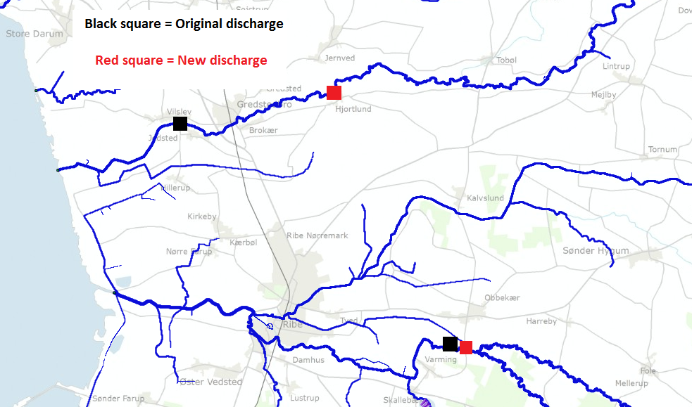

Figure 11 shows the projection of discharge data in Ribe Å and Konge Å